**Object Oriented Programming Final Project Report**

SchedNara

**BY**

Name : Ella Raputri

Student ID : 2702298154

Class : L2AC



**Bina Nusantara International University**

**Jakarta**

**2024**

Computer Science Program

School Of Computing and Creative Arts

**Table of Contents**

**Cover Page**.....................................................................................................................................................i

**Table of Contents**.........................................................................................................................................ii

**A.** **Introduction** 1

1. Background 1

2. Problem Identification 1

**B.** **Project Specification** 3

1. Program Name 3

2. Program Display 3

3. Program Features 4

4. Program Input 7

5. Program Multimedia Output 7

6. Imported Java Packages 8

7. Other Libraries and API 10

8. Program Files and Folders 11

**C.** **Solution Design** 13

1. Design Choices 13

2. Font and Audio 15

3. Diagrams 16

4. Data Structure Used 16

**D.** **Essential Algorithms** 17

**1.** **Regular Classes** 17

a. Contact 17

b. Flow 17

c. Message 18

d. Task 18

e. Workflow 19

f. CalendarToday 19

**2.** **Custom JComponent Classes** 20

a. ButtonCustom 20

b. WrappedLabel 21

c. CloneablePanelContact 22

d. CloneablePanelMsg 24

e. CloneablePanel Workflow 25

f. CloneablePanelFlow 28

g. CloneablePanelTask 30

h. PlaceHolderJTextArea 32

i. PlaceHolderTextField 33

j. RoundJTextField 35

k. AranaraDropShadowPanel 36

l. CalendarCell 38

m. CalendarPanel 40

n. CalendarCustom 41

o. PanelSlide 44

**3.** **Sound Classes** 45

a. MusicPlayer 45

b. SfxPlayer 46

**4.** **Frames** 47

a. WelcomePage 47

b. SignUp 48

c. Login 53

d. HomePage 54

e. AddWorkflowMenu 61

f. CreateNewWorkflow 65

g. EditWorkflow 66

h. TextResult 73

i. CalendarPage 75

j. AddNewTask 77

k. EditTask 79

l. InsertWorkflowTask 82

m. ContactOthers 85

n. ContactsList 87

o. MsgTemplate 90

p. AranaraMenu 92

q. EditAranara 93

r. AranaraChatMenu 97

**E.** **Evidence of Working Program** 104

**F.** **Lesson Learnt (Reflection)** 105

**G.** **Resources** 106

**SCHEDNARA**

1. **Introduction**
2. **Background**

As a part of our Object-Oriented Programming class that is conducted using the Java programming language, we are expected to create a project that should solve a small but interesting problem in our daily life. The project at the bare minimum should focus on the topic that we have covered in class, which is related to Object Oriented Programming, so that we can learn new things while creating this project.

Hence, after some thought, I decided to initiate a project that I have planned to do since my first semester holiday, which is a workflow and scheduling app. The reason why I planned to create this application is closely connected to my jobs in one of the organizations that I have joined, which is KTOM (Kontes Terbuka Olimpiade Matematika).

KTOM is an organization that holds a monthly free Math Olympiad contest to help Indonesian people learn and practice high school Math Olympiad problems. One of my jobs there is to help the committee arrange the monthly schedule based on KTOM’s workflow.

For example, let the contest day be D-day, then 21 days before D-day (D-21) until 15 days before D-day (D-15) is the problem creation date range. After that, on D-14, the head of the problem setters will hand over the problems to the QC division, and so on. Then, if D-day is on June 14th, then the problem setters have to start create the problems for the contest from May 24th until May 30th. The head of them will hand the problem to the QC division on May 31st. One of my jobs is to help remind each division of a particular date based on the workflow. In this example, I have to remind the problem setter division on May 24th and May 30th, while for the division head and the QC division, I have to remind him on May 31st.

Every month has different dates, but the workflow is still the same, so it is tiresome to count and set the date manually every month. Besides that, several kinds of contests have different flows or checkpoints. Before this, I have created a similar function terminal program to help me with this problem when I was in my first semester. However, the functions are not sufficient enough for my job now. So, I thought of creating a GUI app with more features that can help me with my job in arranging workflows and schedules.

Besides that, to make the app look more fun and intriguing, I designed the app based on my favorite NPCs in Genshin Impact, which is the Aranaras. I also created an Aranara menu to let the user interact with them without wasting too much time (because the main point of this app is to help arrange schedules) with the cute Aranara to help relieve the pressure in our daily lives.

1. **Problem Identification**

The first thing that I thought of in this Object-Oriented Programming Final Project is to make an app that can help increase my work efficiency, so that I can use it frequently even after the final project is submitted. That is why I was motivated to upgrade the previously terminal-based counting date program to a GUI program with more features.

User needs to sign up or log in to their account first so that they can access the tasks and workflows specified to them. Although this program will be only used by me in the future, in my opinion, it is beneficial to separate the workflows and tasks for individual matters and works.

After that, there are four main menus that users can access, which are the homepage, the add workflow menu, the calendar, and the Aranara menu. The main function of this program lies in the second and third menus, which are the add workflow and the calendar menu. In the add workflow menu, users can create, delete, and edit workflows. Meanwhile, in the calendar menu, users can create, delete, and edit tasks and also insert tasks based on specific workflow into the calendar. The homepage only functions as a landing page and contains user task completion streaks and some random quotes. Meanwhile, the Aranara menu allows users to interact with particular Aranara. User can also ask the Aranara about their task, weather, etc.

So, my main objectives for creating this program are:

1. Help user to arrange their workflows.
2. Let user insert tasks based on their workflow into their schedule.
3. Help user arrange their tasks.
4. Relieve user stress or motivate users by providing interaction with the Aranaras.
5. **Project Specification**
6. **Program Name**

**“SchedNara”**

SchedNara is an abbreviation of the Schedule of Nara. Schedule refers to my main goal in creating this app which is to assist in arranging schedules based on the tasks and workflows. Meanwhile, Nara is what the Aranaras in Genshin call humans. So, SchedNara is the schedule of humans, or to be exact, the schedule of the user.

1. **Program Display**

The size for all the mainframes in this program is 1280 px × 720 px. The background pictures of all frames are created by me in Figma using shapes, pen, and pencil tools provided there. The icons are also all imported from Figma using the Iconify plugins that are available there. The only pictures that are imported from other sources are the Aranara pictures. Reference and pictures used in this program will be further discussed in part C1.

In total, this program has seven different backgrounds. However, some of them are similar and are different because of certain elements that are added to the picture. If we remove that certain element, then some frames are basically the same. So, the frames that have drastic differences are only four, which are the welcome page frame, the default main menu frame, the edit workflow frame, and the edit Aranara frame. Besides four of them, several mini frames only have white color as the background.

The welcome page frame consists of a hillside scenery with blue sky, white clouds, and green grass. This background can be viewed on the welcome page, the login, and the signup page. The default main menu frame is a standard white frame with a blue rectangle on the left. Inside the blue rectangle are the icons or buttons to direct the user to other main menus or log out. Both the welcome page and default main menu background have the SchedNara logo. For the welcome page, it is positioned on the top, while for the default main menus, it is positioned on the bottom left of the frame.

As its name suggests, the edit workflow background is used only for the edit workflow frame, where the user can add, update, or delete the flows or checkpoints in a certain workflow. Lastly, the edit Aranara frame which is the main frame for the user when interacting with the Aranara also has its unique background. The background is in a living room with a window, wooden floor, and some decorations. The Aranara will stand on a round carpet.

This program also utilizes the custom Cloneable Panel in an abundant amount. The Cloneable Panel is a JPanel that can be cloned based on the user input. These cloneable panels can be seen on things that the user can perform CRUD (create, read, update, delete) with, for example: workflows, flows, tasks, etc.

1. **Program Features**

The program has several main menus. Each main menu or main page has its special features. Below are the explanations of all menus and their features in SchedNara.

1. Welcome Page, Login, and Sign Up pages

The welcome page only consists of two buttons, which prompt the user to log in to their existing account or sign up for a new account. If the user chooses Login, then the user only needs to fill in their username and password. Meanwhile, if the user chooses Sign Up, the user needs to also enter their username and password, but they need to also confirm it. Password needs to be in the length of 8 and consists of letters and numbers. Both the Login and Sign Up pages also have validation that can change the field that is not correct yet to be colored in red. After the user presses the submit button and all fields are correct, the user will be directed to the homepage.

1. Home Page

On the homepage, user can view their task completion rate or streaks in the form of a bar chart. The bar chart will be reset weekly. There is also the text that tells the user about their completion rate for today. Another thing on the homepage is the random quote generator. All the quotes are from Genshin characters, including the Aranaras. Some buttons can redirect you to other main menus or log out.

1. Add Workflow Menu

The add workflow menu consists of several important features, from adding workflow, editing the name of the workflow, and deleting workflow. Users can also search the workflow based on its name. The add workflow menu can also redirect the user to the edit workflow menu to edit the flows or checkpoints for each workflow.

1. Edit Workflow Menu

The edit workflow menu consists of a white panel that consists of fields related to a workflow (name, type, day, notes, color), a save button, and a delete button on the left side. Meanwhile, on the right side, there is a scroll pane for all the flows that the workflow contains. If the user selects the flow inside the scroll pane, then the white panel on the left will automatically be filled with the information of the selected flow. Users can edit or delete that flow from the white panel. If the user does not select any flow, then the delete button is disabled and only the save button is enabled. If the user clicks that save button and already fills in all the information, then a new flow will be added. Besides that, there is also a generate workflow to text button. Users can input a specific date as D-day and the program will generate the date of each flow based on D-day. The date generated are also copiable through a button provided there.

1. Calendar Menu

When first accessing this page, the user can see a calendar with a size of about 1080 × 540 pixels. Users can use the < and > arrow to move around to see other months. The date of today is marked differently than others, while Sundays are marked red. Dates from other months are colored lighter than the dates in the current month. Below the date are dots that represent the color of the tasks on that day. On the right side of the calendar, there is a task panel that contains the tasks for the selected date. There is also an add task button that enables the user to add a new task. For every task that is displayed in the scroll pane in the task panel, there is also the edit button and a checkmark box. The edit button allows users to edit specific tasks. Meanwhile, the checkmark box can be ticked by clicking on it and it is used to help users know if the task is completed or not. Above the calendar are the WhatsApp button and the Insert Workflow Tasks button. Similar to the generate workflow to text button, the insert workflow tasks will prompt the user to input a date as the D-day and then it will insert all the flows as tasks into the calendar. The WhatsApp button is created to help me with my jobs to remind people. It will direct the user to WhatsApp chat based on the number inputted and type the message in the chat based on the message template available in SchedNara. The message template and the contacts can also be edited through the menu directed by this button.

1. Aranara Menu

The Aranara menu contains three different panels which lead to three different Aranara, which are Arama, Ararycan, and Arabalika. Three of them have similar interaction dialogues. Only for some dialogues that each of them is unique. Arama is the most cheerful one, Ararycan is friendly but kind of pessimistic, and Arabalika is antagonistic with his signature “Hmph”. Arama is the default Aranara for every user. The user has to reach a total affection of 60 to unlock Ararycan and 120 to unlock Arabalika.

1. Edit Aranara Menu

Edit Aranara Menu or Aranara Activity Page is where the user interacts with a specific Aranara. On the right side, there is the set default and pat button. All users default Aranara when signing up as Arama. They can switch to another Aranara by using the set default button. Every Aranara also has different background music, so if the user switches to another Aranara, then the background music will be changed. The pat button is used to pat the Aranara, every user is limited only to a total of three times patting for a day. When patting, there will be also specific dialogue from the Aranara. The chat button on the left side is used to open the Aranara Chat Menu on top of the Edit Aranara Menu.

1. Aranara Chat Menu

The Aranara Chat Menu can be closed using a left arrow button on the Edit Aranara Menu which is only visible when the Aranara Chat Menu opens. Meanwhile, Aranara Chat Menu itself has eight buttons inside it. All of the eight buttons can not increase the Aranara affection towards the user.

* The ‘Greet’ button, is used to greet or say hi to the Aranara. Each Aranara will reply to your greetings differently.
* The ‘Tasks’ button, is used to ask the Aranara about the task in today, tomorrow, or other dates. The Aranara will tell the user the task names on that particular date.
* The ‘Word’ button, is used to open Microsoft Word.
* The ‘Excel’ button, is used to open Microsoft Excel.
* The ‘PowerPoint’ button, is used to open Microsoft PowerPoint.
* The ‘Timer’ button, is used to set a timer and remind the user when the time is up.
* The ‘Weather’ button, is used to ask the Aranara about the weather today in a specific city. The Aranara will tell the user the temperature, the weather description, and some friendly recommendations regarding the weather conditions.
* The ‘Game’ button is used to play the simple rock, paper, scissors game with the Aranara.

1. **Program Input**
2. Mouse’s left button, to click the buttons inside the program.
3. Keyboard key ‘Enter’, which can be used when filling out the information on Sign Up and Login page. Clicking the field is also allowed here besides the ‘Enter’ key.
4. Other keyboard keys, to input the information needed in all fields and text areas inside the program.
5. **Program Multimedia Output**

Besides the text output, which is the tasks, workflows, affection rate, etc., there is also multimedia output which is the image of the frame, icons, and buttons in this program. All of the images can be accessed in the ‘src/App/img’ folder. Meanwhile, the audio files (background music and sound effects) are available in the ‘src/App/sound’ folder with the specifications below.

1. Background music

* EnchantingBedtimeStories.wav for Welcome Page, Login, and Sign Up.
* MelodyofHiddenSeeds.wav for the main menu background music if the default Aranara is Arama.
* IveNeverForgotten.wav for the main menu background music if the default Aranara is Ararycan.
* ForRiddlesForWonder.wav for the main menu background music if the default Aranara is Arabalika.

1. Sound Effects

* win.wav, when the user wins the rock paper scissors game.
* select.wav, when the user clicks a button in the Edit Aranara menu or Aranara Chat Menu, except for the chat button.
* lose.wav, when the user loses the rock paper scissors game.
* draw.wav, when the rock paper scissors game ends in a draw.
* chat.wav, when the user clicks the chat button or the button to collapse the Aranara Chat Menu.

1. **Imported Java Packages**
2. AWT and Swing

AWT and Swing are two APIs that are used to develop the GUI (Graphical User Interface) of the application. These two APIs are used to construct the display of this program.

1. SQL

The java.sql is a package that provides a method for accessing and processing data stored in the SQL database. This program stores user, workflow, task, contact, message template, and other information in the MySQL database. Hence, to access and update it based on user input, this program has to utilize the java.sql.

1. Text

The java.text is a package that provides classes and interfaces for handling text, date, and strings. In this program, this text package is mainly used to format and parse dates (task dates).

1. Time

Java Date and Time API contains classes and an interface that handles date and time values and is available in java.time package. This program is highly dependent on counting dates because it is a scheduling app. This package provides methods that help me in counting and handling dates and times (mostly used in task dates).

1. Util

The java,util package is a package that contains collections framework, date and time facilities, random generator, and many more. This program heavily relies on the usage of Linked List to store the list of tasks, workflows, etc. Besides that, this program also uses HashMap to store specific months and their corresponding number and also the random generator to generate Aranara dialogue randomly. Linked List, HashMap, and Random are all from the java.util package.

1. io

The java.io package contains classes and interfaces that help users with input and output-related operations. One of its main features is for reading and writing data to files. This program needs to read a txt file that contains the quotes so that it can display it on the homepage. To do so, it will utilize a class from the java.io package.

1. Net

The java.net package is used to establish a communication link between devices over the internet. In other words, it is used to implement networking applications. In this program, when user wants to contact others through WhatsApp, they will be redirected to the WhatsApp web on the internet. Hence, to achieve this, this program needs the java.net package methods.

1. Sound

The javax.sound is a collection of classes and interfaces for controlling and handling sound media in Java. In this program, there are several different background music and sound effects which are all audio files. Therefore, we need the javax.sound to help us to handle them.

1. **Other Libraries and API**
2. Absolute Layout.jar

The Absolute Layout is used to ease the process of designing in Java Netbeans so that we can specify the exact location (x,y) of the children in the frame. When designing, Absolute Layout also allows the designer frame in the Netbeans to not enlarge its size automatically (most of the time).

1. Mysqlconnector.jar

This jar file is used to help connect the program with the existing MySQL local database so that the program can access and process the data stored there. Another advantage of using the database is that when we close the program, we will not lose the data that we inputted before so we do not need to restart everything when we start our program again.

1. jcommon.jar and jfreechart.jar

The JFreeChart is a Java class library that is used to handle and create charts. In this program, I used to create the bar chart on the homepage based on the user’s task completion rate. The JFreeChart itself utilizes the JCommon class library which is a collection of useful classes for text utilities, displaying information, custom layout managers, etc.

1. OpenWeatherMap API

The Open Weather Map API is a weather API that allows users to access various weather data. In this program, this API is used to get the current weather in a specific city that is inputted by the user.

1. json.jar

This jar is used to handle the JSON file from the weather API call. When we call the OpenWeatherMap API through the weather button in the Edit Aranara menu, the API will return the weather result in the form of a JSON file. This jar contains methods to help us handle and get the information that we want from the returned JSON file.

1. **Program Files and Folders**

All documentations of this program are stored inside the ‘document’ folder, while all the libraries used are stored in the ‘libs’ folder. Codes and media (image and audio) are stored inside the ‘src/App’ folder where the image files are stored inside the ‘img’ folder and the audio files are stored inside the ‘sound’ folder. Below is the more detailed description for each file inside the ‘src/App’ folder (excluding the ‘img’ and ‘sound’ folder files).

1. AddNewTask.java, used for adding new tasks to the calendar.
2. AddWorkflowMenu.java, used for creating, editing, and deleting workflows.
3. AranaraChatMenu.java, contains buttons to interact with the Aranara.
4. AranaraDropShadowPanel.java, a custom panel class that is used as an individual panel for each Aranara in the Aranara menu, so that the user can choose which Aranara that they want to visit.
5. AranaraMenu.java, contains panels of different Aranaras.
6. ButtonCustom.java, a custom button class for buttons with round edges.
7. CalendarCell.java, a custom button class for the calendar cell for each date.
8. CalendarCustom.java, a custom panel class that contains the calendar panel, task panel, and several labels and buttons to create the whole calendar display.
9. CalendarPage.java, a menu that consists of the calendar and several features related to tasks.
10. CalendarPanel.java, a custom layered pane class that contains all the calendar cells that construct the calendar panel.
11. CalendarToday.java, a class that is used to store methods for handling today’s date.
12. CloneablePanelContact.java, a custom panel class for displaying list of contacts.
13. CloneablePanelFlow.java, a custom panel class for displaying list of flows.
14. CloneablePanelMsg.java, a custom panel class for displaying list of message templates.
15. CloneablePanelTask.java, a custom panel class for displaying list of tasks.
16. CloneablePanelWorkflow.java, a custom panel class for displaying list of workflows.
17. Contact.java, to initialize and handle Contact objects.
18. ContactOthers.java, contains feature to contact other people through WhatsApp.
19. ContactsList.java, used for creating, updating, and deleting contacts.
20. CreateNewWorkflow.java, used for creating a new workflow.
21. EditAranara.java, used as the main page for interacting with an Aranara.
22. EditTask.java, used for updating information of a specific task.
23. EditWorkflow.java, used for editing flows inside a workflow.
24. Flow.java, used for handling Flow objects.
25. HomePage.java, initialize the HomePage frame and display information inside it.
26. InsertWorkflowTask.java, used to insert the workflow as tasks based on the inputted D-day.
27. Login.java, initialize the login page to let the user login into their existing account.
28. Message.java, used for handling Message objects.
29. MsgTemplate.java, used for creating, updating, and deleting message templates.
30. MusicPlayer.java, used to play the background music.
31. PanelSlide.java, a custom panel class that allows the slide animation. This class mainly used when user switches month in the calendar.
32. PlaceHolderJTextArea.java, a custom textarea class that contains a placeholder.
33. PlaceHolderTextField.java, a custom textfield class that contains a placeholder.
34. Quotes.txt, contains the random quotes that will be displayed in the homepage.
35. RoundJTextField.java, a custom textfield class that is round edged and has no placeholder.
36. SfxPlayer.java, used to play the sound effects in the Edit Aranara menu.
37. Signup.java, initialize the sign up page to let the user create a new account.
38. Task.java, for handling task objects.
39. TextResult.java, used to generate the date in form of text based on the workflow and inputted D-day.
40. WelcomePage.java, initialize the welcome page.
41. Workflow.java, for handling workflow objects.
42. WrappedLabel.java, a custom label class that allows the text to be wrapped or continue to the next line after the text has a certain width.
43. **Solution Design**
44. **Design Choices**

For this program, I did not want to have a rigid static design as a formal application although its main feature is closely related to productivity. Hence, I thought of using Genshin based cute character in the main design as Genshin Impact is currently my favorite game. I then thought of my favorite characters in the game which are Nahida and the Aranaras. At last, I chose the Aranaras as I thought they were easier to implement as part of the element in the app. Hence, the main design reference of this program is from HoYoVerse Genshin Impact or 原神 (<https://genshin.hoyoverse.com/>).

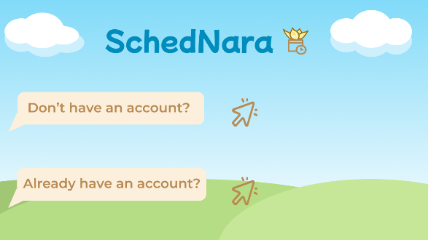As stated before in part B2, all the background images inside the program are drawn by me using the tools on Figma. These are the four main backgrounds that are distinct from each other as I have explained before in B2.

Default main menu

Welcome Page

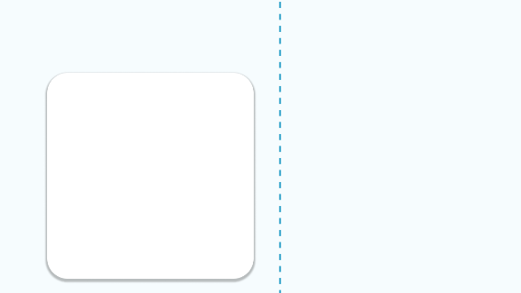

Edit Aranara

Edit Workflow

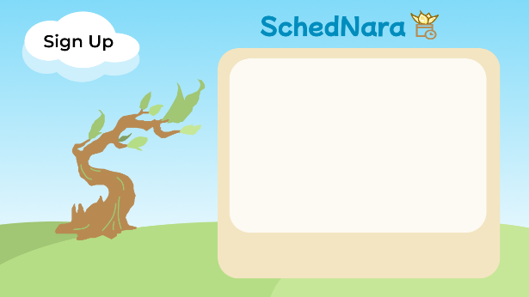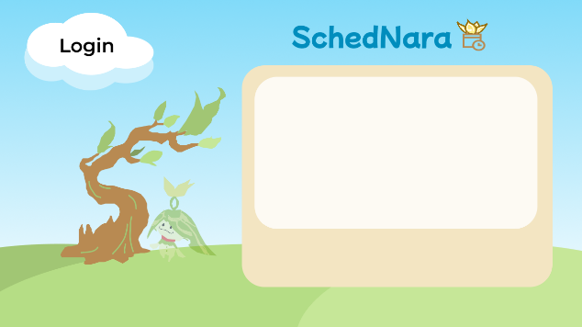The login and the signup page is similar to the welcome page with the presence of Arama and the Ashvattha Tree as at the end of the Aranara quest, Arama becomes the seed of that specific tree. Another background page is the homepage background which is similar to the default main menu background with the only distinction being having several shadow panels.

Sign up

Login

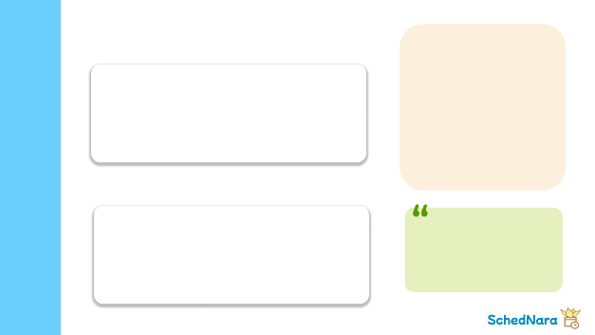

Homepage

Meanwhile, the icons are imported from the Iconify plugins in Figma. 

The only objects that I did not create or use Figma assets are the Aranara (Arama, Ararycan, and Arabalika). The images are shown below. The source of these three images is from Misaaa哈啾 on Weibo (<https://weibo.com/6671732232/M9lWyBnCp>) where she/he allows personal use of these images.



To further enhance the liveliness of the Aranaras, I also animate the Aranara, so that they are floating and I export them into .gif files. Therefore, in the Edit Aranara menu, the Aranara is doing several minor movements (the .gif file), while on the homepage, they are still static (in the form of .png file).

1. **Font and Audio**

The font that I used in this application is mainly Montserrat (Regular, Medium, and SemiBold) because, after all, this program is used to help with user work, so an upright sans-serif font is more suitable. However, for the logo and some of the text in the Edit Aranara menu, I used the Mochiy Pop One font due to its cuteness. It is also in line with my desire as I did not intend SchedNara to be a fully rigid and formal schedule app.

* Source for Montserrat: <https://fonts.google.com/specimen/Montserrat>
* Source for Mochiy Pop One: <https://fonts.google.com/specimen/Mochiy+Pop+One>

Meanwhile, for the audio files, as this program design heavily references Genshin Impact, the background music is also mainly from HOYO-MIX. Below is the detailed source for each background music and sound effect.

1. **Background Music**

* Enchanting Bedtime Stories (by HOYO-MIX)

<https://youtu.be/5bp51REb1pw?si=Vd_7S71qH6NiLA18>

* For Riddles, For Wonders (by HOYO-MIX)

<https://youtu.be/p2QSNcAJLTI?si=4J_JXqUUVM-gSTBr>

* I’ve Never Forgotten (by ChillChill for 2023原神新春会, piano by Frost Piano (프뮤))

<https://youtu.be/SnrDK5kbYZk?si=6SOpCb_zlqlwG_c7>

* Melody of Hidden Seeds (by HOYO-MIX)

<https://youtu.be/w_14Ibukqo4?si=5KTH_a0j1DuWllqE>

1. **Sound Effects**

* win.wav, by Pixabay from Pixabay (<https://pixabay.com/sound-effects/success-fanfare-trumpets-6185/>) .
* select.wav, by Otto VoiceBosch from Pixabay (<https://pixabay.com/sound-effects/menu-select-button-182476/>).
* lose.wav, by UNIVERSFIELD from Pixabay (<https://pixabay.com/sound-effects/fail-144746/>).
* draw.wav, by floraphonic from Pixabay (<https://pixabay.com/sound-effects/90s-game-ui-6-185099/>).
* chat.wav, by UNIVERSFIELD from Pixabay (<https://pixabay.com/sound-effects/button-124476/>).

1. **Diagrams**

All the diagrams (the use case diagram, the activity diagram, and the class diagram) are inside the ‘document’ folder (in the same folder as this report).

1. **Data Structure Used**

There are three data structures used in this program, which are the Linked List, HashMap, and Array. Linked List is mainly used for storing objects that are going to be created cloneable panels for it. For instance, contacts, workflows, flows, tasks, and so on. Linked List is great for storing them because their order matters and Linked List has methods to properly update objects in a particular index.

Meanwhile, there are two types of HashMap in this program which are the month Map and the color Map. The month Map stores a pair of String keys and String values with the key being the name of the month and the value being the number representation of the month (example: “January” : “01”). The color Map stores a pair of String key (color name) and Color object value. The month Map is used to get the representative number of a specific month based on its name, while the color Map is used to get the Color object based on the color name.

Lastly, Array is used to store the quotes read from the txt file and for storing Strings that will be set in the JComboBox. The array has a fixed size, so it is safer for these kinds of data so that they can not easily be changed.

1. **Essential Algorithms**

In this part, I will only show and explain some crucial code and algorithms for each class.

1. **Regular Classes**

This program uses several regular classes to initialize objects as instances of them to ease the code implementation. For example, a flow has several attributes, so we will make a Flow class that contains all the attributes needed so that we do not need to initialize multiple variables and keep it on track every time. We only need to initialize the Flow object. All regular classes have getters and setters for all of the attributes that they have and a constructor.

1. **Contact**

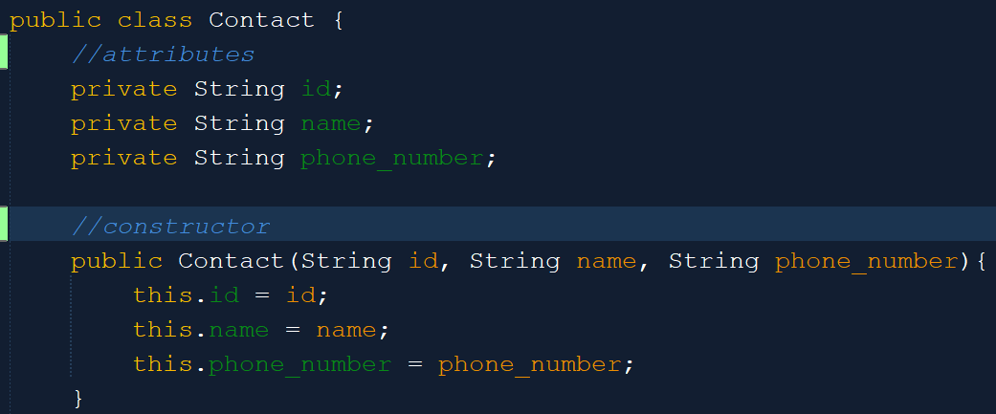

Contact instances are used to represent a person’s contact. Contact objects are used in ContactsList and ContactOther when the user wants to contact others through WhatsApp. A Contact object has id, name, and phone number as its attributes.

1. **Flow**

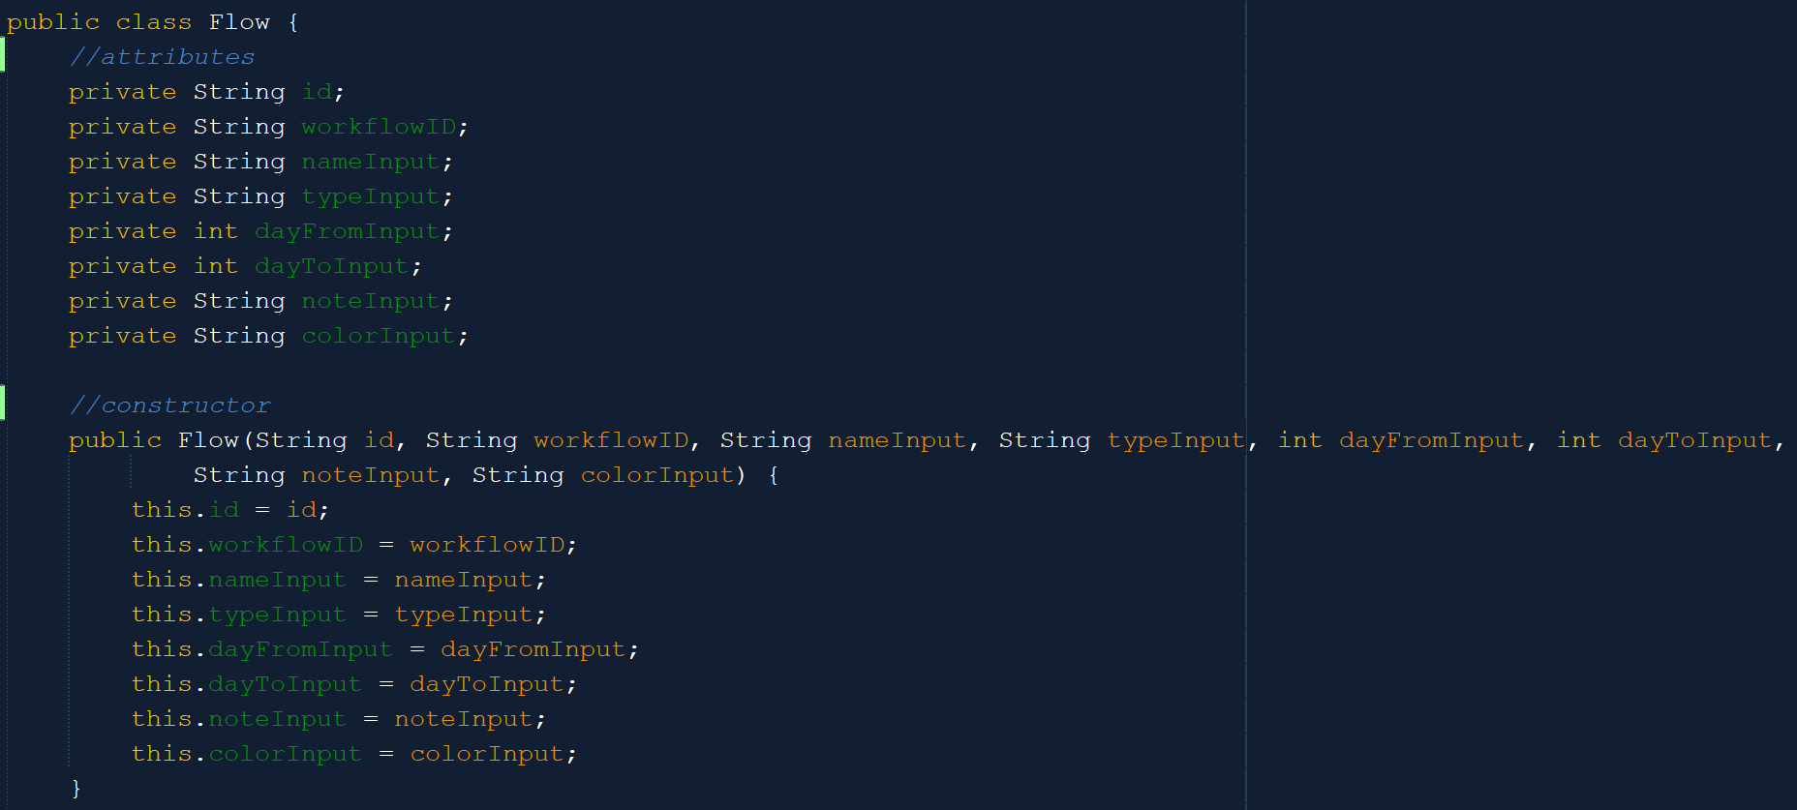

A Flow object is used to represent a flow or a checkpoint inside a workflow. The word flow is used to refer to the task, step, or process that has to be done in the workflow. For example, to make wine, we need to harvest the grape, clean and crush it, and after that ferment it. Each step is called flow in this context. Flow has 8 attributes, which are id, workflowID, name, type, dayFrom, dayTo, note, and color. Flow has two types, which are one-day event and multiple-day event. Meanwhile, dayFrom is the starting day and dayTo is the last day. dayTo is only observed if the Flow type is a multiple-day event.

1. **Message**

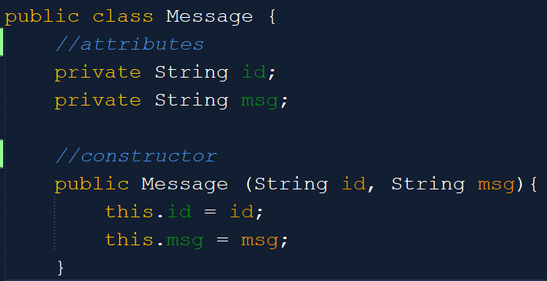

The Message object is used to represent a message. The message object will mostly be used in the MsgTemplate and ContactOthers menu where the user can customize the message template for sending it to other people. A Message object only contains two attributes, which are the id and the msg (the message content).

1. **Task**

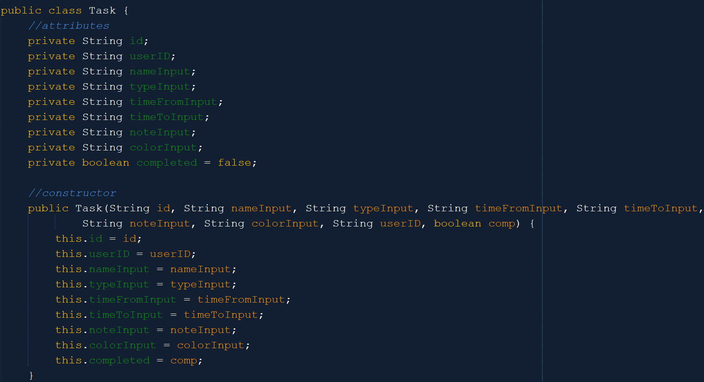

As its name suggests, the Task object is used to depict a task in the calendar. The Task object is similar to the Flow object, but it has the completed attribute and the time attributes are in String. Flow object only represents a step for doing something, while Task object represents a real task that you have to accomplish (you are already in the process to do it). That is why the time attributes (timeFrom and timeTo) are in String because they represent the date and completed represents whether the task is completed or not. Task also uses userID rather than workflowID because it is not part of a workflow. Other than that, the other attributes (id, name, type, note, color) are the same.

1. **Workflow**

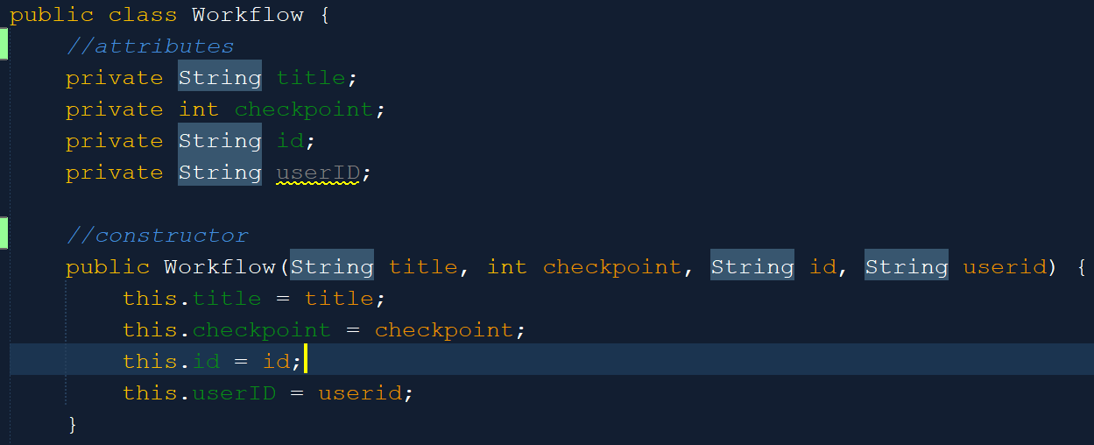

The Workflow object is used to represent the workflows. It only has four attributes, which are title, checkpoint, id, and userID. The checkpoint here refers to the number of checkpoints or flows inside the workflow.

1. **CalendarToday**

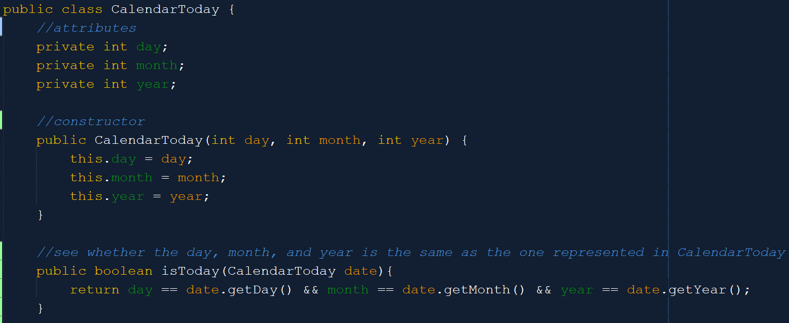

The CalendarToday object is used to represent today’s date. It has three attributes, which are day, month, and year (all in integer). Besides getters and setters, it has another method, which is the isToday method. The isToday method will see whether the date from another object is the same or not as the one represented by CalendarToday (today’s date).

1. **Custom JComponent Classes**

This program utilizes many custom classes that inherit JComponent because of the limitations that the default JComponent has. For example, the JButton in the default javax.swing package did not have round edges. Therefore, to realize the appearance of these components, I have used several custom classes, which are specified below.

1. 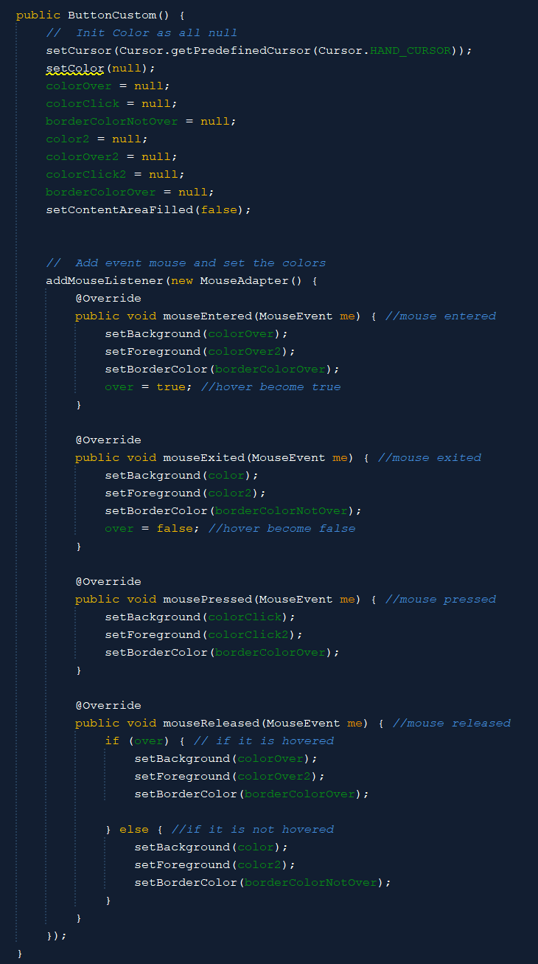**ButtonCustom**

The ButtonCustom is a custom class inherited from the JButton class.

When first initializing ButtonCustom, all the colors are set to null. After that, for every mouse event, we change and condition the color. Then, we override the paintComponents method from JComponent, so that it will draw a round rect (so that we have round edges).

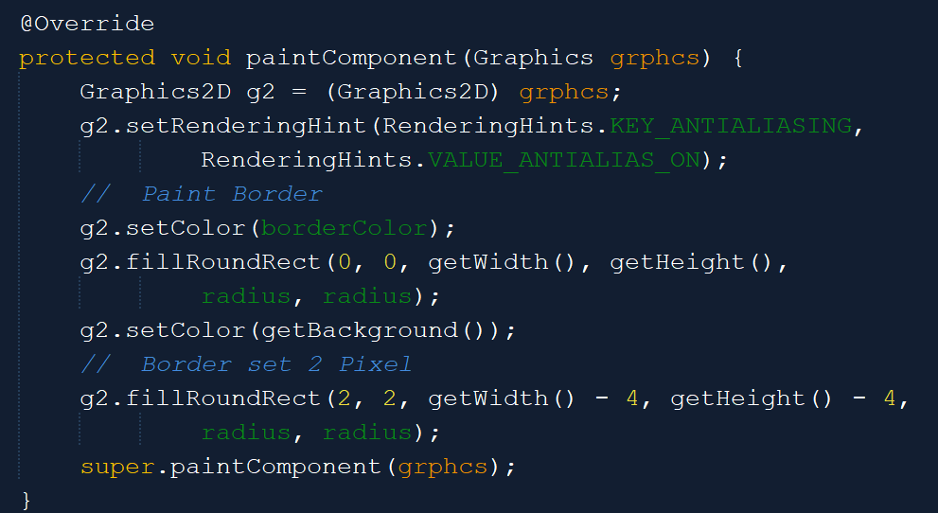

1. **WrappedLabel**

The WrappedLabel is a custom class that inherits from the JLabel class, where it can wrap the text inside the label so that it will continue in a new line (not changing to ...).

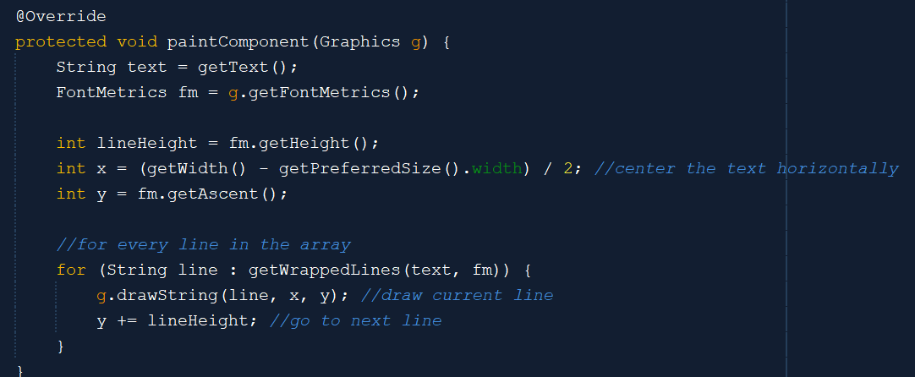

It will first get the text and calculate the height of the text. Then, it will calculate the x starting position. After that, it will iterate over the line wrapped array and draw each line of text. 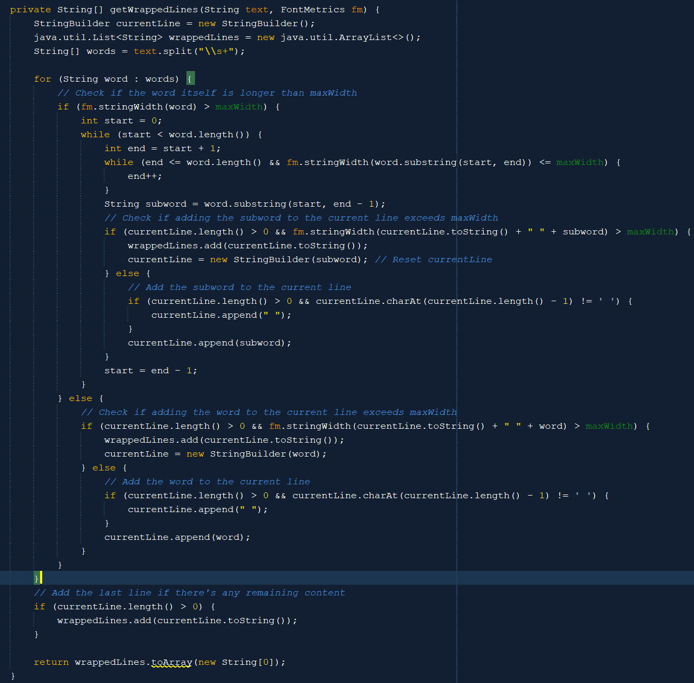

The getWrappedLines() method is used to return a String array of each line content or text. It will first check whether the text width is larger than the max width. If it is larger, then it will iterate to split the text into two lines. If the current line is longer than the max width, it will split again until the last line. It will then return the wrapped lines as an array of String.

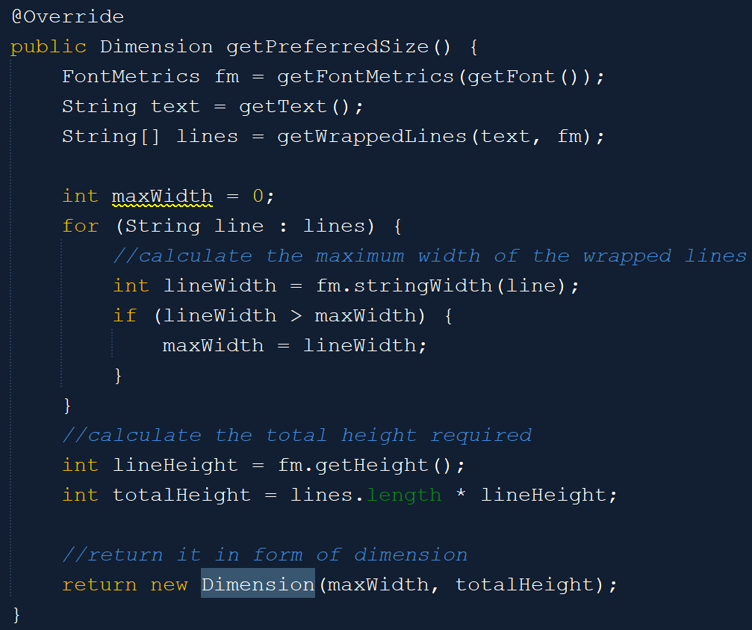

The getPreferredSize is overridden from the JComponent method. Here, this method will get the max width and the total height (line height times the amount of lines) as the preferred size dimension.

1. **CloneablePanelContact**

In this program, there is a total of 5 different but similar cloneable panels that inherit from the JPanel class. The difference between each of them is only the content inside the panel which is often specified inside the constructor. Some have buttons and labels, some only have labels, and so on.

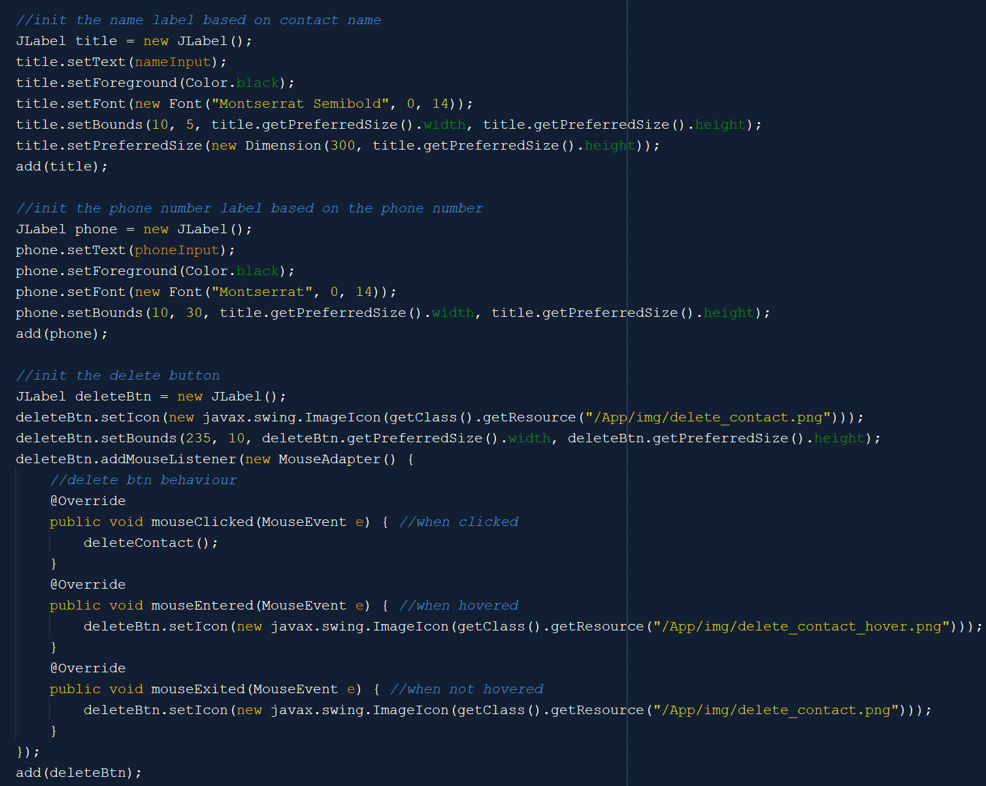



For contacts, the cloneable panel has the title and phone number label and a delete button. The labels and buttons have properties as specified above.

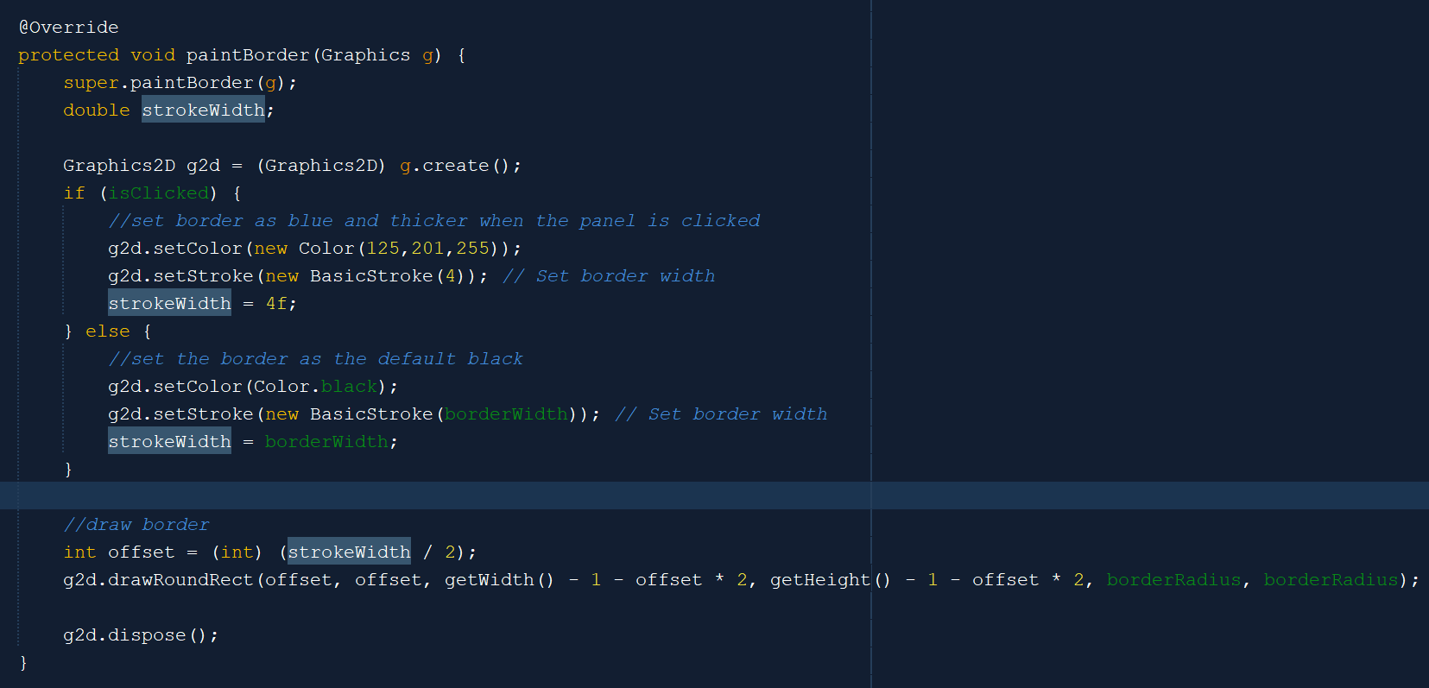

If the panel is clicked, then it will have a blue border color, while in default, the border color is supposed to be black.

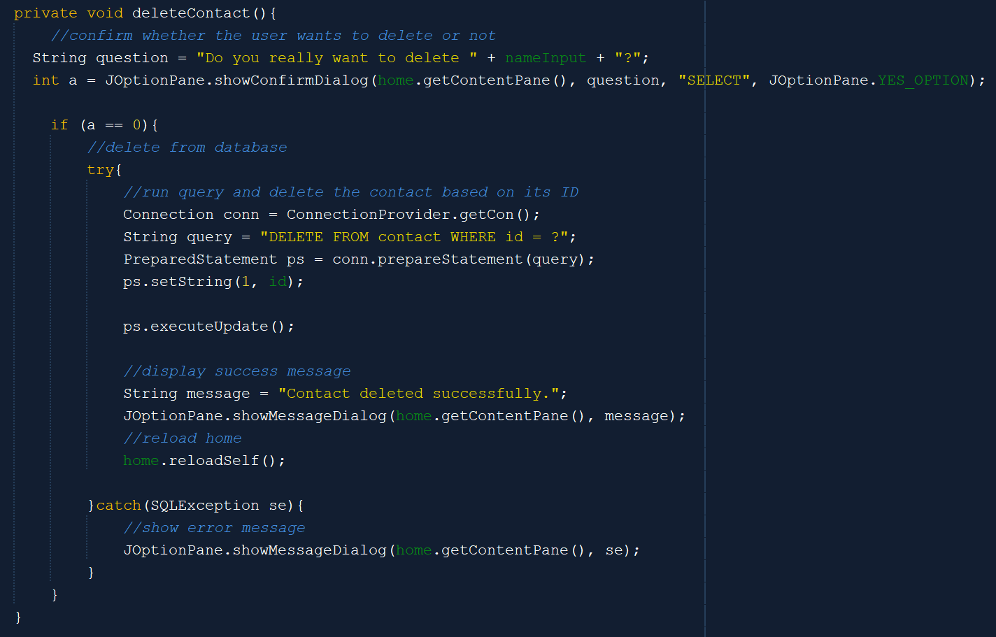

When the delete button is clicked, then it will first ask for confirmation from the user. If the user says yes, then it will delete the contact from the contact table in the MySQL database based on the contact ID. After that, it will display the success message and reload the frame where this cloneable panel belongs.

1. **CloneablePanelMsg**

The cloneable panel for messages is highly similar to the cloneable panel for contacts. The difference is only that this cloneable panel is made for messages, not contacts.

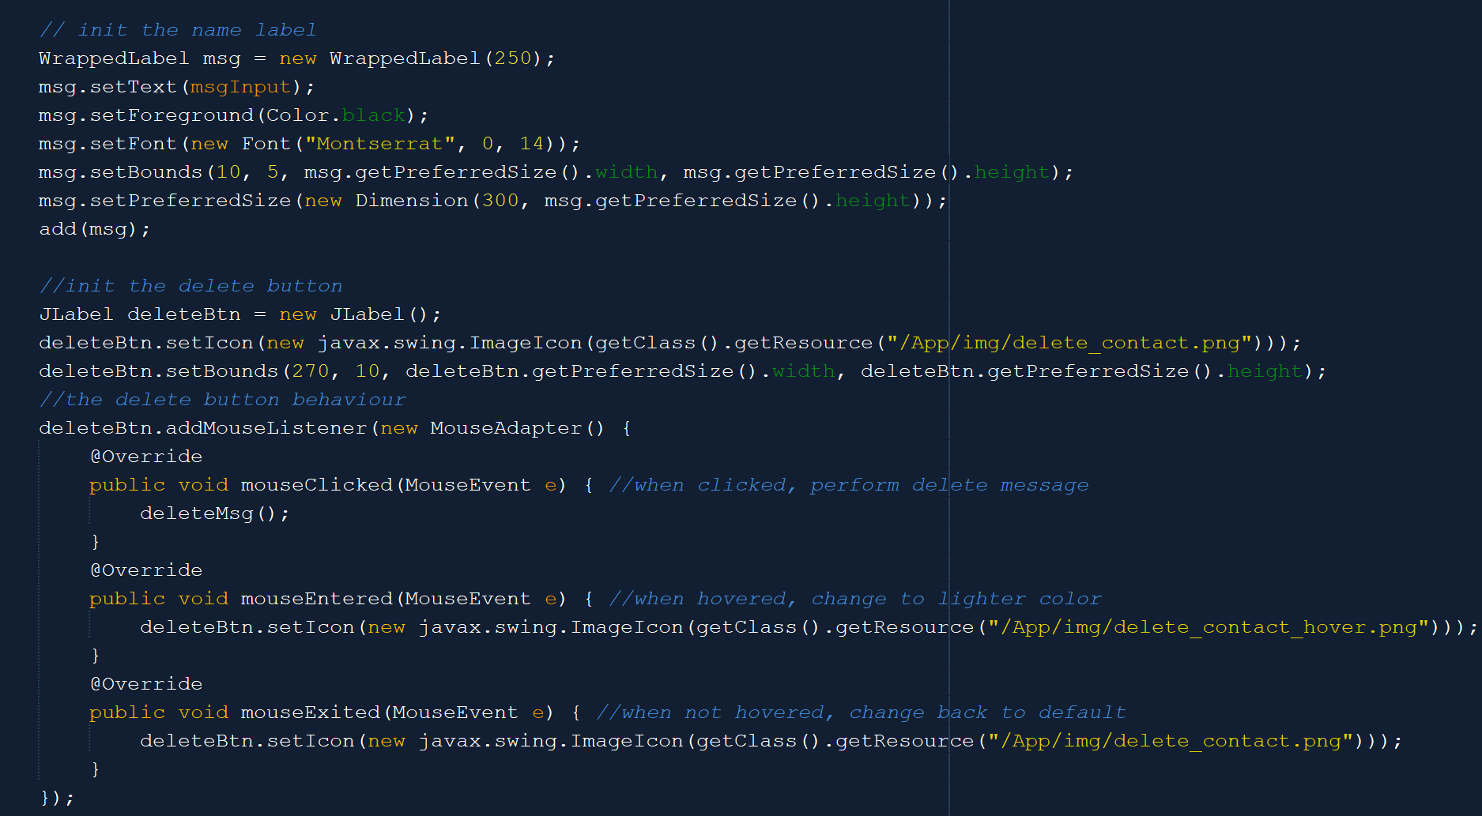

The cloneable panel for messages only has the label for the message and a delete button. If the delete button is clicked, then it will delete the selected message. The selected message panel (similar to the contact cloneable panel) also has a blue border color while the default border color is black. That is also why the paintBorder method for CloneablePanelMsg is the same as the one in CloneablePanelContact.

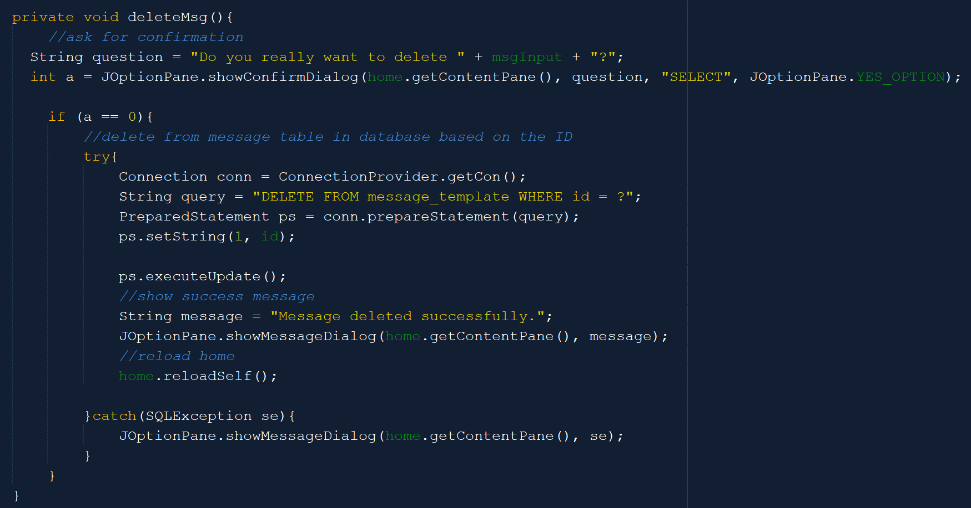

The deleteMsg() function is also almost the same as the delete contact function. It will first ask the user for confirmation, then it will delete the message from the message_template in the database based on the message ID.

1. **CloneablePanel Workflow**

The cloneable panel for workflow is made for workflows.

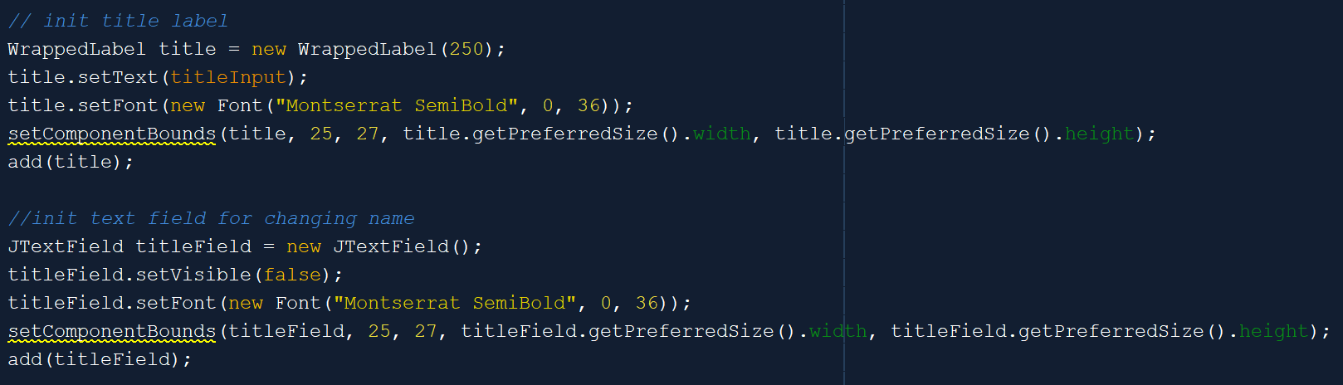

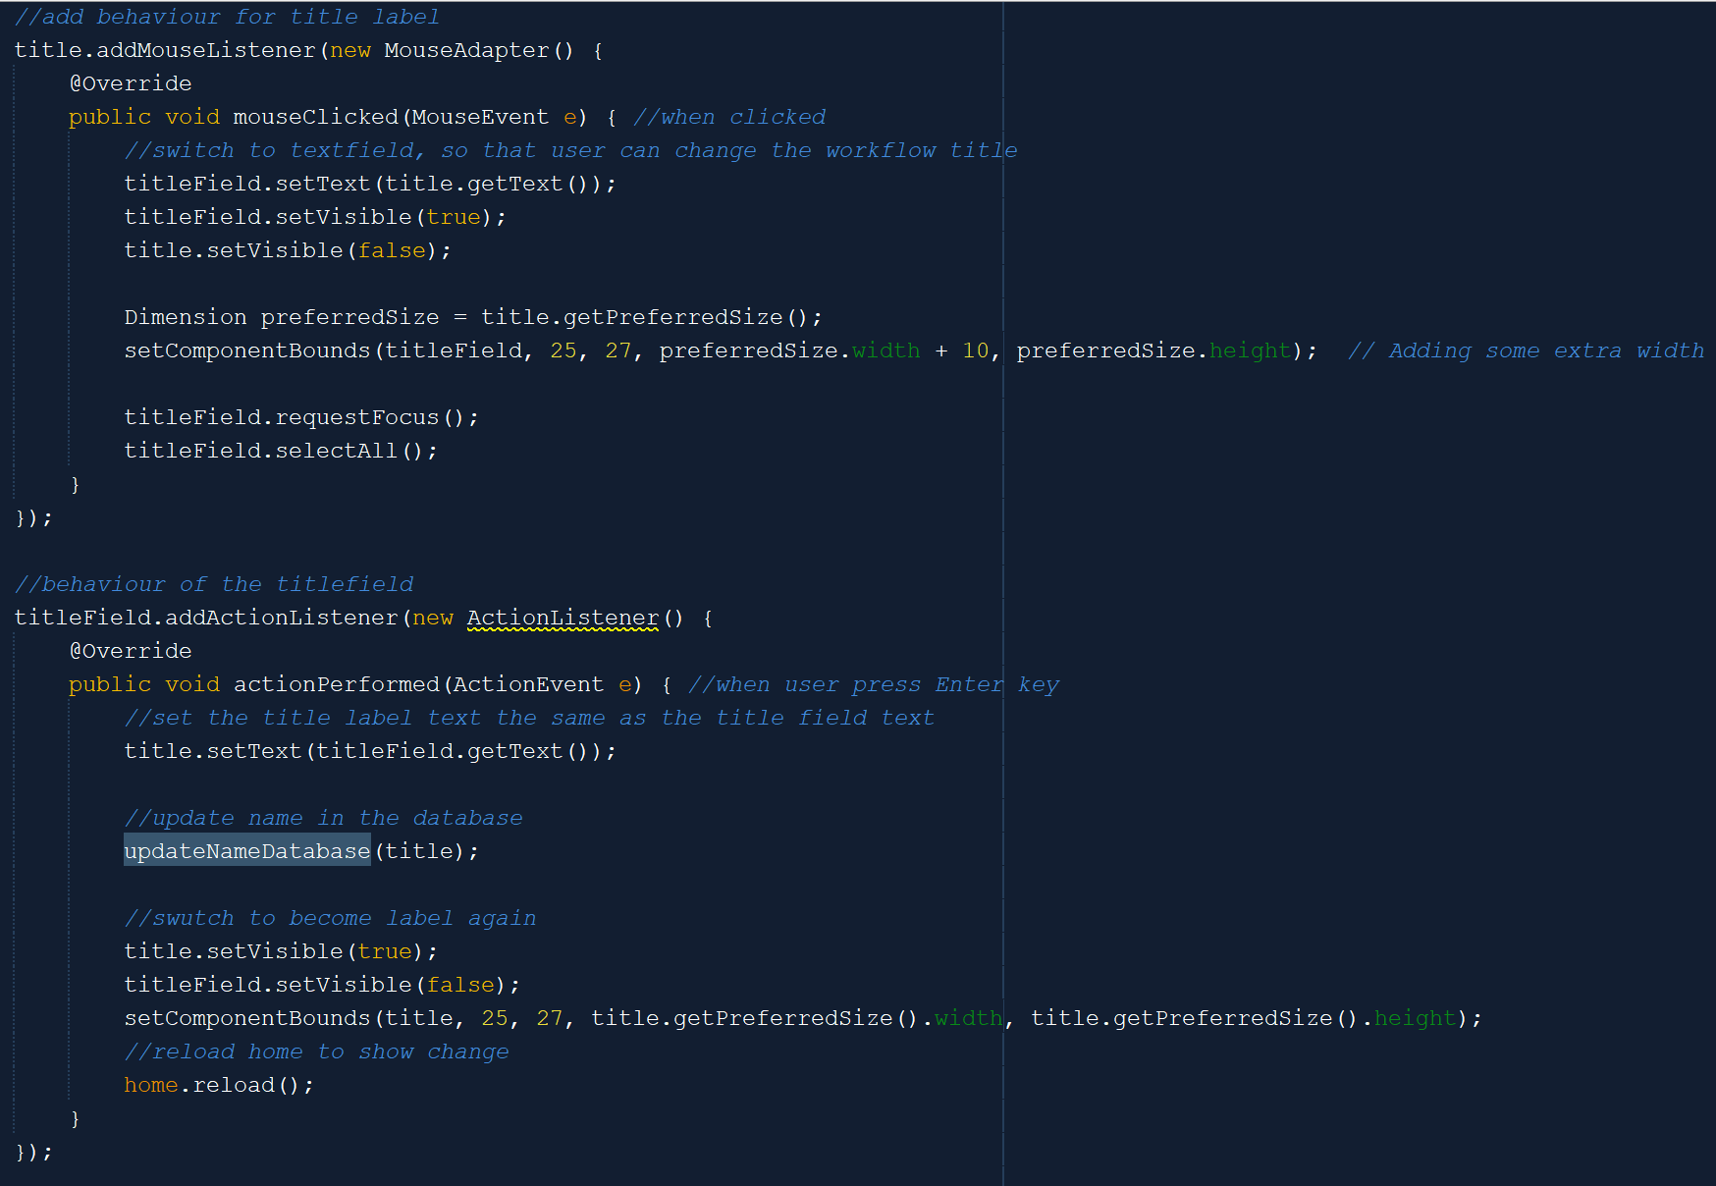

Its title is displayed in a WrappedLabel, but when the user clicks that label, then it will switch to a text field. Users can change the workflow name in the text field and press Enter. After that, the frame will reload and the name in the frame and database will be changed.

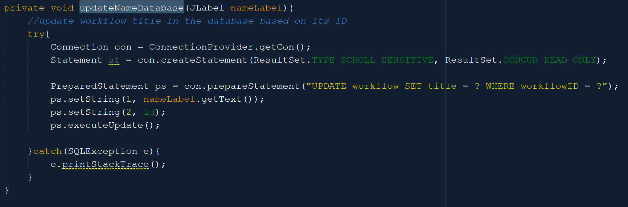

The updateNameDatabase method will first get the new title from the label. Then, it will update the workflow table and set the title of the corresponding workflow (based on its ID) with the new name.

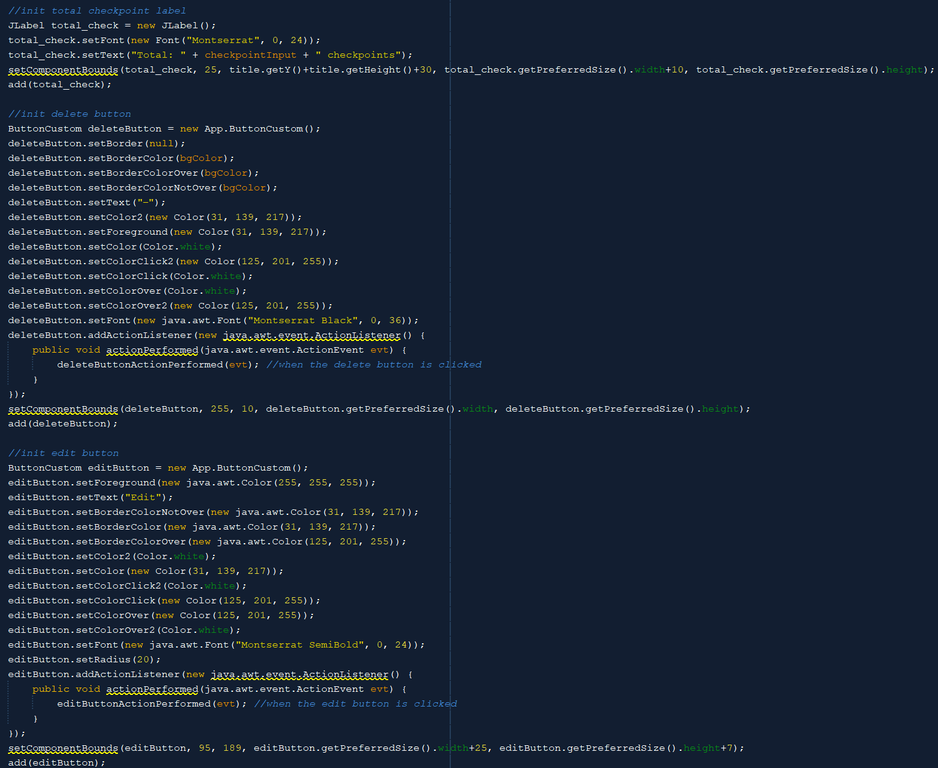



Besides the title label and text field, the cloneable panel also has a label that shows how many flows or checkpoints the workflow has, a delete button to delete the workflow, and an edit button to go to the edit workflow frame.

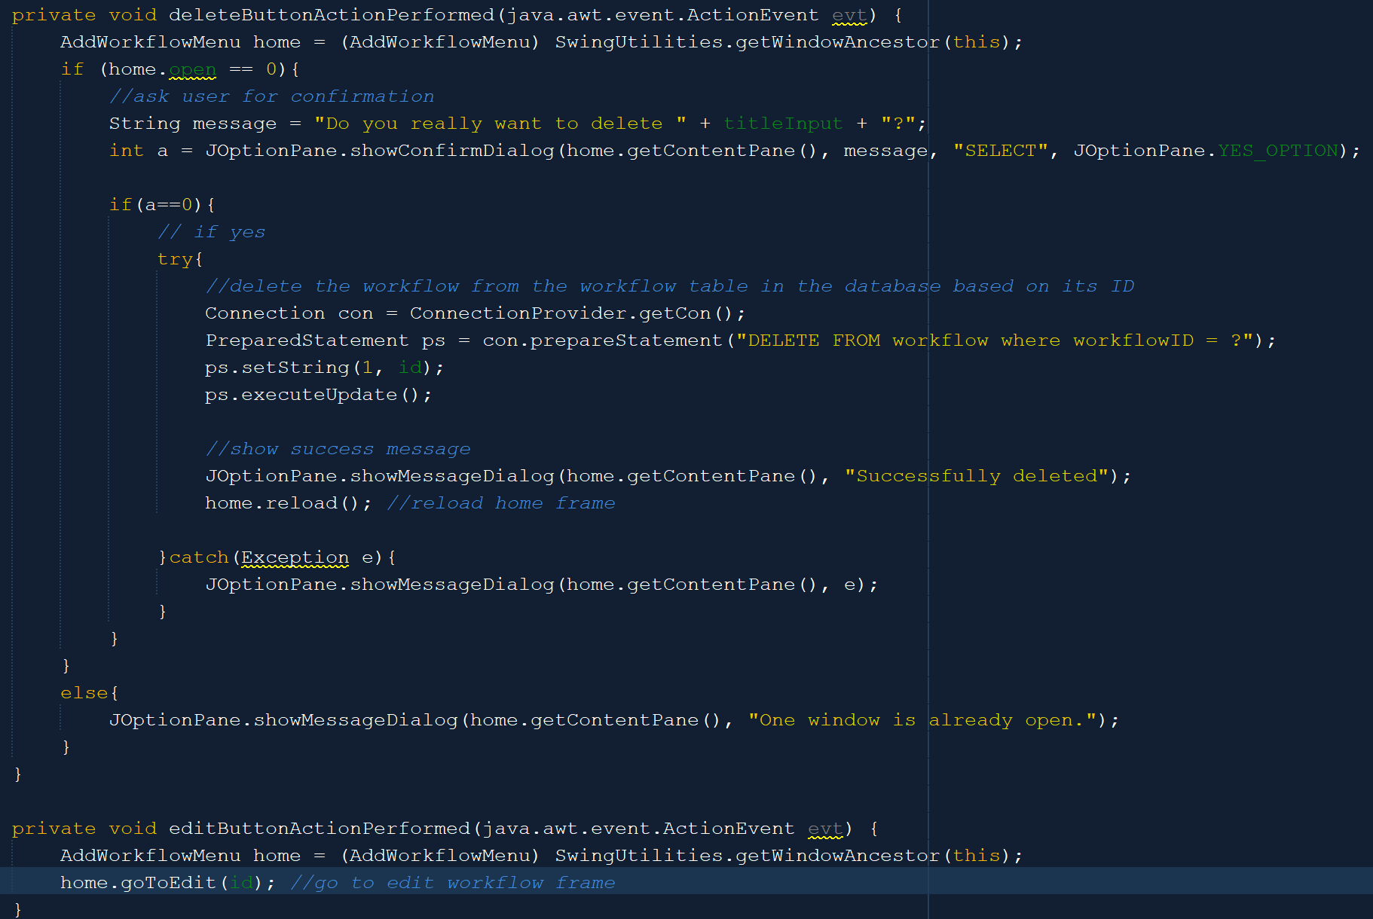

When the delete button is clicked, it will first ask the user for confirmation. If the user says yes, then it will delete the workflow with the corresponding ID from the workflow table in the database. After that, it will display a success message and reload the home frame, so that the change will be shown. Meanwhile, if the edit button is clicked, then the user will be redirected to a new frame where they can edit the corresponding workflow flows.

1. **CloneablePanelFlow**

The cloneable panel for the Flow object exists in the Edit Workflow frame which is the frame that can be accessed when clicking the edit button in the previous CloneablePanelWorkflow.

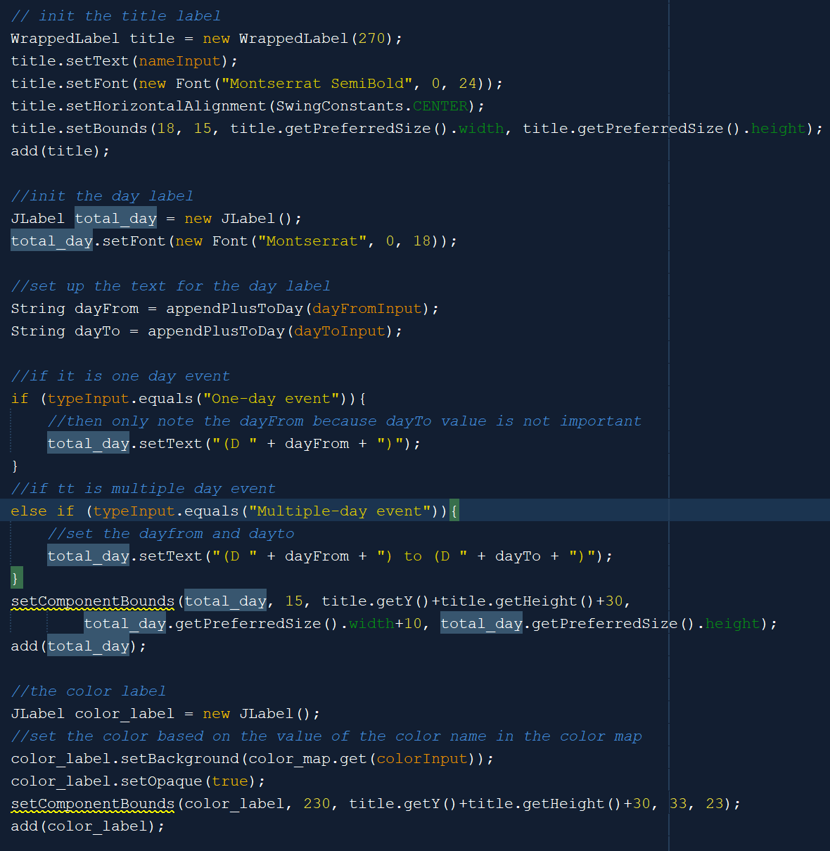



The CloneablePanelFlow is used to display information about a flow. It has a title label to display its title, a total_day label to display its duration, and a color label to display its color. The color label will only have color and no text. The custom appendPlusToDay method here is to condition the String so that when the dayFrom equals 1, the final result String will be D + 1.

The CloneablePanelFlow also has a different border color when it is clicked. The method is the same as the one in the previous CloneablePanelMsg and CloneablePanelContact where we override the paintBorder method. It will have a blue border color when it is clicked, but by default, the border color is black.

1. **CloneablePanelTask**

CloneablePanelTask is a cloneable panel for the Task object. Same as CloneablePanelWorkflow, it can not be selected.

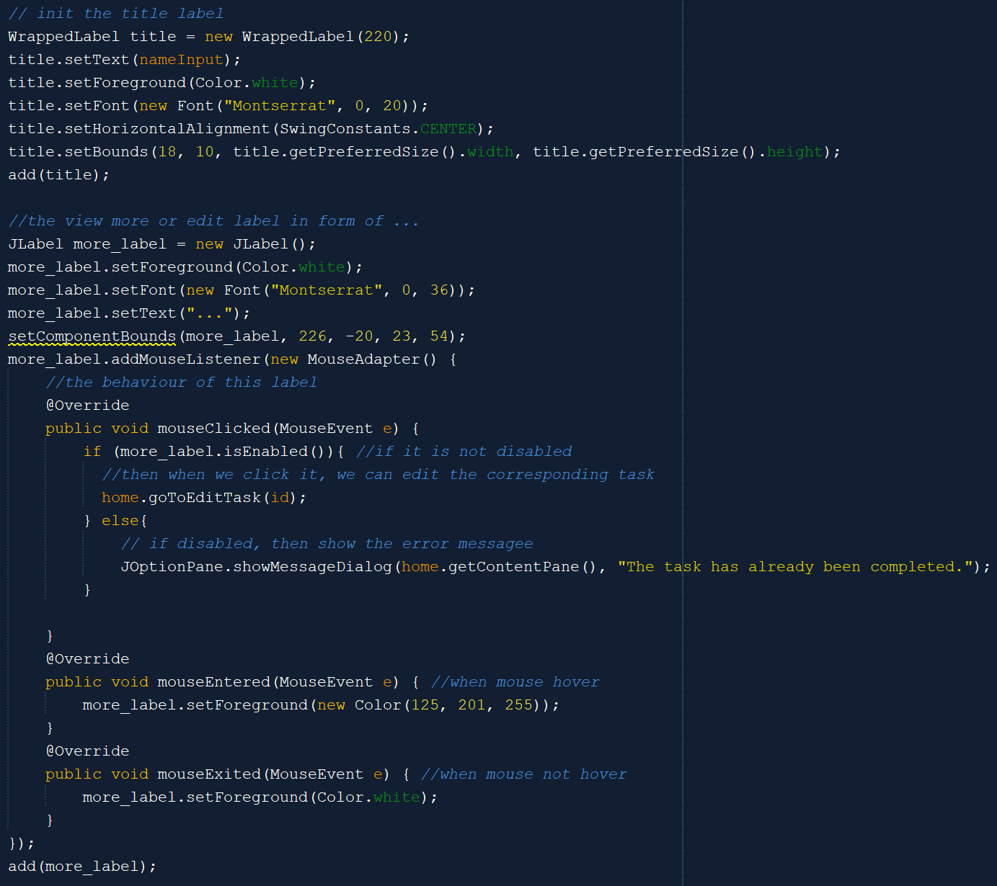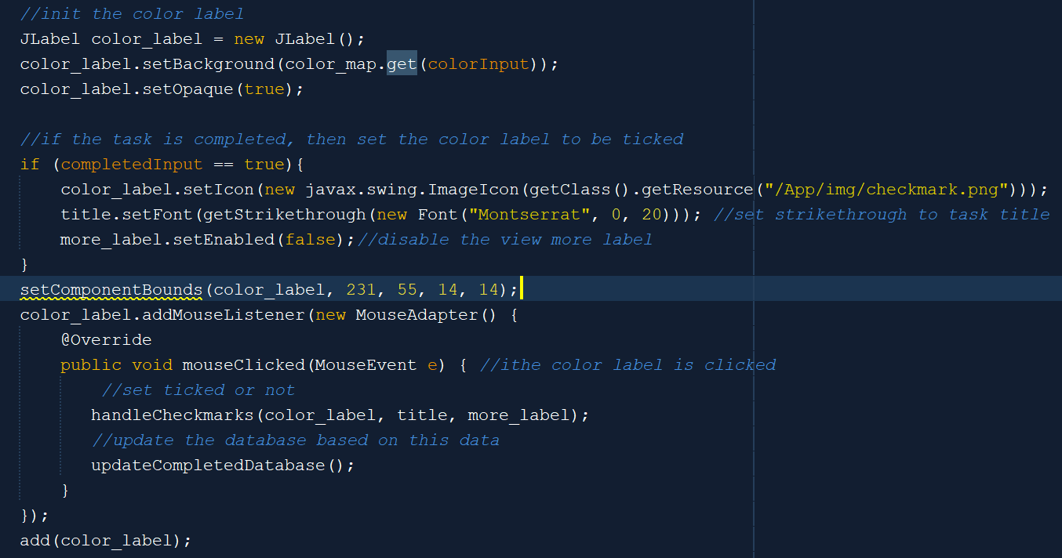

The CloneablePanelTask has a title label to display its title, the more label to redirect the user to edit the corresponding task, and a color label that can be ticked (ticked color label means that the task is already completed). When the task is completed, the color label will be ticked, the title text will be strikethrough, and the more label will be disabled. If we untick the color label, all of the components displayed will be back to the default one.

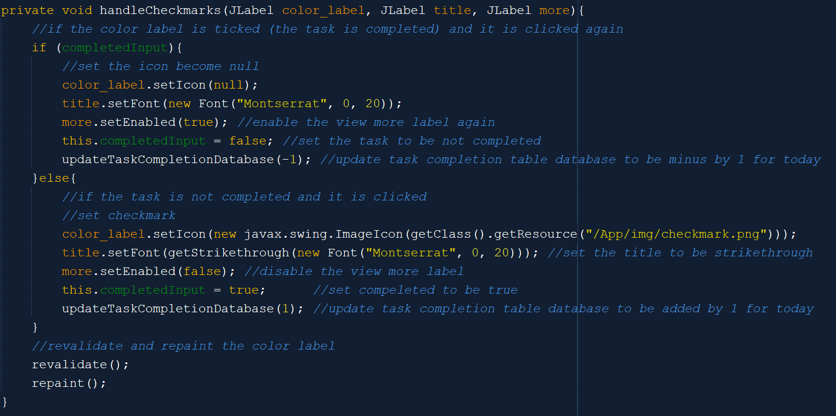

The handleCheckmarks() method is used to handle the display of the components when the color label is clicked. If the task is already completed and clicked, then untick the color label, set the title to default, enable the more label, and update the task amount in the task_completion table minus by 1. If the task is clicked, but not completed, then tick the color label, set the title to strikethrough, disable the more label, and update the task amount in the task_completion table plus by 1.

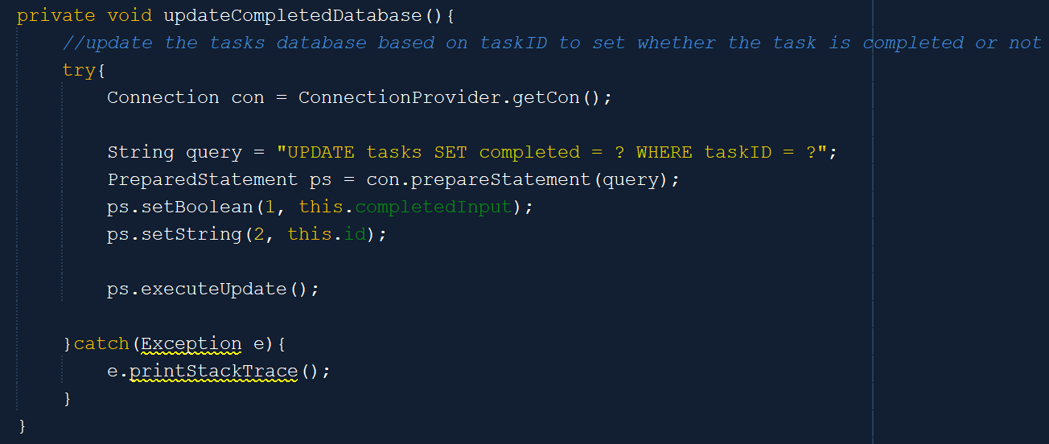

This method will update the tasks table, where it will set the completed to be true or false based on the color label (whether it is ticked or not).

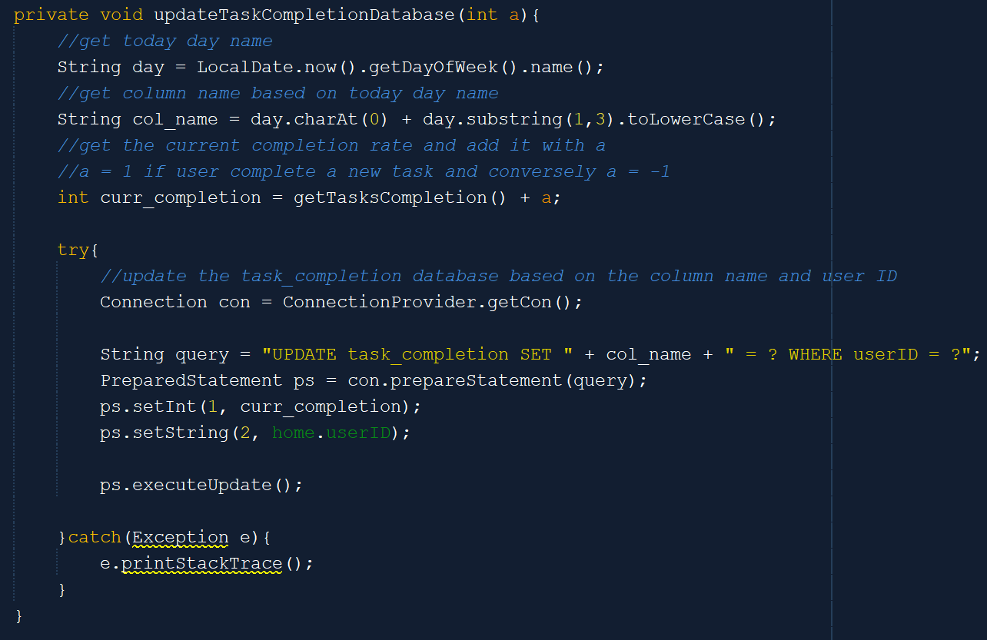

Besides the tasks table, we also need to update task_completion table. The task_completion table stores the number of tasks that the user completes each day so that it can generate a chart on the homepage. So, first, it will get the name of today and after that update the number of tasks that the user completed today. Note that this table will be reset after each week (it will be discussed more in the homepage frame).

1. **PlaceHolderJTextArea**

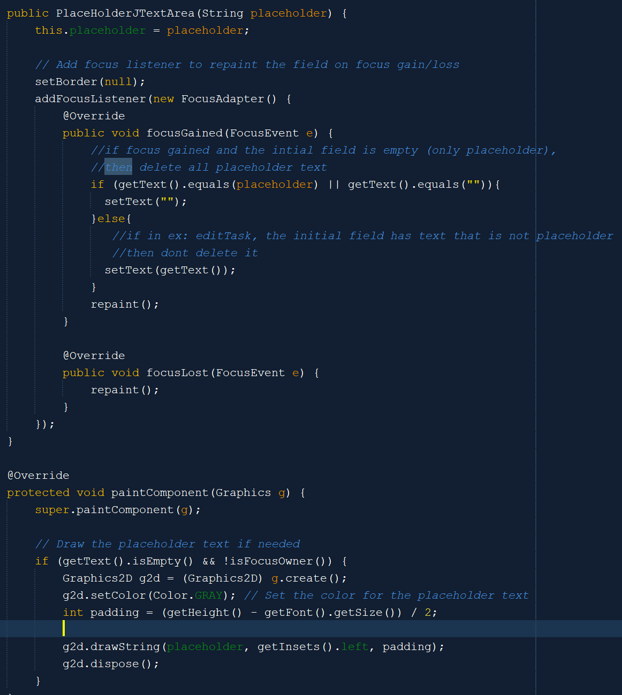



The PlaceHolderJTextArea is a custom text area class that inherits from JTextArea. The difference is that it has placeholder text, while the regular JTextArea does not. Based on the above code, the placeholder is configured when focus is gained and focus is lost. When the focus is gained and the text area only contains the placeholder (that means that it is still empty), then the text area text will be empty. If the text area is not empty, then when the focus is gained, the content will be the same. The overridden paintComponent method also provides a way to only paint the placeholder text when the text area becomes empty.

1. **PlaceHolderTextField**

The PlaceHolderTextField is a custom text field class that inherits from JTextField. It also has placeholder text, while the regular JTextField does not. PlaceHolderTextField code is highly similar to PlaceHolderJTextArea’s. The difference between them is that PlaceHolderTextField has another attribute, which is the adder, hence making it more customizable than PlaceHolderTextArea. The adder is used to set the x position of the text inside the text field.

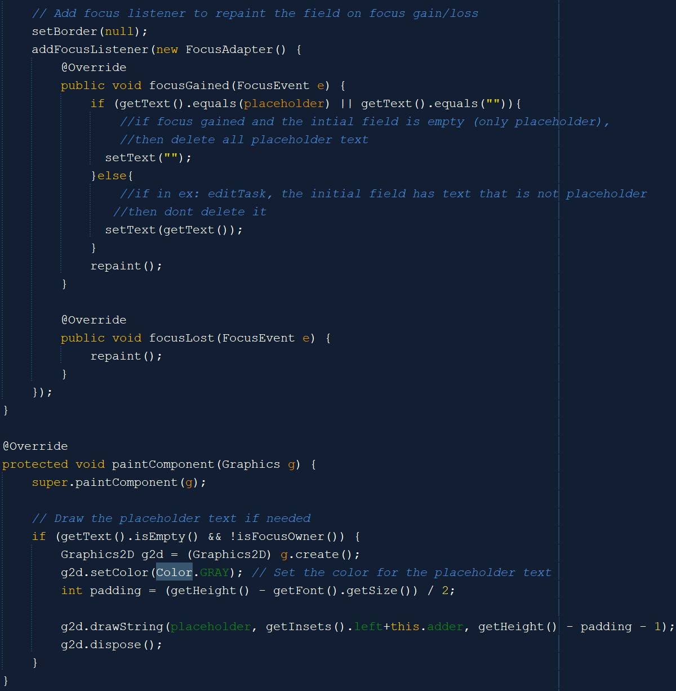

When the focus is gained and the text field only contains the placeholder (the text field is still empty), then the text field text will be empty when we start typing on it. If the text field is not empty (there is content inside the text field), then when the focus is gained, the content will be the same. When the focus is lost, it will check whether the field is empty or not. If empty, then set the placeholder again by calling the repaint to trigger paintComponent. The overridden paintComponent method provides a way to only paint the placeholder text when the text field becomes empty.

1. **RoundJTextField**

RoundJTextField also inherits from the JTextField class. Unlike PlaceHolderTextField, it has round edges. It also has a placeholder similar to PlaceHolderTextField, but its placeholder is more rigid.

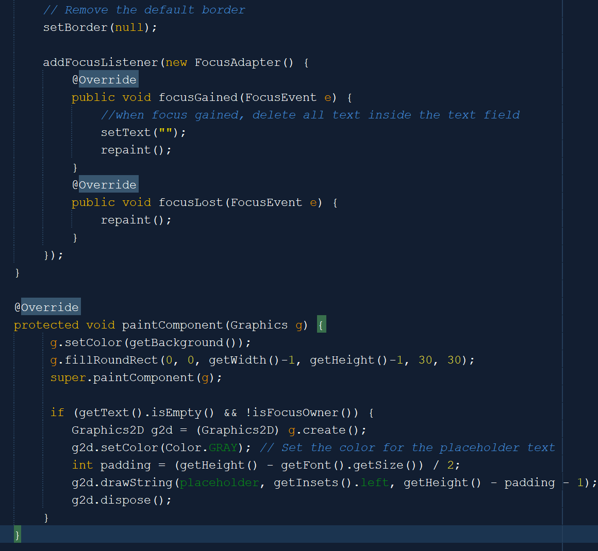

As shown above, the RoundJTextField will not check whether there is non-placeholder content or not inside the text field and automatically remove all text inside it. The paintComponent method is similar to the one in PlaceHolderJTextArea due to not having an adder.

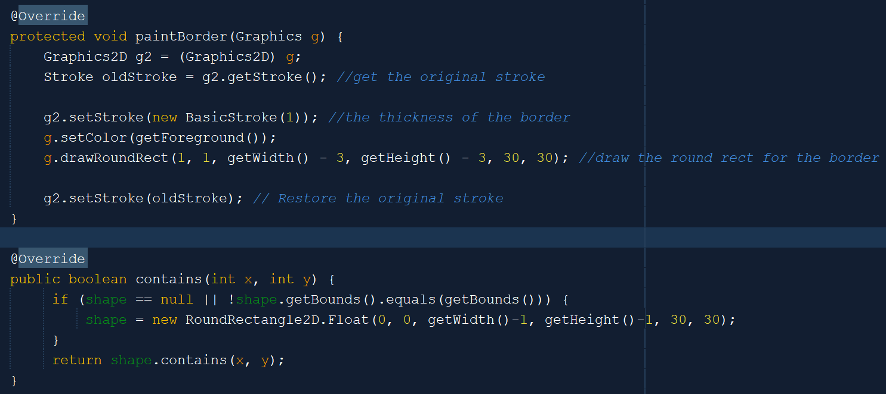

Meanwhile, the more essential thing in this class is the overridden paintBorder method, which will draw a round rect (border with round edges for the text field). The contains method is used to determine if a point (x, y) lies within a custom shape, specifically a RoundRectangle2D for the text field.

1. **AranaraDropShadowPanel**

AranaraDropShadowPanel is used inside the Aranara menu to represent each Aranara that the user has unlocked or not. It inherits from the JPanel class and is similar to CloneablePanel. The difference is that it has a drop shadow behind it and has two states, which are locked and unlocked.

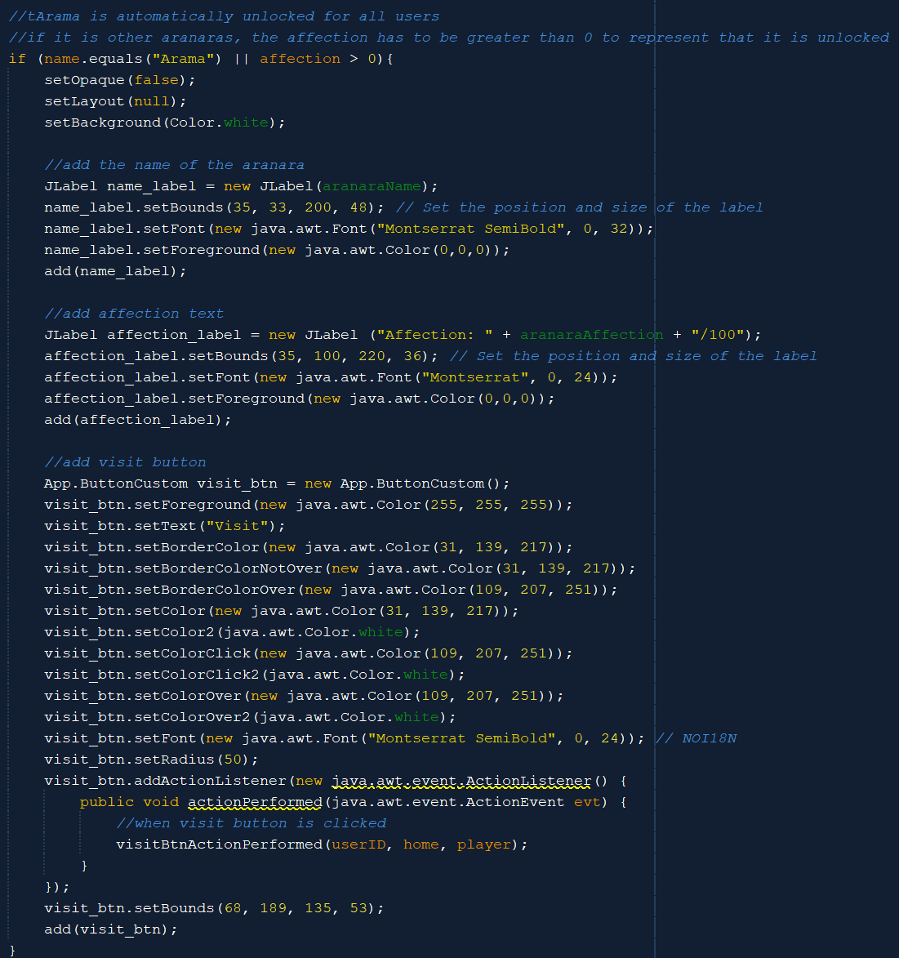

Arama is the default Aranara for every user, so it will be automatically unlocked. The other two Aranaras (Ararycan and Arabalika) are still locked and will be unlocked when the affection reaches a certain number. When it is unlocked, by default, the unlocked Aranara will have 1 affection. So, if the Aranara is Arama or the affection is greater than 0, then set the name label, affection label (to show how much the affection of the corresponding Aranara), and a visit button.

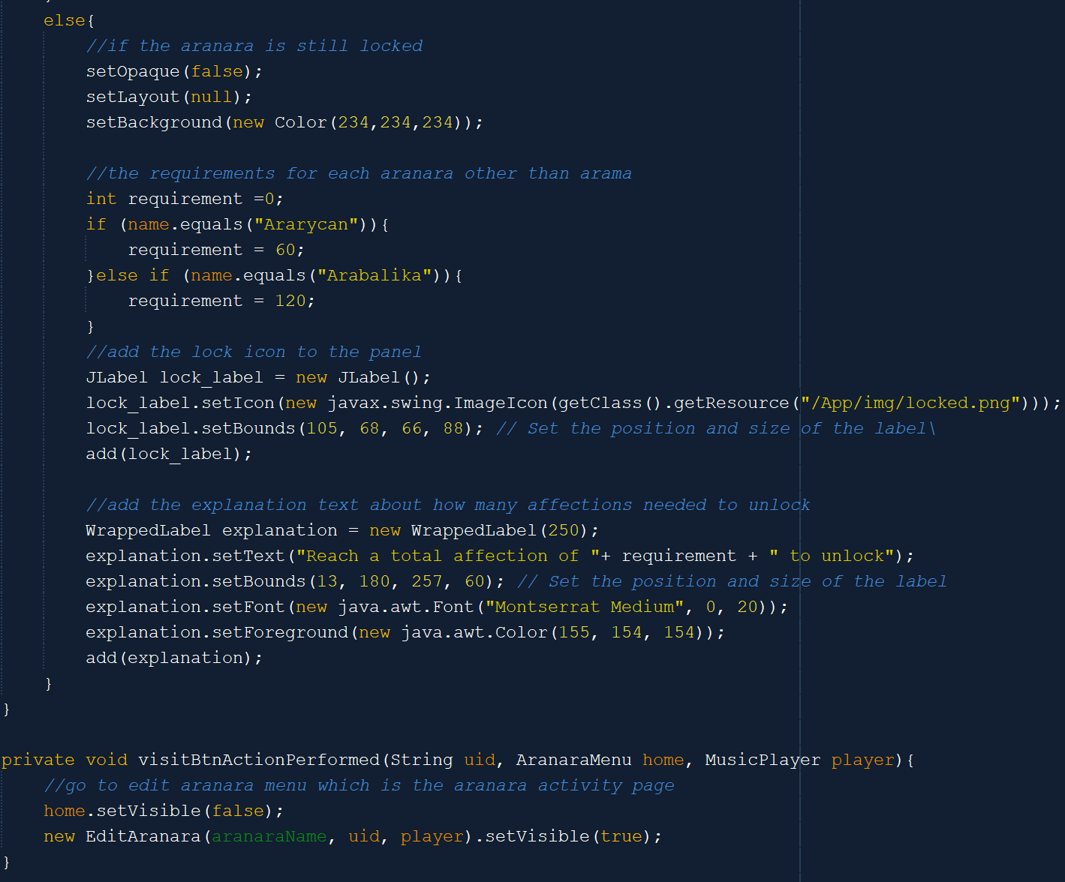

If the Aranara is still locked, then display the lock icon and the explanation about how much affection requirement the user needs to unlock the Aranara. Meanwhile, when the previous visit button is clicked, then the user will be redirected to the Edit Aranara page to interact with the Aranara.

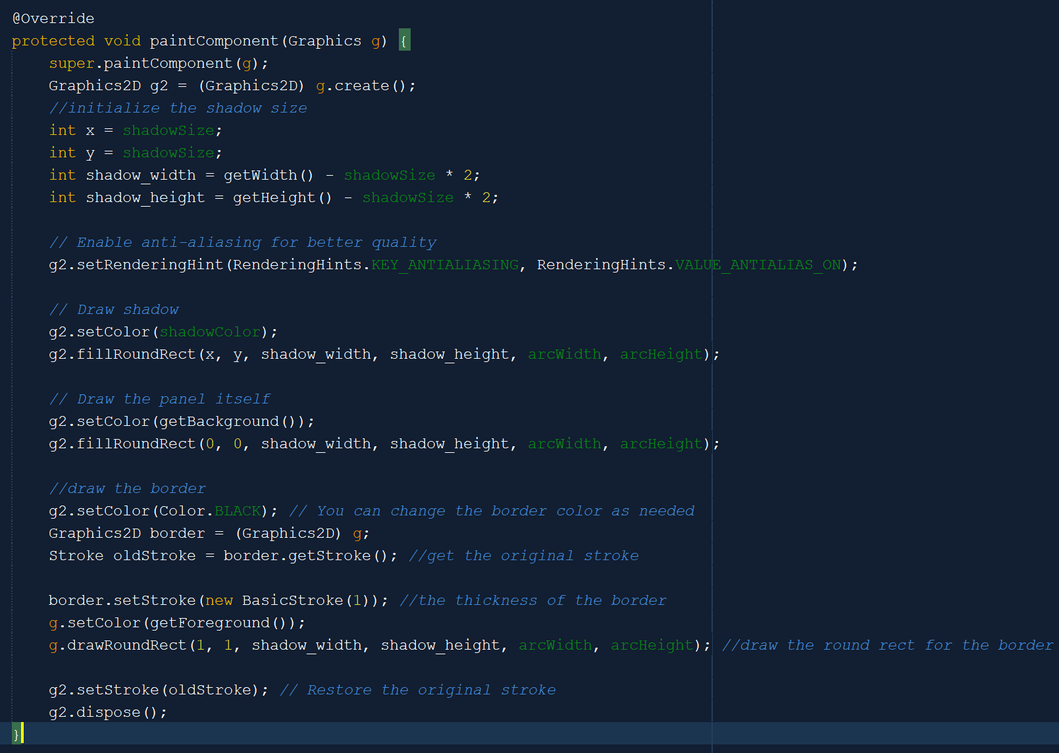



The overridden paintComponent plays a great part in drawing the shadow for the panel. It will first get the size and properties of the shadow. Then, it will draw the shadow based on the size and color. After that, it will draw the panel and the border for the panel. The panel has round edges, so the border will be round rect.

1. **CalendarCell**

The CalendarCell class represents the cell inside the calendar panel on the CalendarPage. The CalendarCell inherits from the JButton class and has several additional attributes, which are date, title (or isTitle), isToday, isSelected, color_map, hasTasks, colorStr, and taskAmount. CalendarCell has getters and setters for title, date, isToday, isSelected, hasTasks, and taskAmount. Additionally, the setter for hasTasks also sets the colorStr. The setter for isToday also sets the text color of the cell that has today's date as blue.

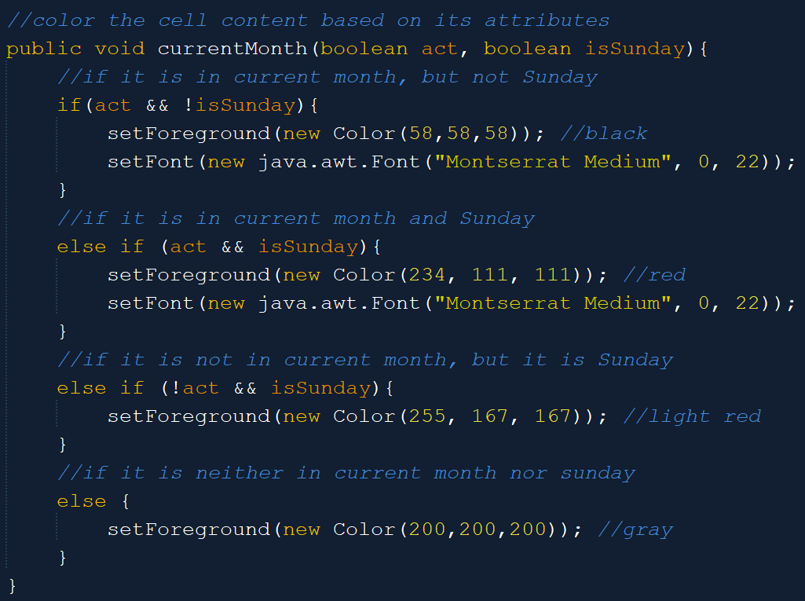

The above method is used to color the text inside the cell based on its attributes. For Sundays, it is red (light red if it’s not in the current month) and for the rest, it is black if it is in the current month and grey if it is not.

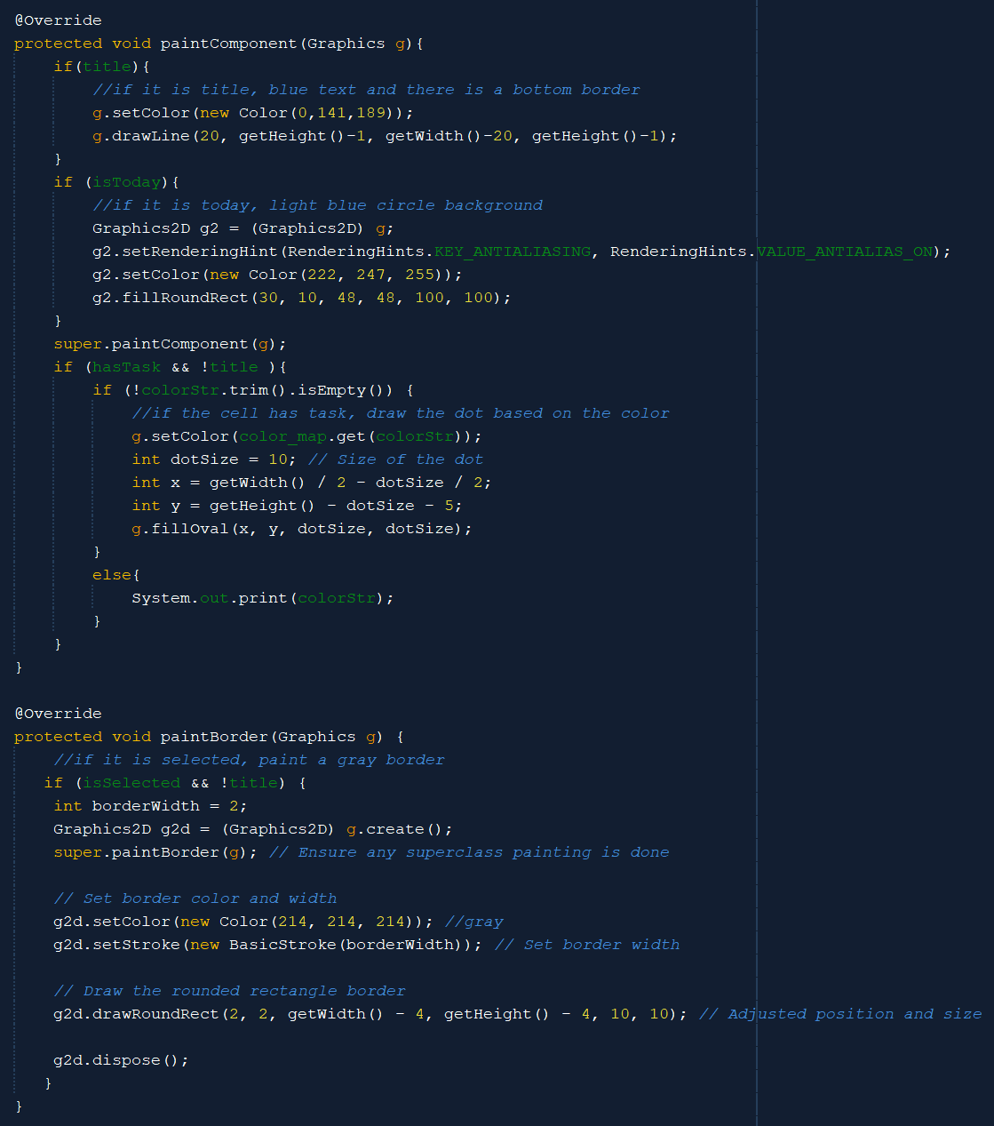

The overridden paintComponent is used to draw the title (day name) to have a blue color and bottom line border, a light blue circle background behind today’s date text, and draw the dot on the cell based on the color. Meanwhile, the paintBorder method is used to draw a grey border for the cell if the cell is selected and is not the title (day name).

1. **CalendarPanel**

CalendarPanel is a custom class that inherits from the JLayeredPane class. It has the 7 x 7 GridLayout so that it can contain 49 CalendarCells.

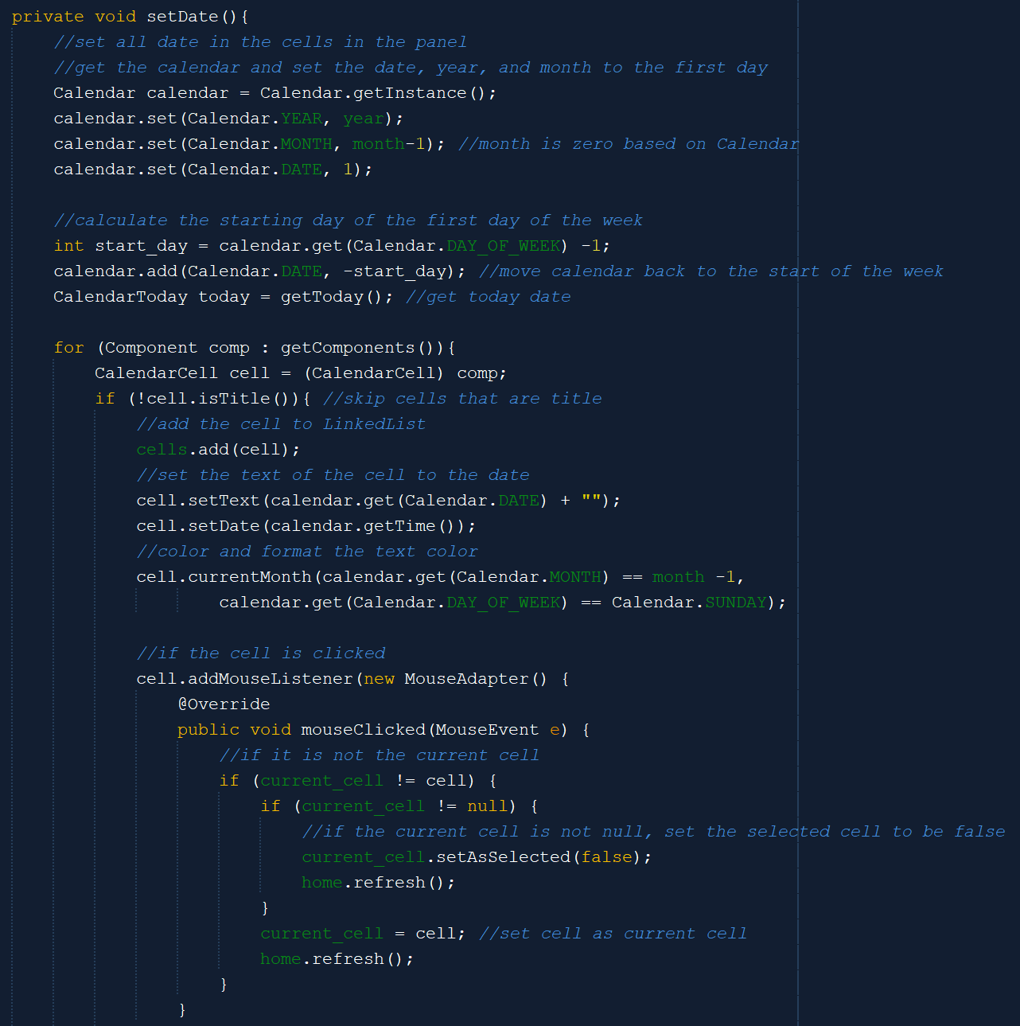

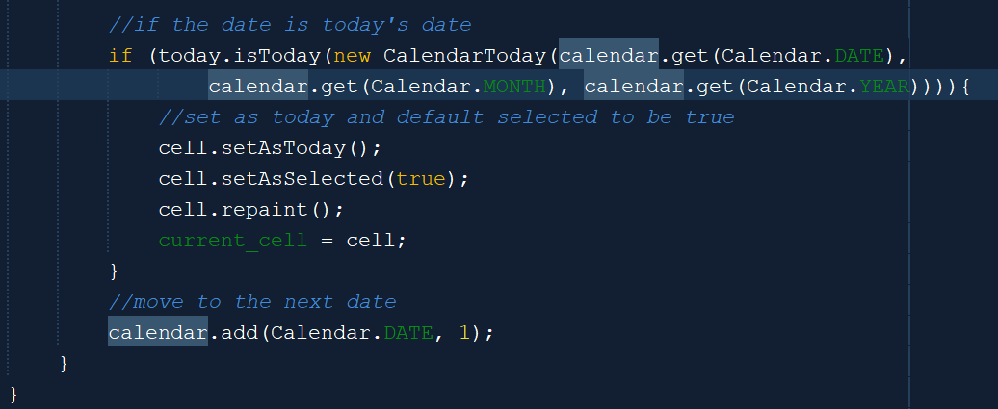

The above method is the essential algorithm to set the date for the CalendarPanel. It will first get the calendar instance and set the date, year, and month for the first day. After that, it will calculate the first day of the week of that first day and move the calendar back to the start of the week. It will now color and format the date based on their month (whether they are in the current month or they are Sundays). Then, when the cell is selected, the selected cell will become the current cell. After that, this method will set the date which is the same as today’s date to be selected by default. In other words, the default current cell will be the cell with today’s date.

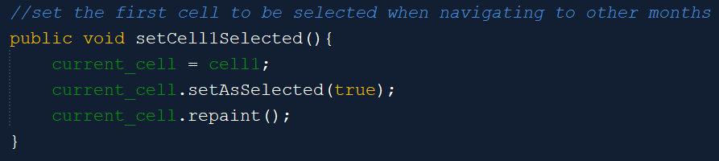

When navigating to another month, this method will automatically set the first cell in the calendar to be the current cell (or is selected).

1. **CalendarCustom**

The CalendarCustom is a custom class that inherits from the JPanel. It consists of two major panels, which are the previous CalendarPanel and the taskPanel. There are also two arrows to navigate back and forth from one month to another month.

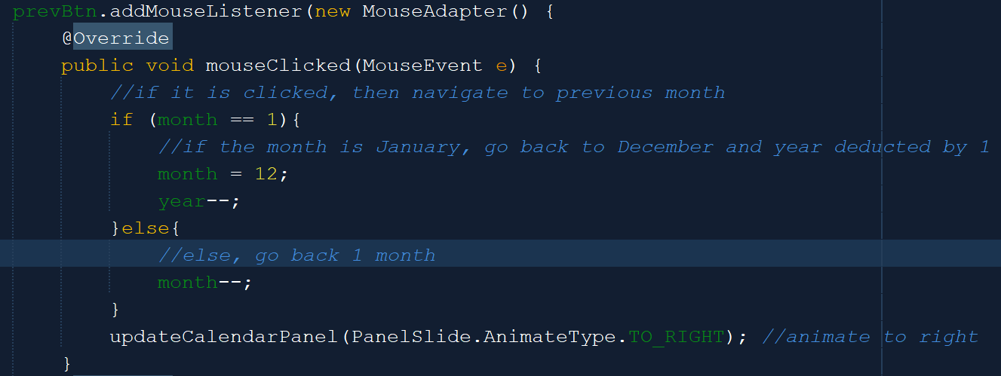

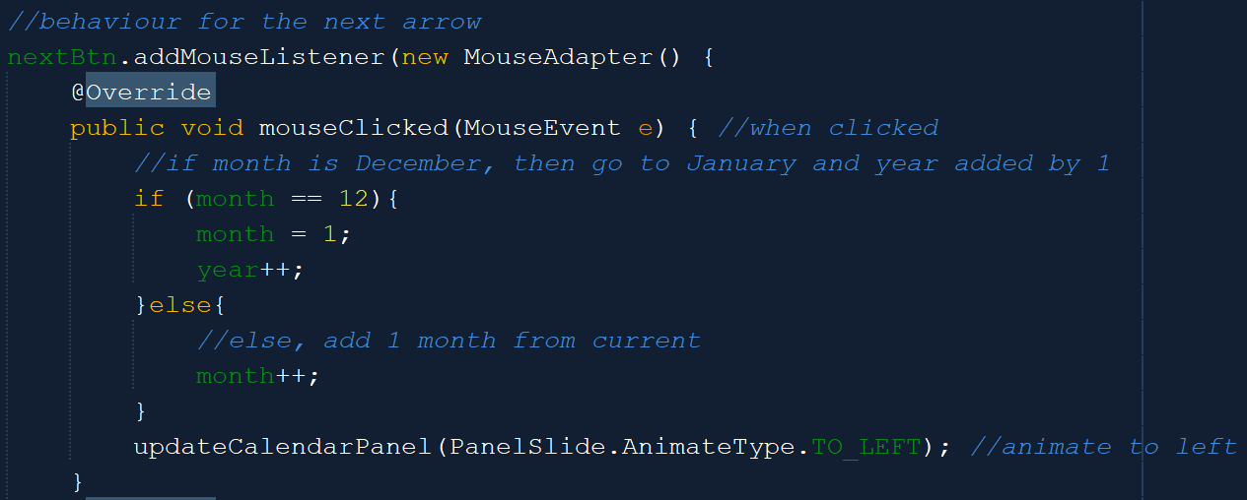

The prevBtn is used to move to the month before the current month, while the nextBtn is to move to the month after the current month. When the prevBtn is clicked, the month will be reduced by 1, except if the current month is January. The month will instead become 12, but the year will be reduced by 1. Meanwhile, when the nextBtn is clicked, the month will be added by 1, except if the current month is December. The month will instead become 1 and the year will be added by 1. When moving backward, the animation is to the right, while when moving forward, the animation is to the left.

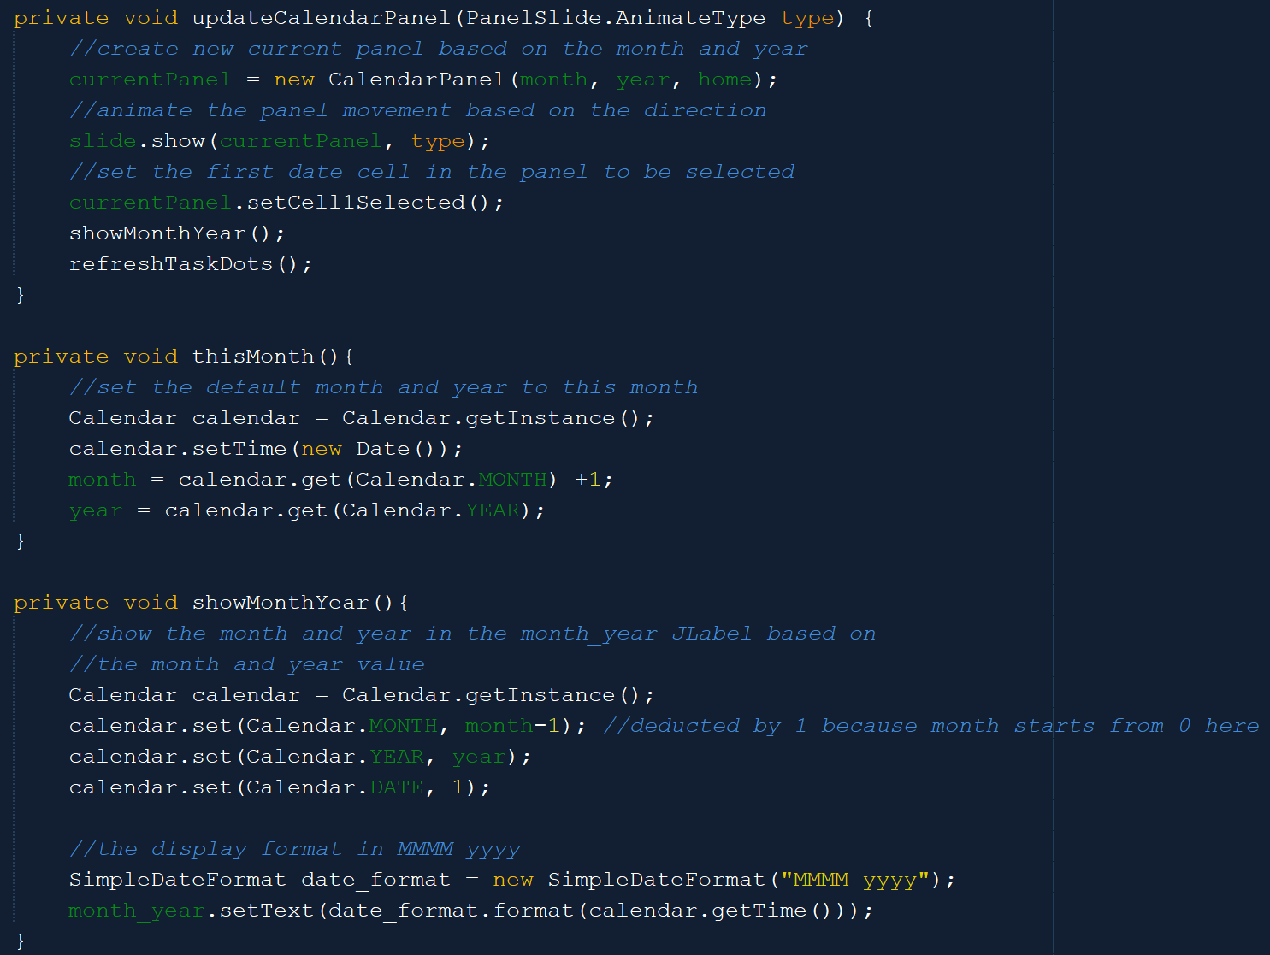

The updateCalendarPanel method will update the panel based on the month and year and also animate the panel movement. The first date cell will also be set to be selected by default. The thisMonth method is called when we first initialize this CalendarCustom. It will set the default month and year as our current month and year. The showMonthYear method is used to show the month and year in the JLabel on top of the CalendarPanel in the format of month year.

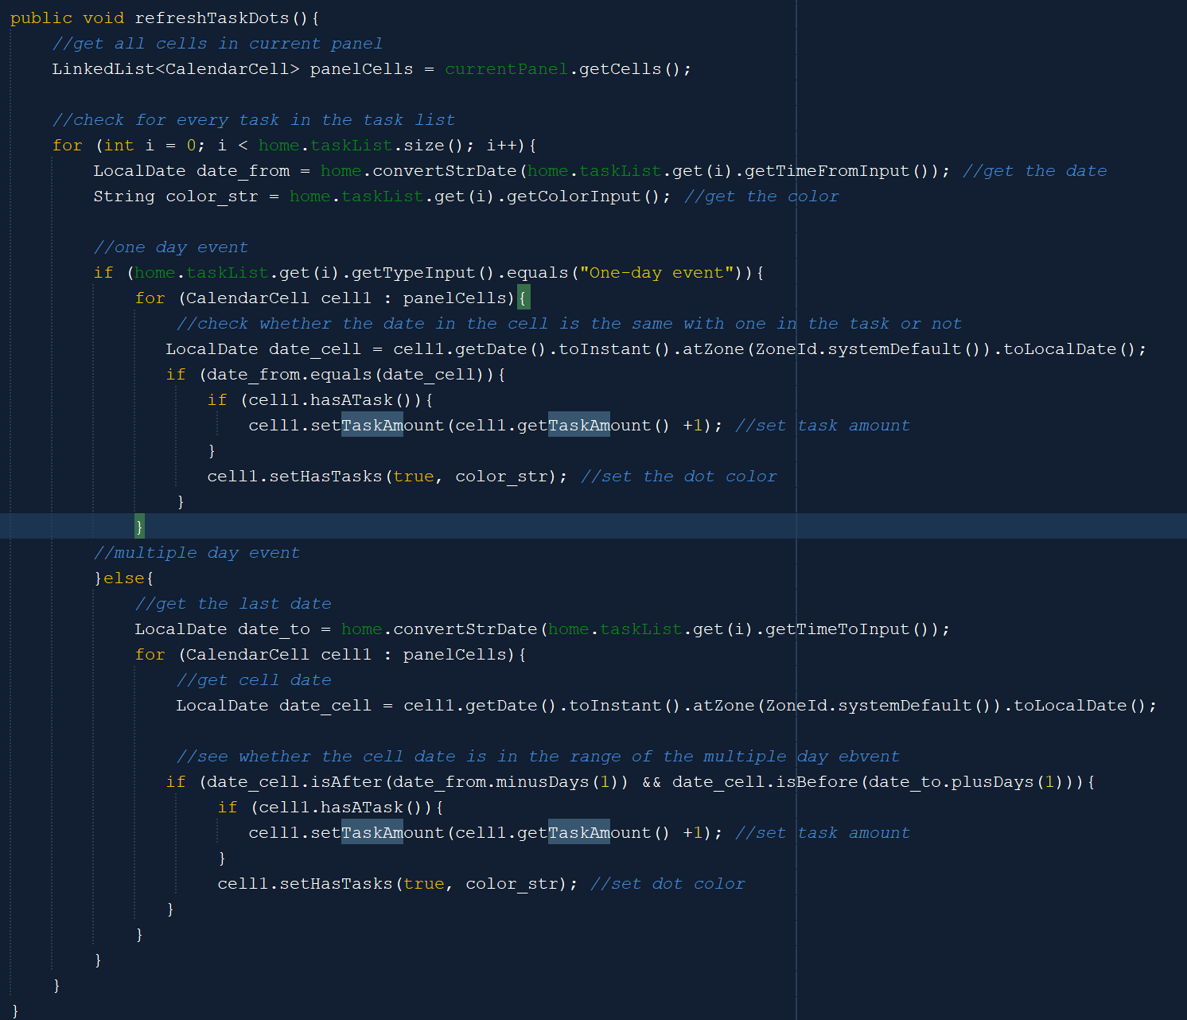

The refreshTaskDots method is used to refresh the task dots inside the CalendarCell. It will first iterate for every task in the LinkedList and every cell in the panel to check whether the date is the same (if it is one-day event) or the date is in the range of the task date (if it is multiple-day event). If yes, then it will set the colored dot. The task amount of the corresponding cell will be incremented too.

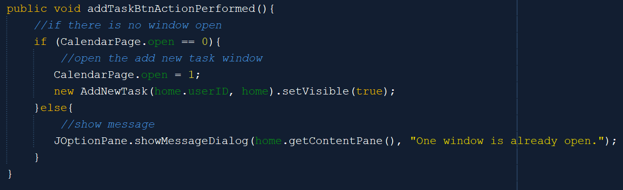

The addTask button inside the taskPanel will open a new AddNewTask window when it is clicked if there are no other windows that are open in the CalendarPage.

1. **PanelSlide**

PanelSlide is a custom class that inherits from the JPanel. It has a special property which is it can be animated. Below is the essential algorithm for animating the panel.

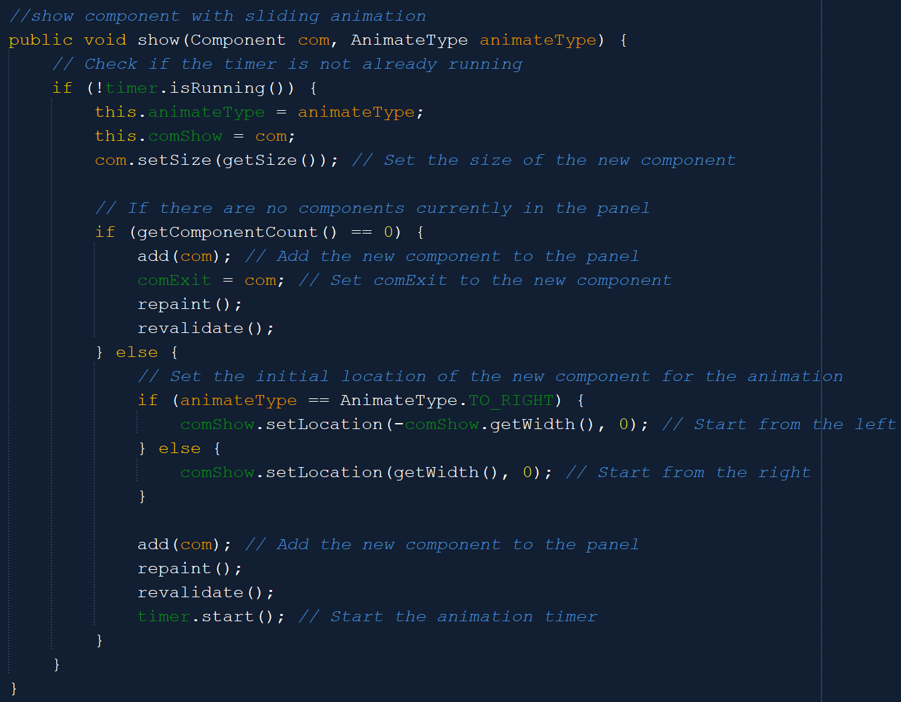

The show method is used to show the old and new component movement or animation. The PanelSlide uses a timer to track the movement time. If the timer is not running, then we will set the size of the new component. If there are no components currently in the panel, we add the new component to the panel and set the existing component to be the new component. If there is still an existing component, then set the location of the new component for the animation.

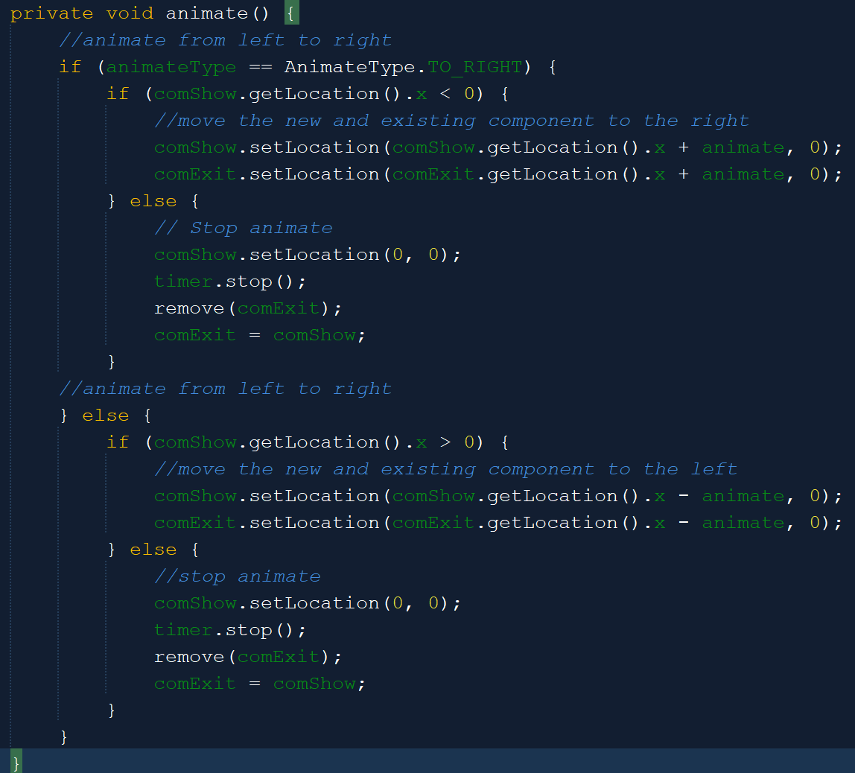



The animate method will first get the animation type and the location of the new and existing components. After that, it will move by incrementing its x position with the animation speed (if the animation is from left to right) or decrementing its x position with the animation speed (if the animation is from right to left).

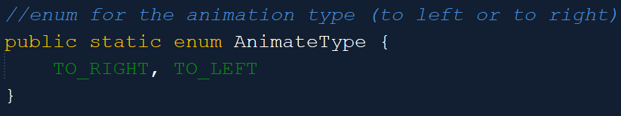

The AnimateType is an enumeration or a group of constants. The aim is to make a datatype that consists of only TO_RIGHT and TO_LEFT AnimateType.

1. **Sound Classes**

The sound classes in this program are divided into two, which are the MusicPlayer to play the background music, and the SfxPlayer to play the sound effects. Both of them are similar.

1. **MusicPlayer**

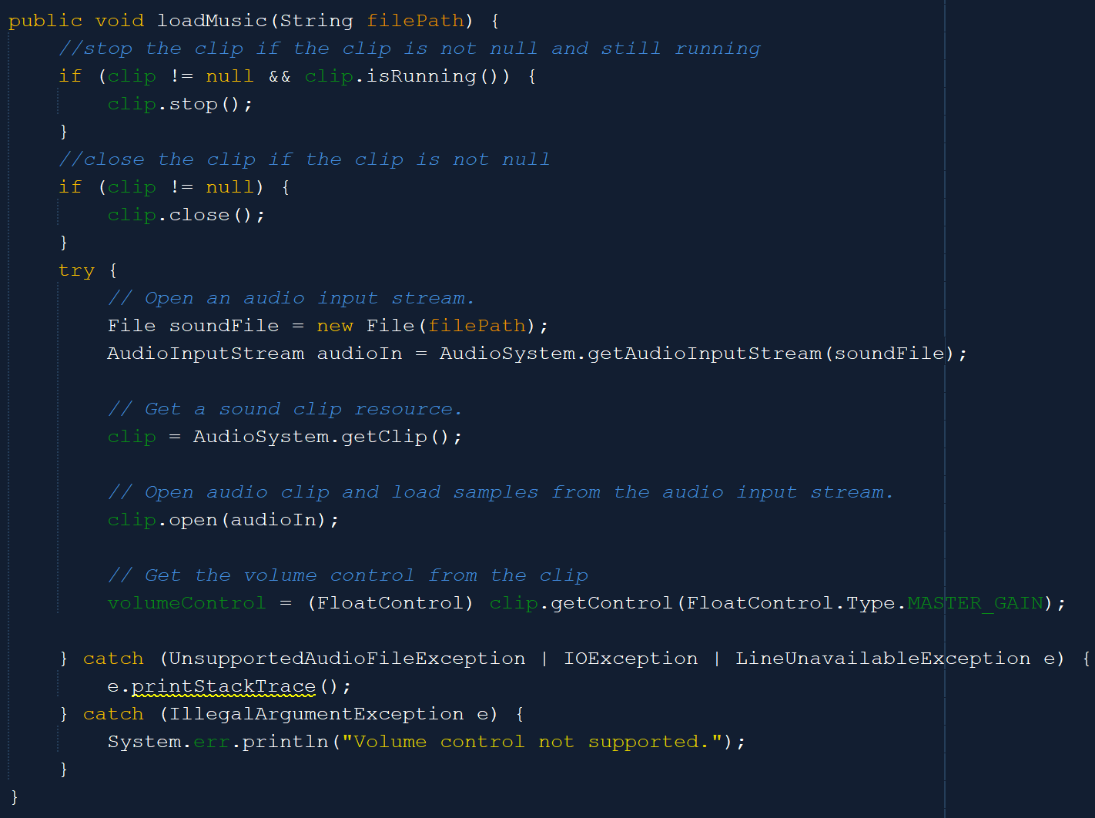



The loadMusic method is the most crucial method for both MusicPlayer and SfxPlayer as it will load the audio file. It will first stop and close the existing clip if it is not null. After that, it will load the audio file based on the filePath and get the clip. It will also open the audio clip, load samples from it, and get the volume control.

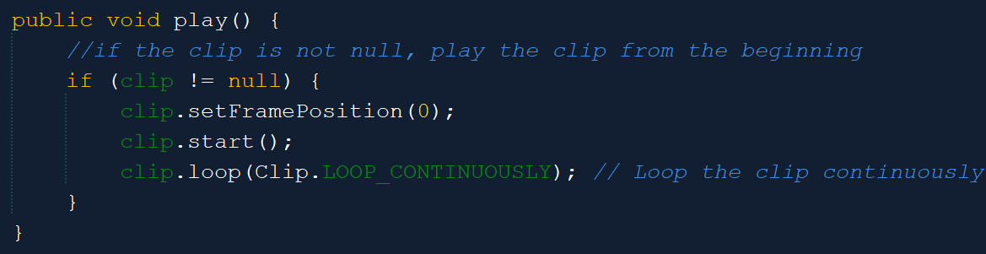

Meanwhile, the play method will play the clip from the beginning and loop it continuously.

1. **SfxPlayer**

SfxPlayer is highly similar to background music although there are some differences.

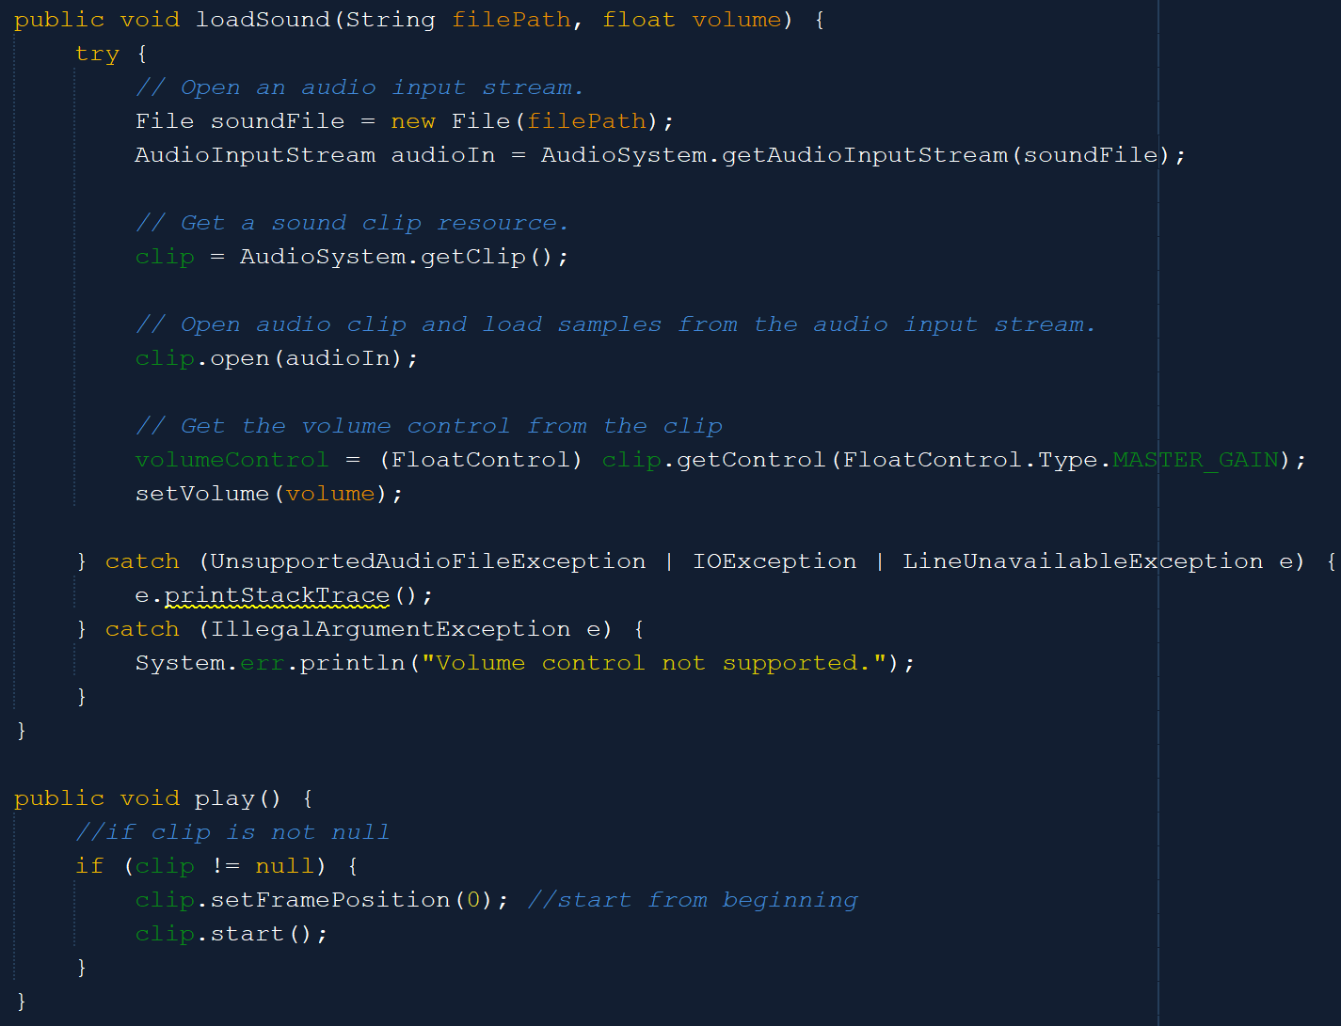



Same as loadMusic in MusicPlayer, loadSound in SfxPlayer will first get the clip from the audio file specified by the file path. After that, it will get the volumeControl. However, here, it will also set the volume based on the inputted volume. Meanwhile, for the play method, the SfxPlayer does not loop the audio file continuously as it is only a sound effect.

1. **Frames**

Below are the frames that are available in this program. I will focus more on explaining the operations behind the frame (how to add, update, or others), while the basic GUI, such as initializing the JLabel or other similar things will not be explained.

Because most of the frames used Absolute Layout, then to add the component inside the frame, we will use the below syntax: getContentPane().add(component, new org.netbeans.lib.awtextra.AbsoluteConstraints(x, y, -1, -1)); where the component is the name of the component, x, and y is the x and y position relative to the frame.

1. **WelcomePage**

WelcomePage is only a simple page with several labels and two buttons, which are the login and signup buttons. If the user clicks the login button, they will be redirected to the login page, and so does it for the signup button.

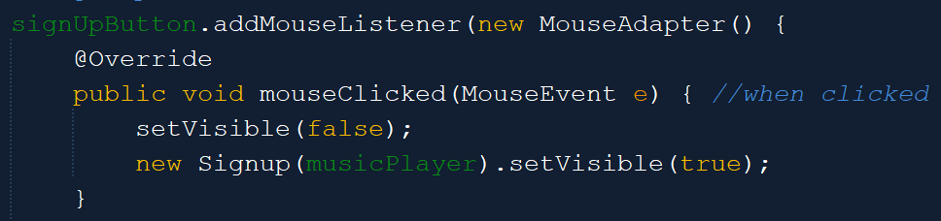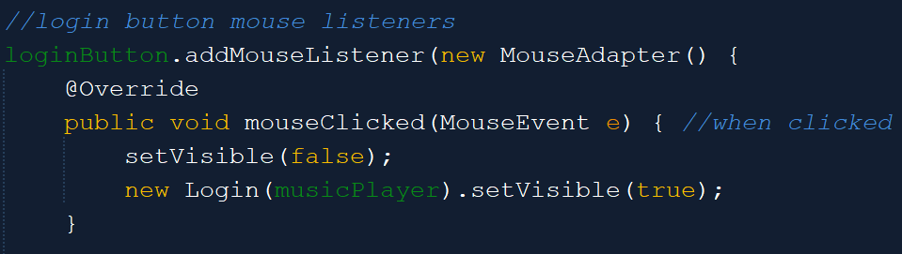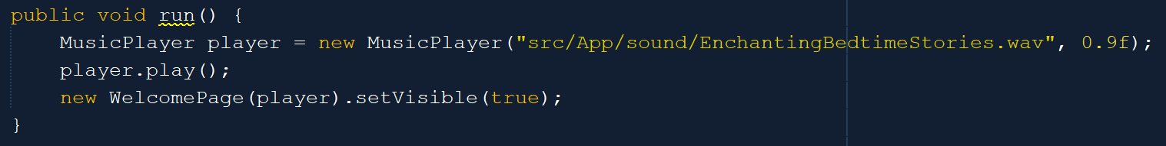

The most crucial thing in the WelcomePage is this run method. Only the WelcomePage frame can be runnable and has the main method. The others do not have it. The WelcomePage then has to initialize the MusicPlayer and play the background music. The initial background music for WelcomePage, Login, and Signup is Enchanting Bedtime Stories and it will be changed when the user goes to their homepage.

1. **SignUp**

The Sign Up page is used to let the user create a new account for SchedNara so that when they open SchedNara next time, they only need to log in. The Sign Up page consists of three fields, which are for the username, password, and password confirmation.

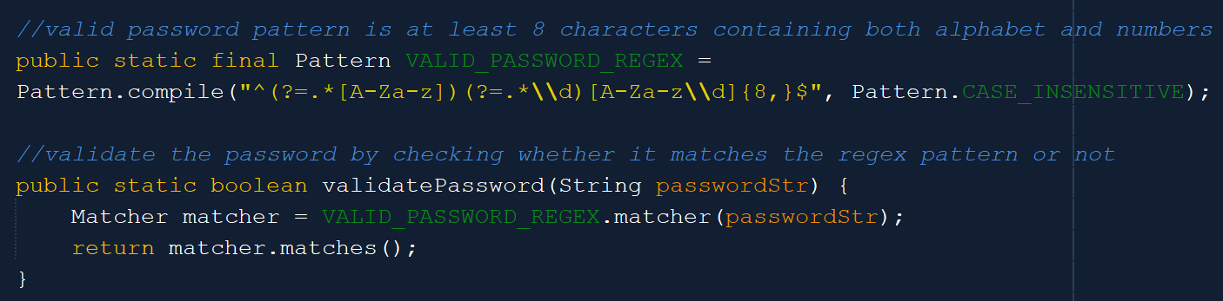

The validatePassword method is used to validate whether the password meets the password criteria. A valid password has to have at least 8 characters and contains both alphabet and number. If the password format is not correct, then it will return false.

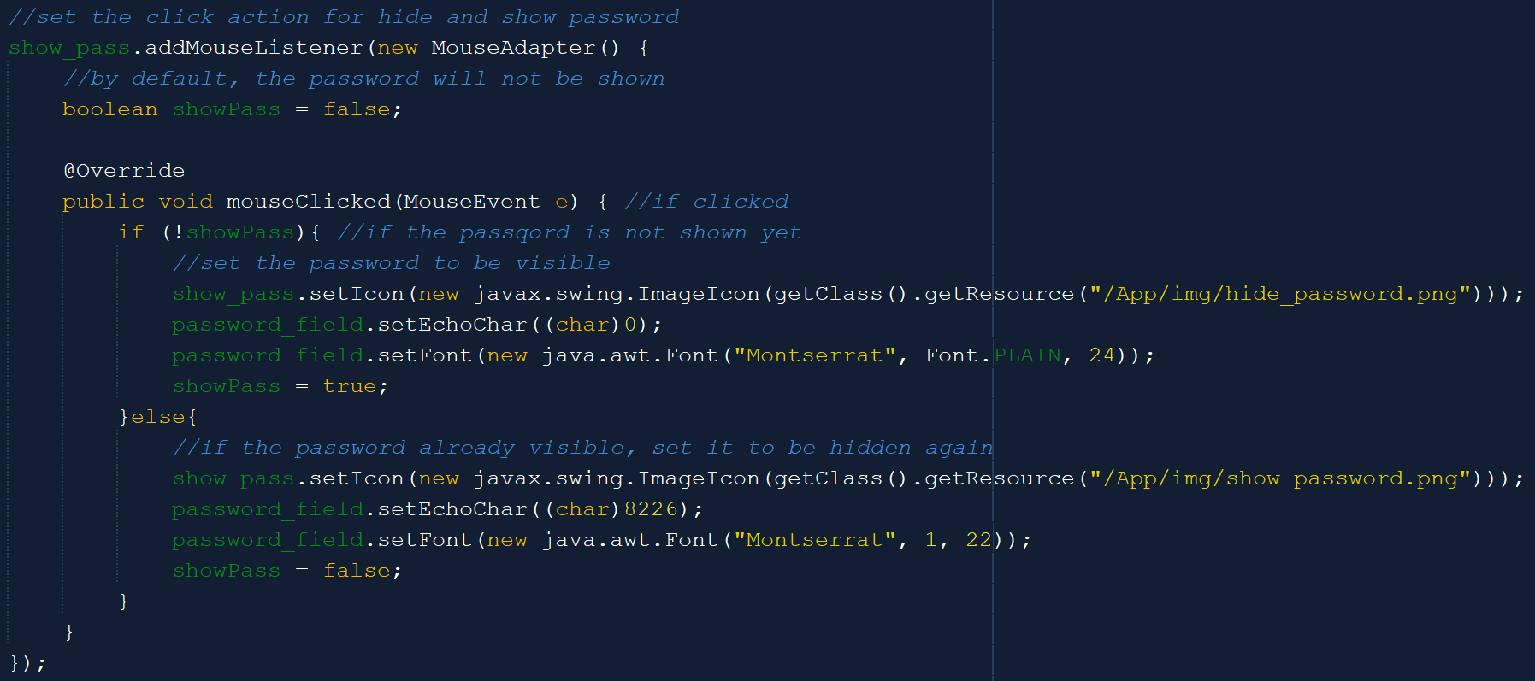

The password field and password confirmation field have the view or hide icon. The above code is used for the view and hides icon behavior in the password field. The view and hide icon for the password confirmation field is also the same. If the icon is clicked and the password is still hidden, then make the password unhidden (set the text to be viewable). Conversely, if the user wants to hide it again, then when clicking the previous icon, all the text will automatically be converted to ... again.

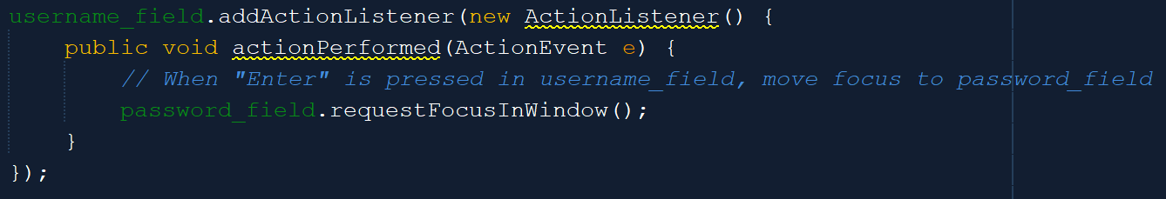

Users can press the ‘Enter’ key to navigate when filling each field. The above code shows that when ‘Enter’ is pressed in the username field, the focus will be moved to the password field. Meanwhile, when it is pressed in the password field, the focus will move to the confirmation field and if it is pressed in the confirmation field, the submit button will be performed.

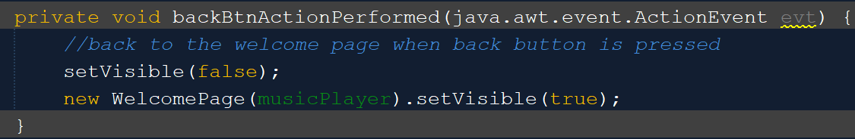

The above method is used when the user navigates back to the Welcome Page.

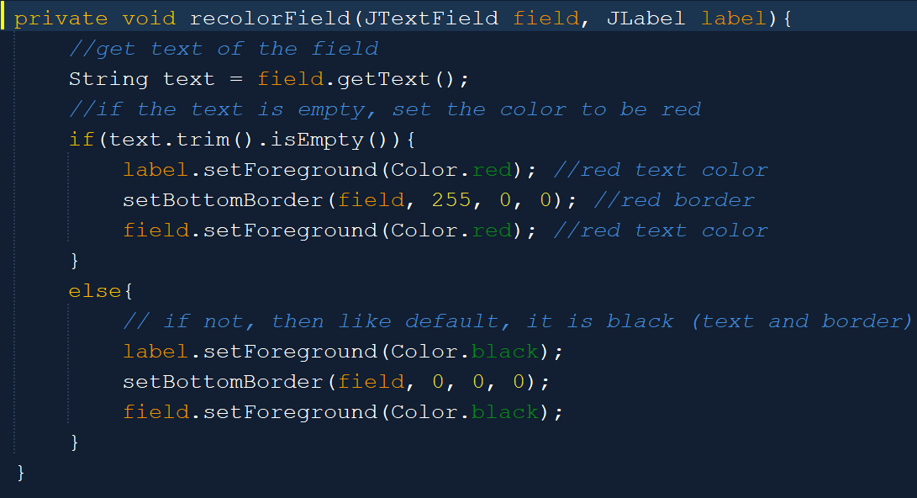

The recolorField method is used to check and color the fields based on the user input. Every field has a document listener to check if there is an add, remove, or change in the field, then it will check the field content. One of these check methods is achieved through the recolorField method. It will check whether the field is empty or not, if it becomes empty, then the color of the field will become red, while by default it is black.

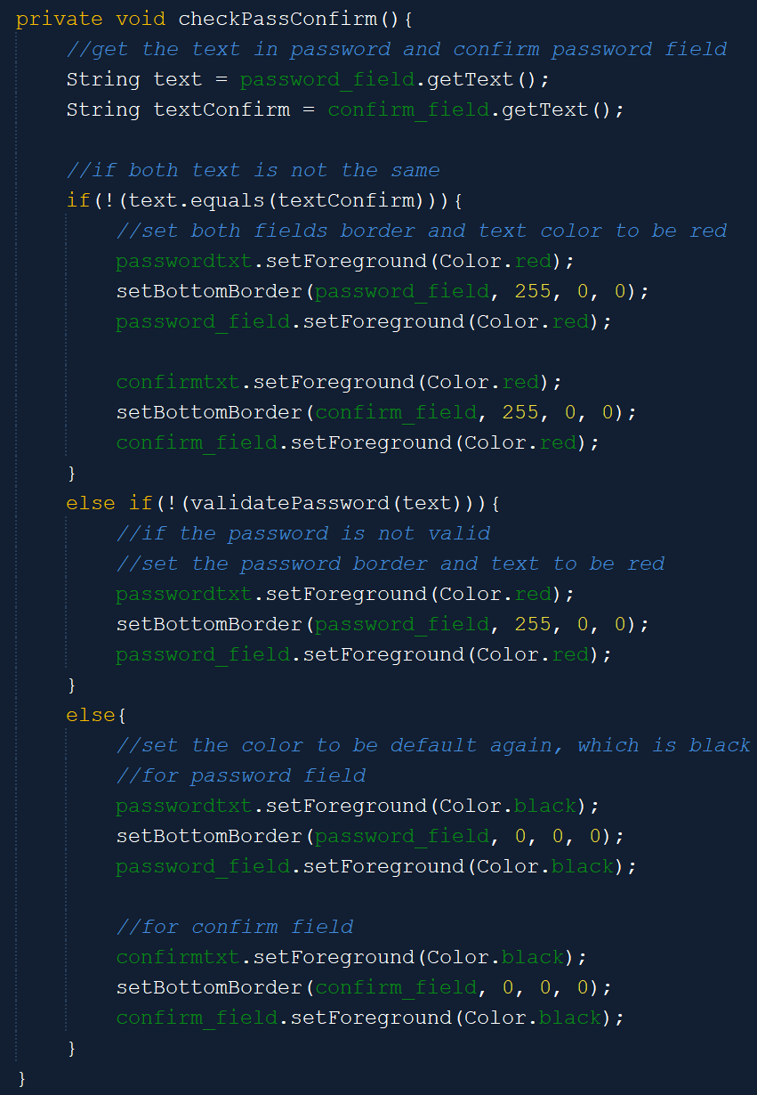Meanwhile, for the password and confirmation fields, there is an additional method to check them besides the recolorField. It will check whether the password and the password confirmation are the same or not and whether the password is valid or not. If it is not equal or the password is not valid, then set the corresponding field red.

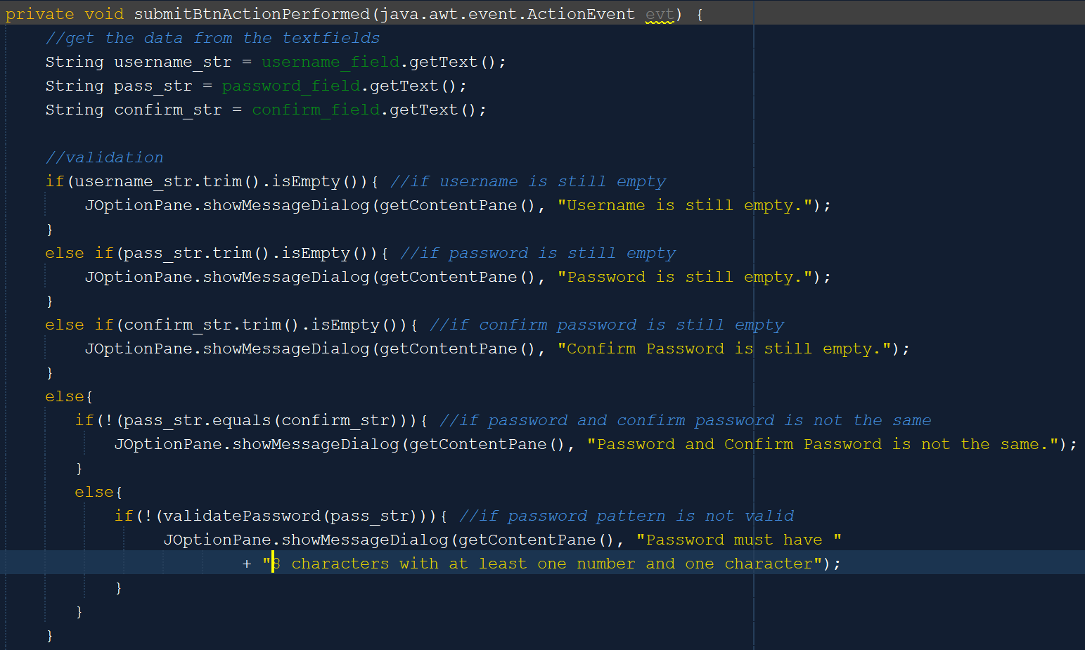

The above method is for when the submit button is pressed or performed. It will first validate the user input (if it is empty or not), then it will validate the password and confirmation field (if it is equal or not), and then the password (if it is valid or not).

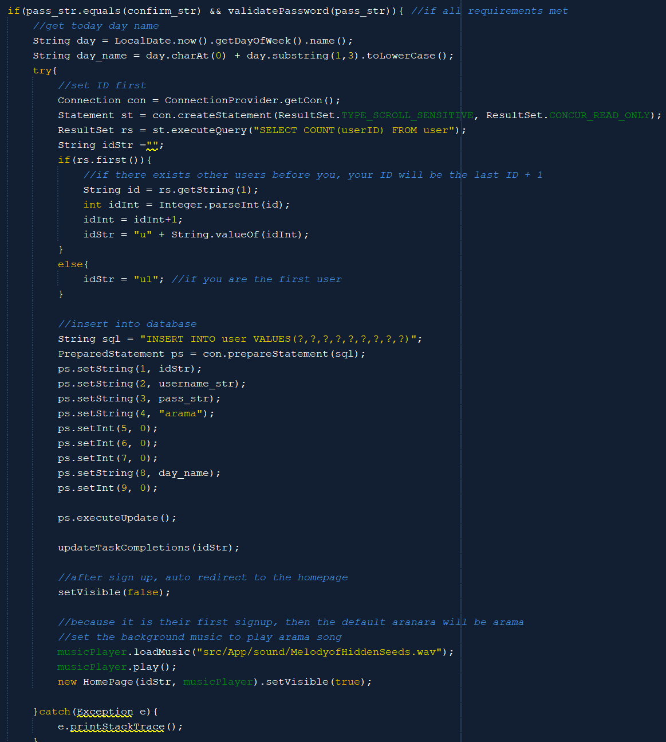



If all conditions are met, then it will generate an ID for the user based on the last ID in the table and insert the user data into the user table. The default aranara will be set to Arama and all Aranara affections are still 0. The pat amount is also 0. After that, it will also update the task completion table to insert the new user data into it. After that, it will redirect the user to the homepage with the default song (Arama song) because the default Aranara for all users is Arama.

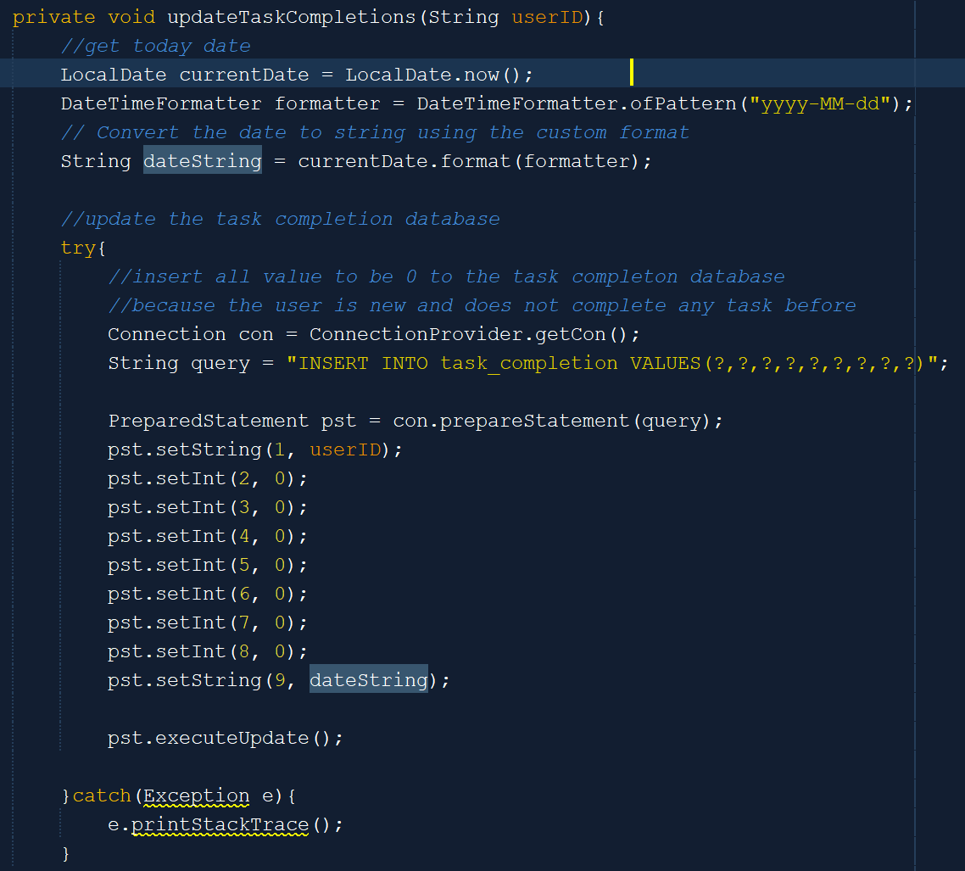

The updateTaskCompletions method is used to update the task_completion table in the database. It will set all task completions for the user this week to 0 because the user is still new and set the last login date to be today’s date.

1. **Login**

The login frame is highly similar to the signup page. The difference is that the login page does not have the password confirmation field so it does not have to check the password confirmation. Besides that, when the user presses the ‘Enter’ key in the password field, the submit button will be performed. Other methods are similar to the one on the Signup page. The two very distinct methods are the method when the user submits the page and the check password method.

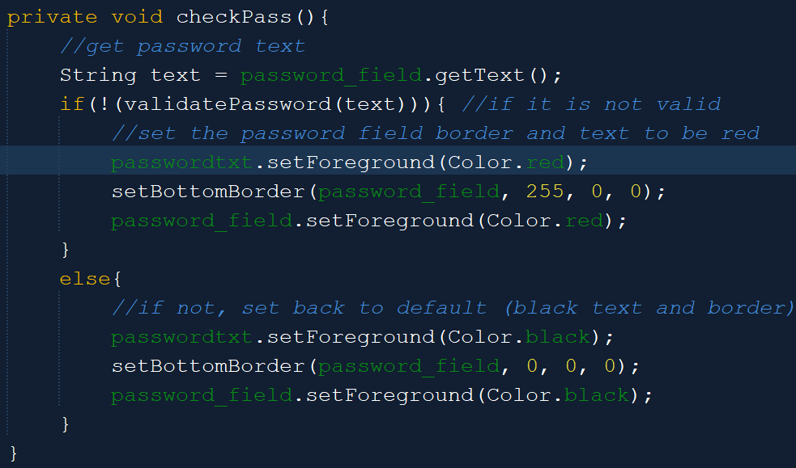

As explained before, the checkPass method now only needs to check whether the password is valid or not and set the password field to red if it is not valid.

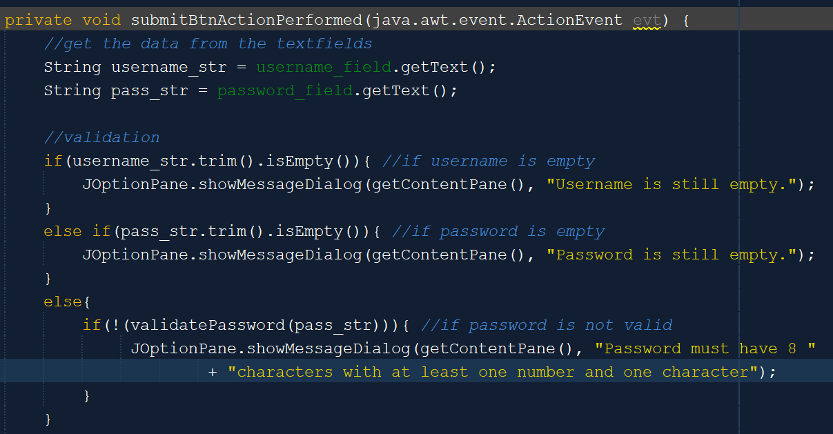

When submitting the data, the method will also only check the password whether it is valid or not and display the appropriate message if it is not valid.

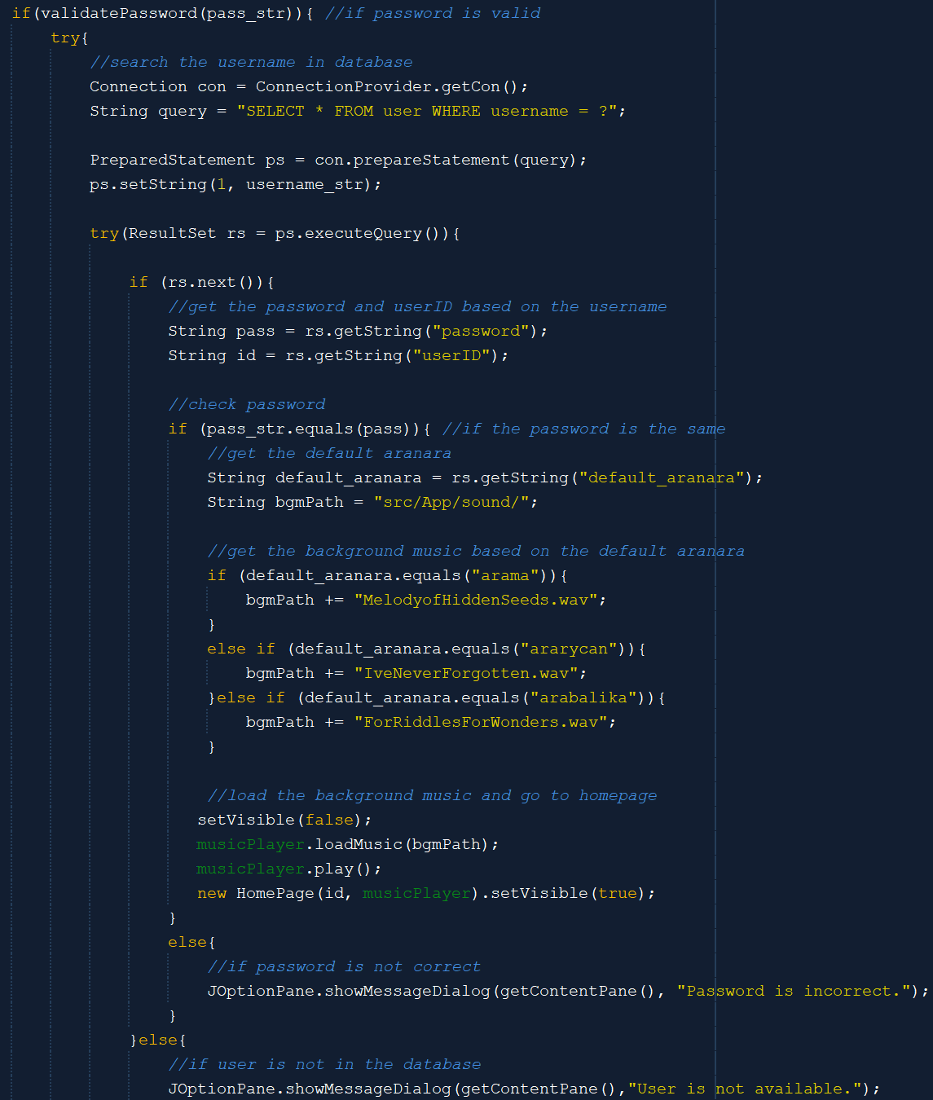

If the password is valid, it will then check whether such a user exists based on the username. If yes and the password in the database is the same as the one inputted by the user, then the method will get the default Aranara of the user and play background music based on the default Aranara.

1. **HomePage**

The homepage is the landing page when the user first signs up or logs in to SchedNara. It consists of several contents, like the default Aranara picture, the task completion bar chart, a random quote, and the upcoming task for today.

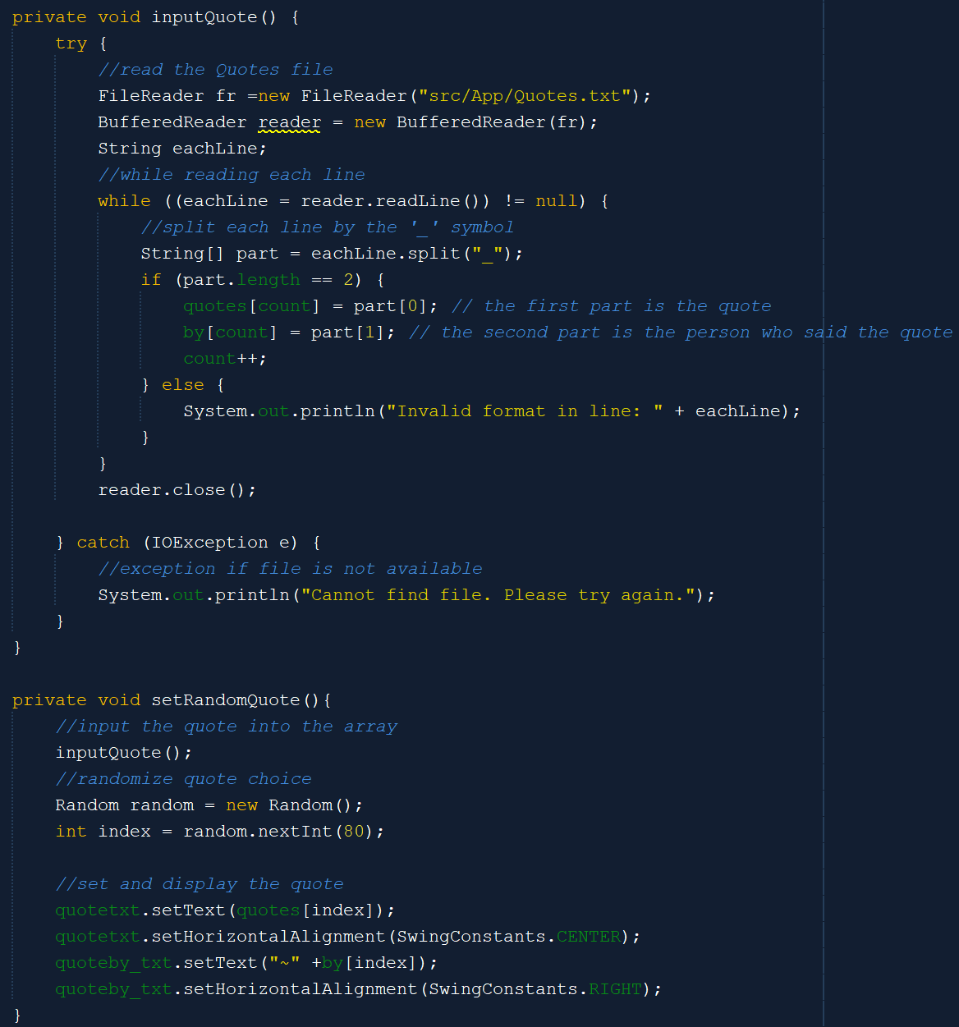

The inputQuote method is used to input all the quotes in the txt file to the array on the homepage. The first array is the quote, while the second array is the person who said that quote. Meanwhile, after getting the quotes, the setRandomQuote method will randomize the quote choice and display it on the homepage.

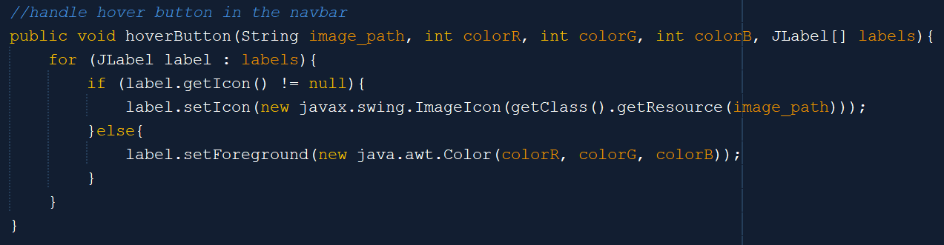

A button inside the side navigation bar consists of an image label and a text label that is grouped in an array. Hence, to ease the hover behavior, the hoverButton method will get the array and set the icon if it is an image label and the color if it is a text label.

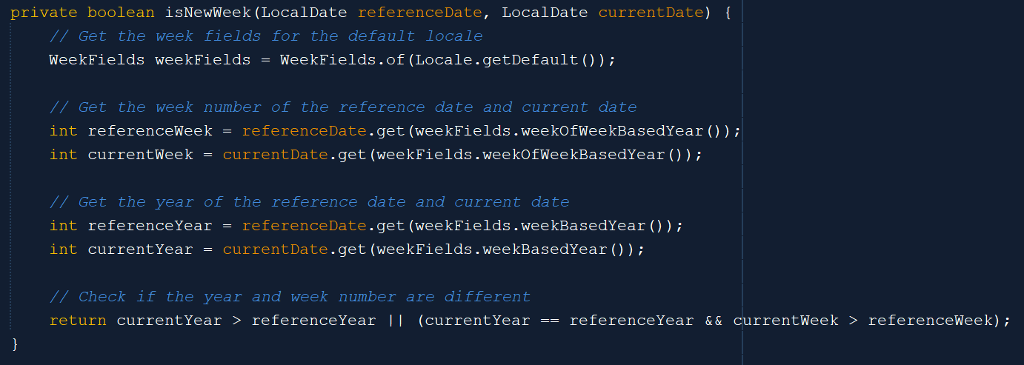

The isNewWeek method is used to check whether the reference date and the current date are on the same week or not. It will check it by getting the week number and the year number of the dates.

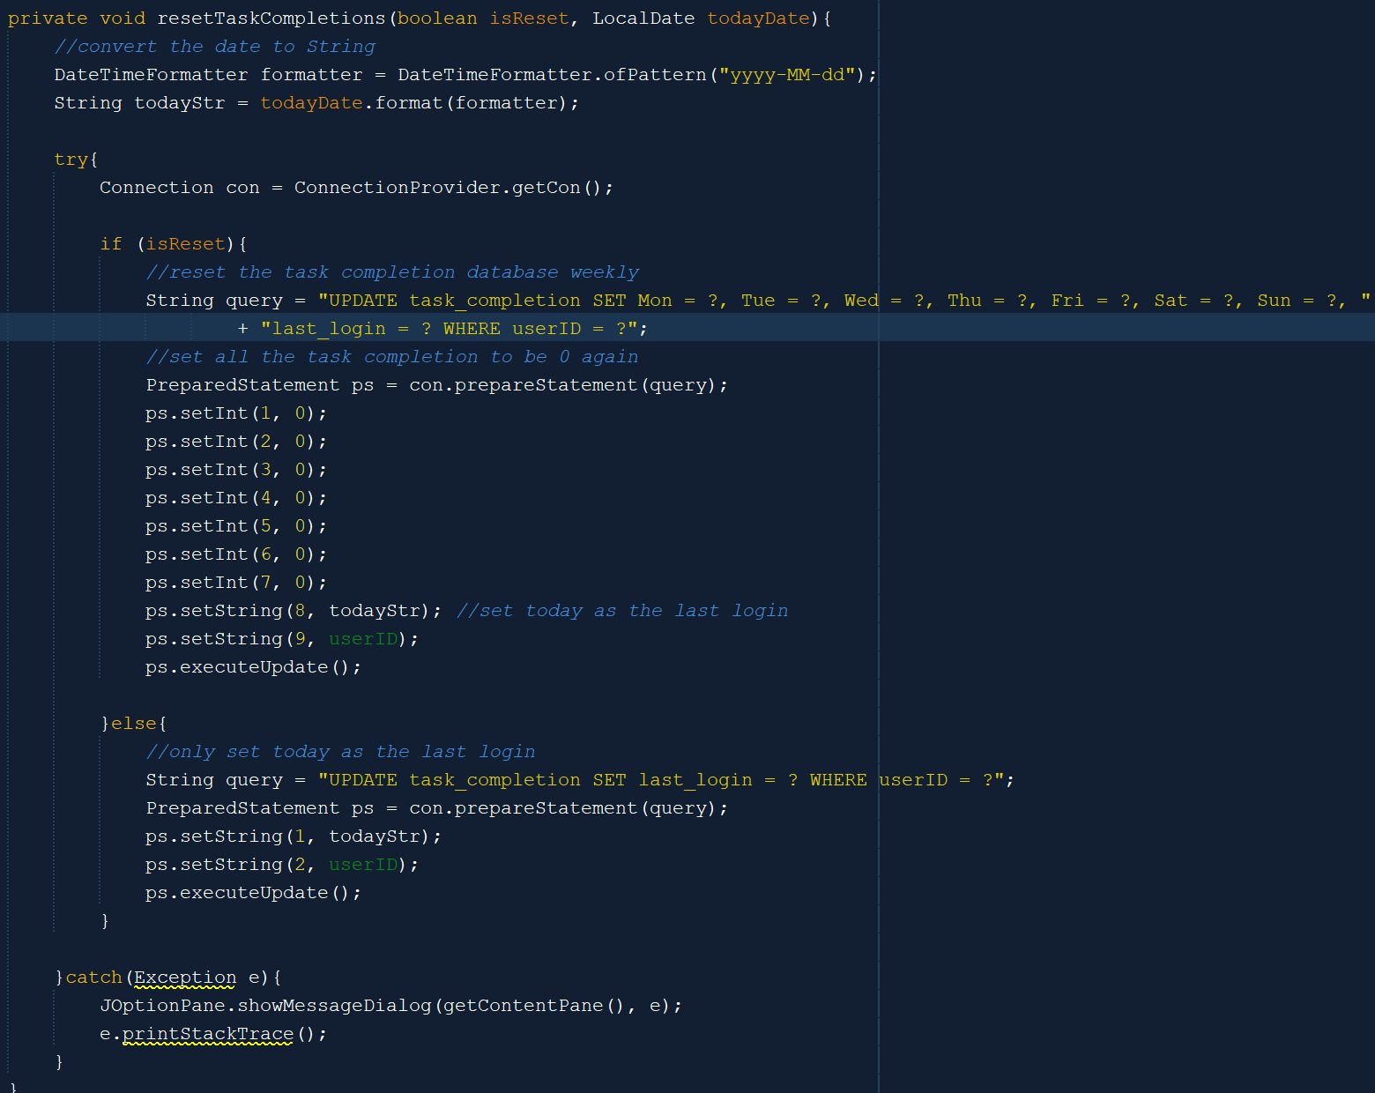

The resetTaskCompletions method is used to reset all the task completions (to become 0 again) in the task completion table if it is in a new week. After that, regardless, of whether it is a new week or not, it will also set the last login date as today’s date.

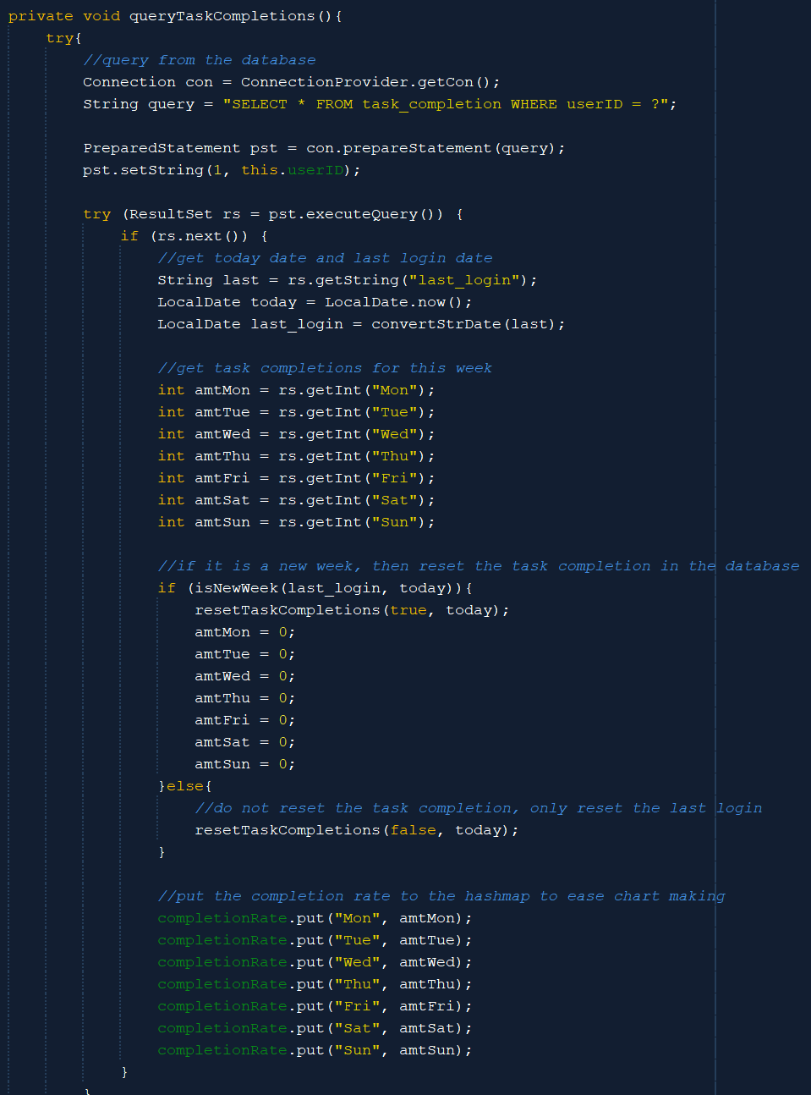

The queryTaskCompletions method is used to populate the completionRate HashMap that will be used to set the bar chart at the next process. It will first get today’s date and check whether it is the same week as the last login date or not. If not, then it will resetTaskCompletions and set all task amounts to 0. After that, it will populate the HashMap based on the task amounts.

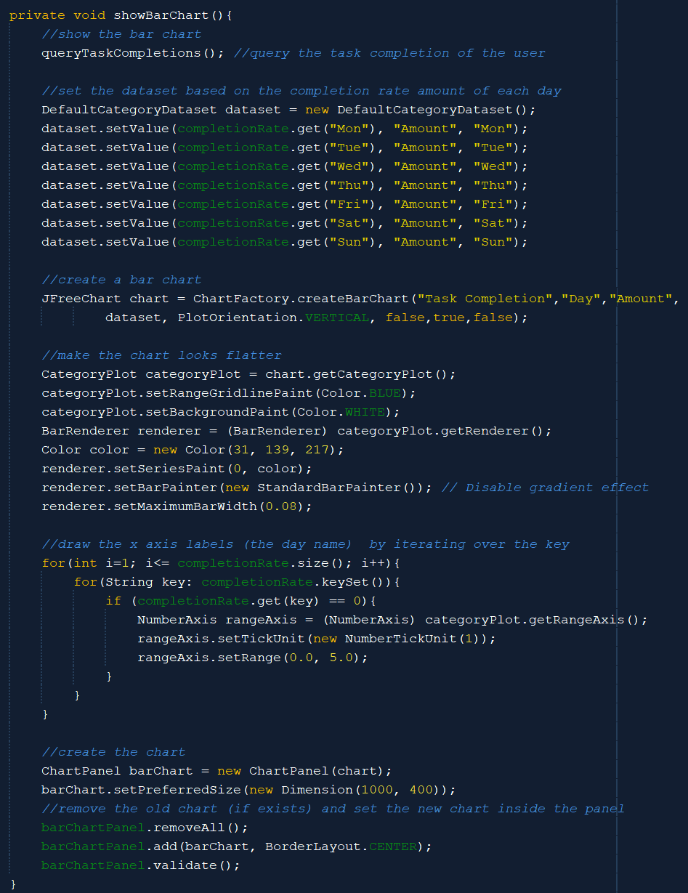

The showBarChart method is used to show the bar chart in the chart panel based on the task completion amount that is populated before in the completionRate HashMap. It will set the dataset based on the task amount in the HashMap, then it creates a flat blue chart and sets the x-axis labels as the day name (the completionRate HashMap keys). After that, it will create the bar chart in the panel. But, before that, all the old charts inside the panel will be removed, so that only the new chart exists.

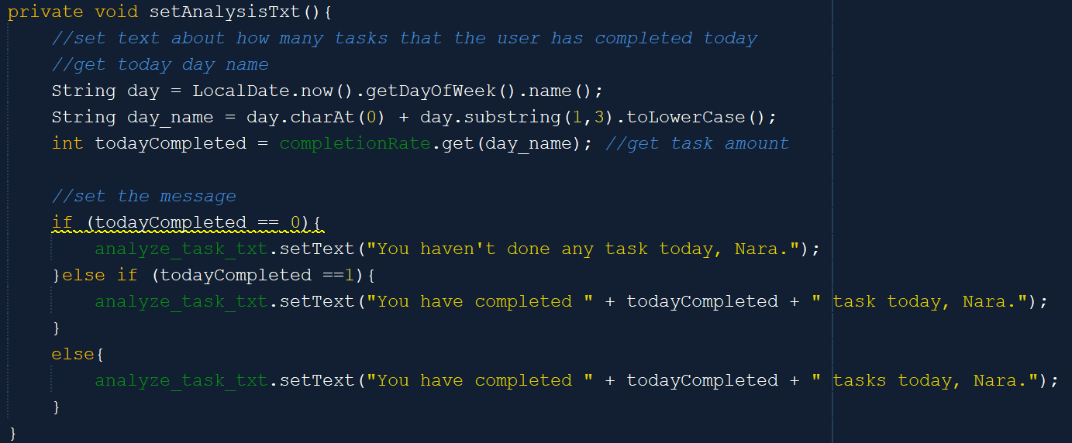

The setAnalysisTxt method is used to set the text below the bar chart panel about the amount of task completion that the user has completed today. It will first get today’s day of name and get the completion rate based on the day name. Then, it will display it in the JLabel.

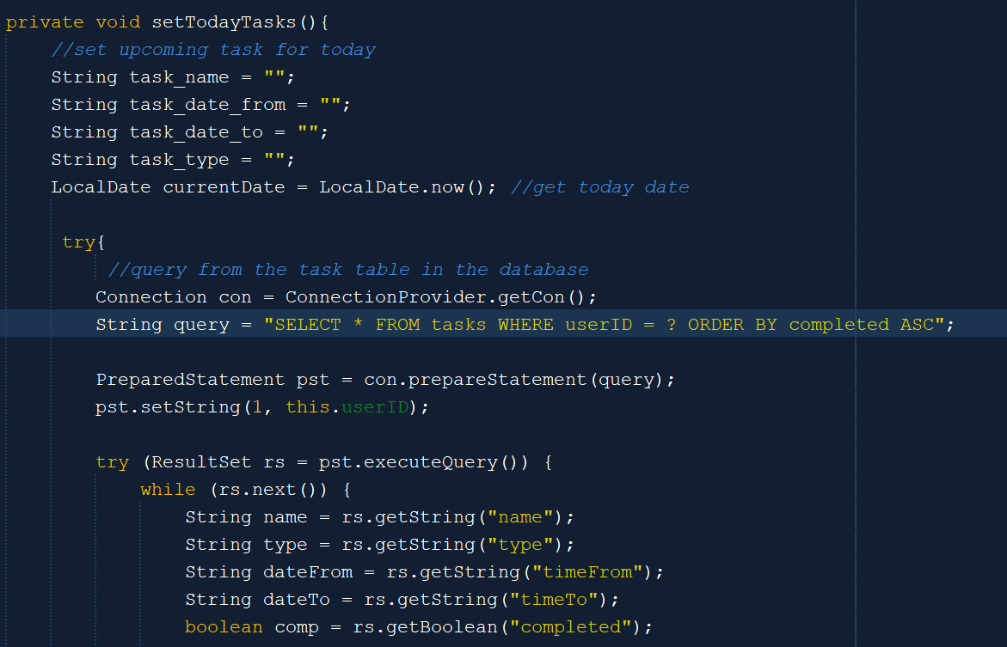

The setTodayTasks method is used to set the upcoming task for today. It will first get today’s date and query from the task table in the database ascending by completed, so that the uncompleted task will be displayed first. It will get all the data about the task.

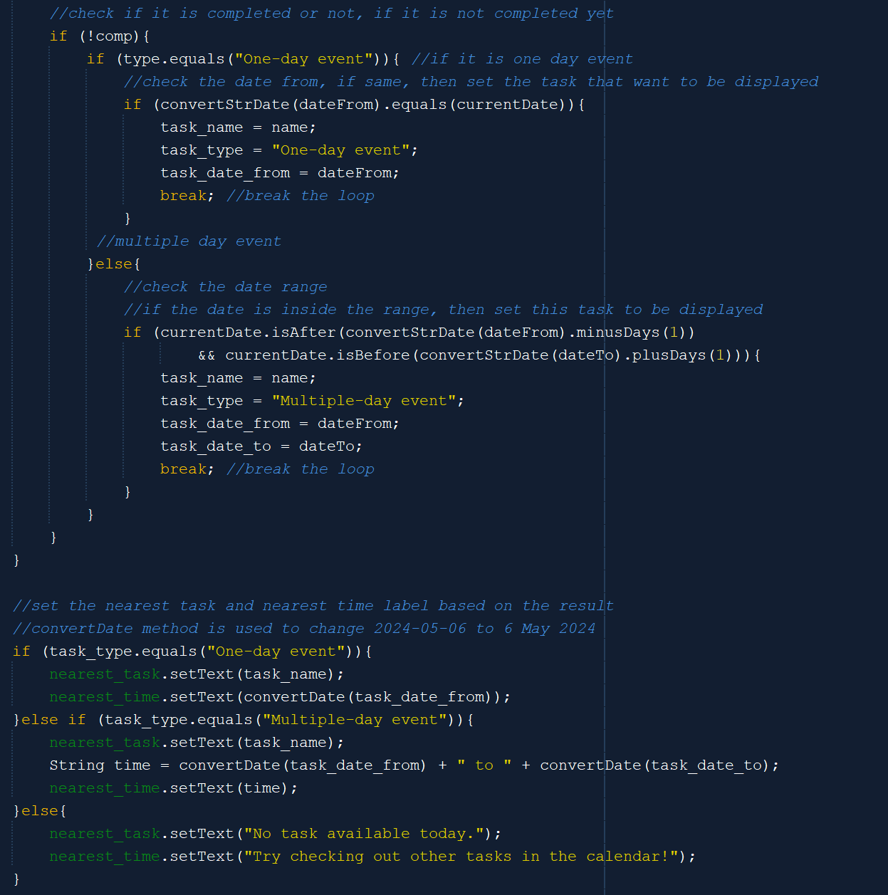

If it is not completed yet, is a one-day event, and the dateFrom equals today’s date, then set this task as the upcoming task and break the unnecessary loop. Otherwise, if it is not completed yet, is a multiple-day event, and today’s date is in range of the dayFrom and dayTo range, then set this task as the upcoming task and break the unnecessary loop. After that, display the task name and time based on its type. If there is no uncompleted task, then set the label to say that there is no task for today.

Other than these methods, there are also some methods to control the navigation of each button. There are five buttons in the side navigation bar, which are the home, add workflow menu, calendar, Aranara menu, and logout button. The home button is not clickable as this is on the homepage, the add workflow menu button will direct you to the add workflow menu, the calendar to the calendar page, the Aranara to the Aranara menu, and the logout button to the Welcome Page and play the Welcome Page’s background music. Other buttons on the homepage are the view more button below the upcoming tasks for today label and the enlarge button beside the default Aranara picture. The view more button will direct you to the calendar page, while the enlarge or new window button to the Aranara menu.

1. **AddWorkflowMenu**

Same as HomePage, the Add Workflow Menu also has a side navigation bar that contains the same five buttons. However, this time, the one that can not be clicked is the ass workflow menu button. Other buttons can be clicked and will redirect the user to their corresponding menu. Hence, the hoverButton method inside this menu is also the same as the one on the homepage.

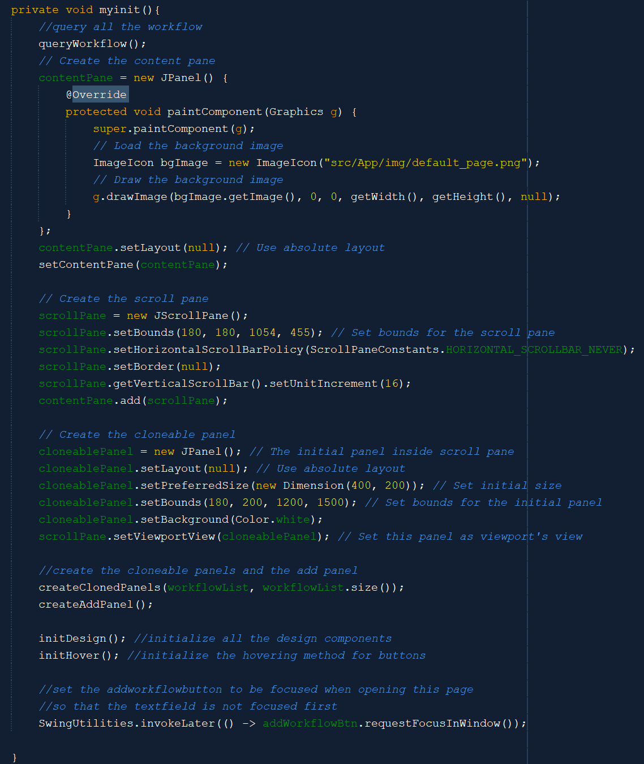

The myinit method will first call the queryWorkflow method. The queryWorkflow method is basically a method that queries all the workflow inside the database and inserts it into a Linked List. The myinit method will then initialize a content pane for the frame and create a scroll pane inside the content pane. The scroll pane will be used to scroll the workflow panels. After that, myinit will create all cloned panels based on the workflow list and also create the add panel on the first order inside the scroll pane. It will also initialize the design and hovering methods and set addWorkflowBtn to be focused, so that the initial focus is not on the search field, so that user knows what is the search field for.

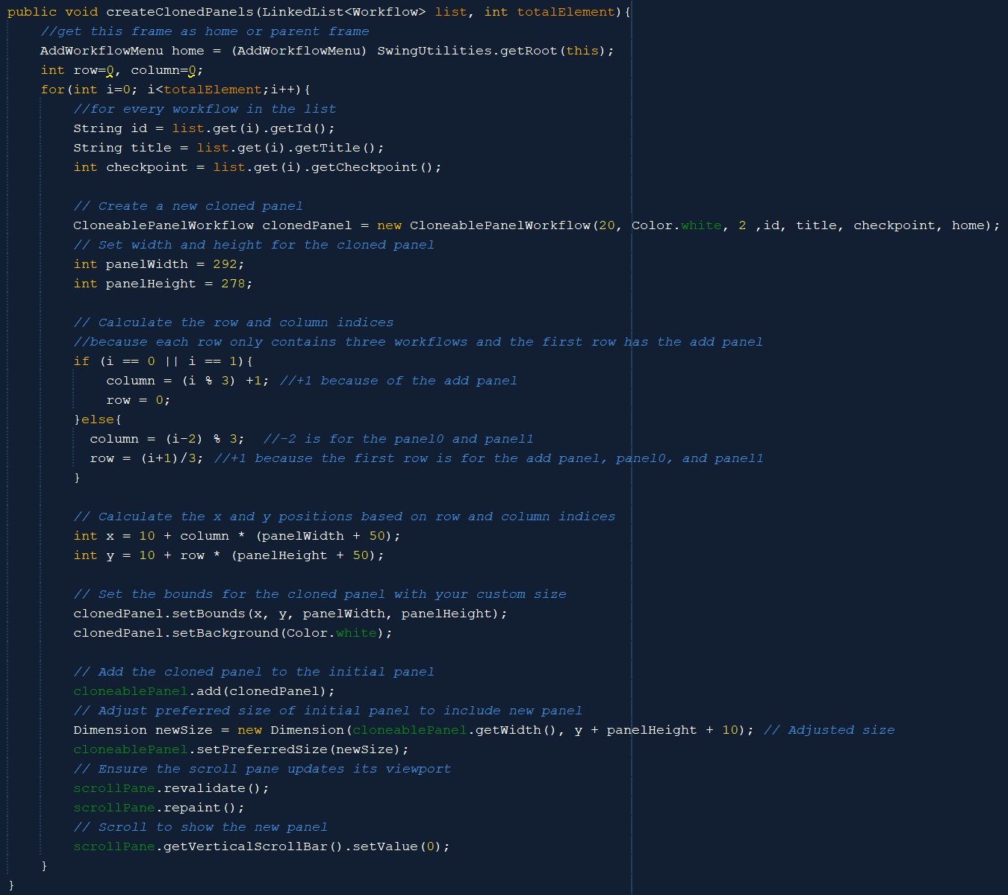

The createClonedPanels method can be seen on other menus when they also use cloneable panels. In this case, it will create the CloneablePanelWorkflow. First, the method will iterate over the list of workflow and create a cloned panel based on the workflow. After that, because in this menu, one row has only three workflows and the first row also contains the add panel, we need to calculate the indices first. After that, the method will calculate the x and y positions based on the column and row positions for the cloned panel. Finally, the cloned panel will be added to the cloneable panel that contains the cloned panel and the scroll pane will be revalidated.

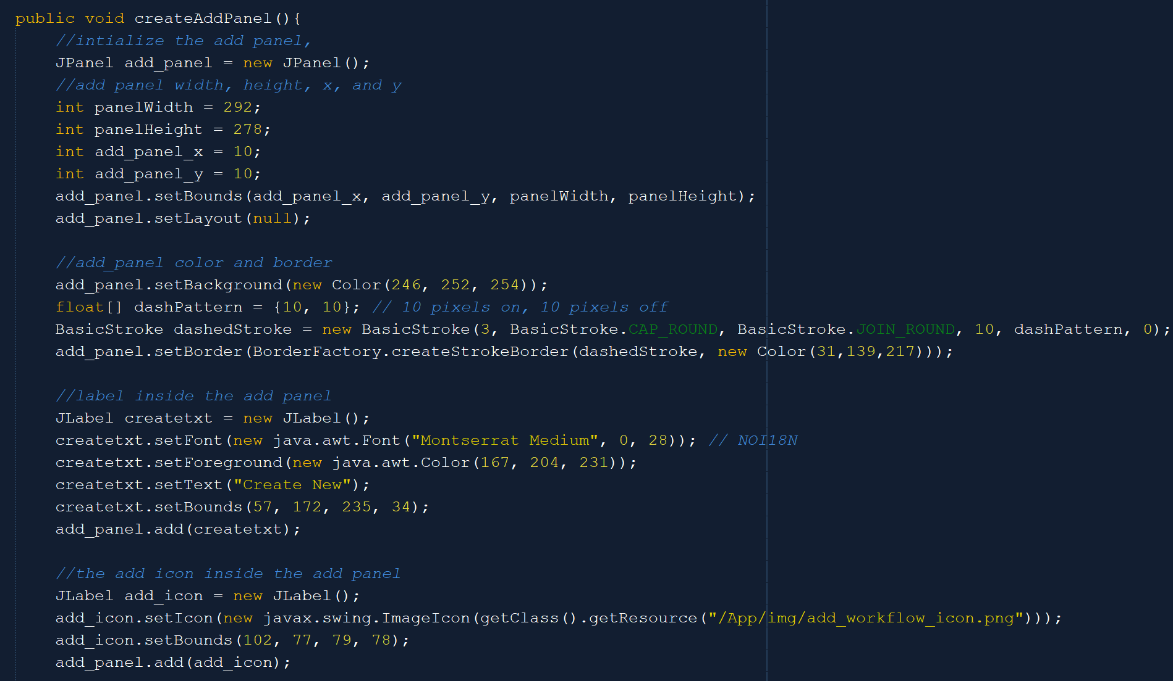

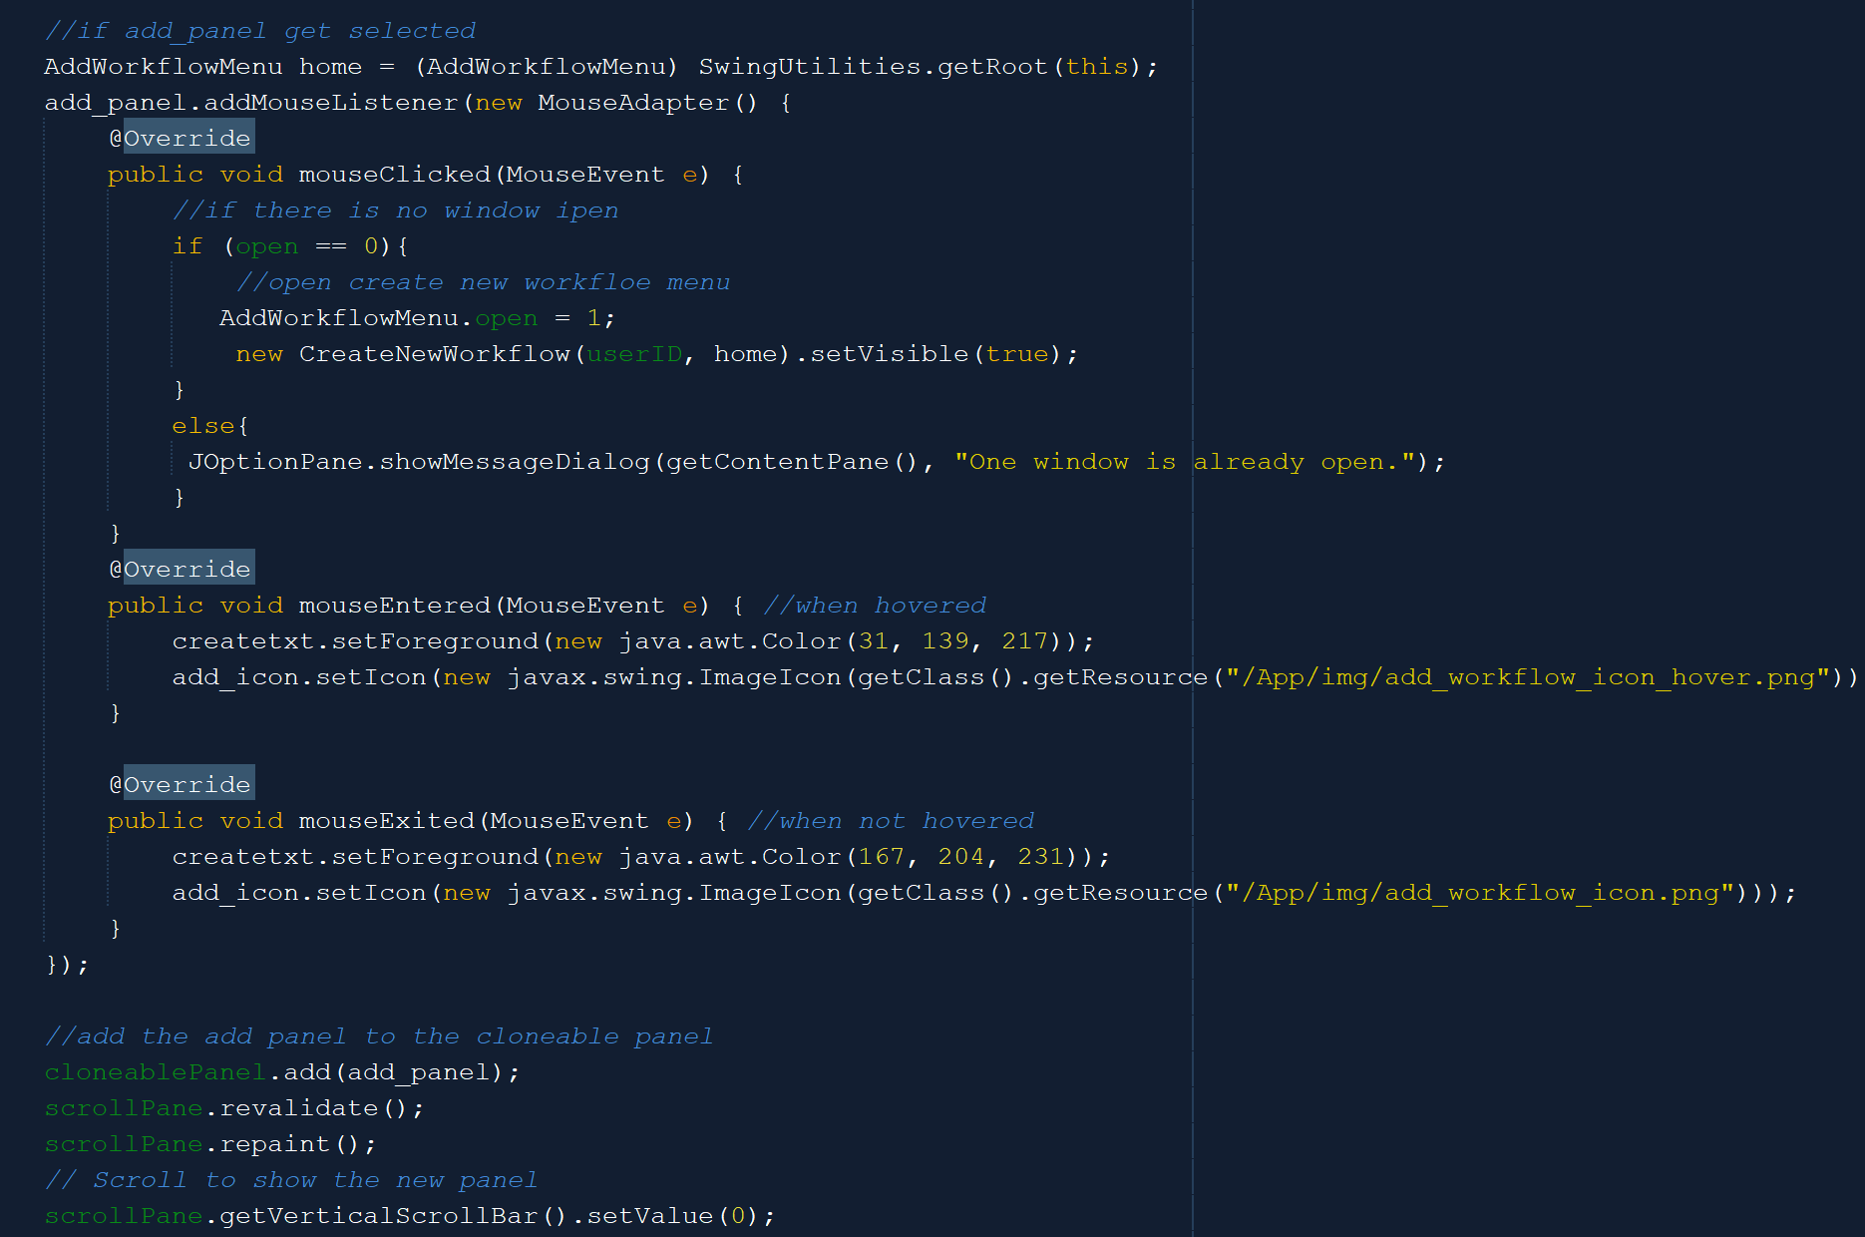

The createAddPanel method is used to create the add panel on the leftmost and topmost positions of the scroll pane. The add panel has a dashed border. It also contains two labels which are the text and the + icon that can change color when the add panel is hovered. If the add panel is clicked, then it will show a new frame on top of the Add Workflow Menu frame to let the user create a new workflow. The add panel is then added to the scroll pane based on its position the position of the add panel is always constant because it will be always on the top-left of the scroll pane.

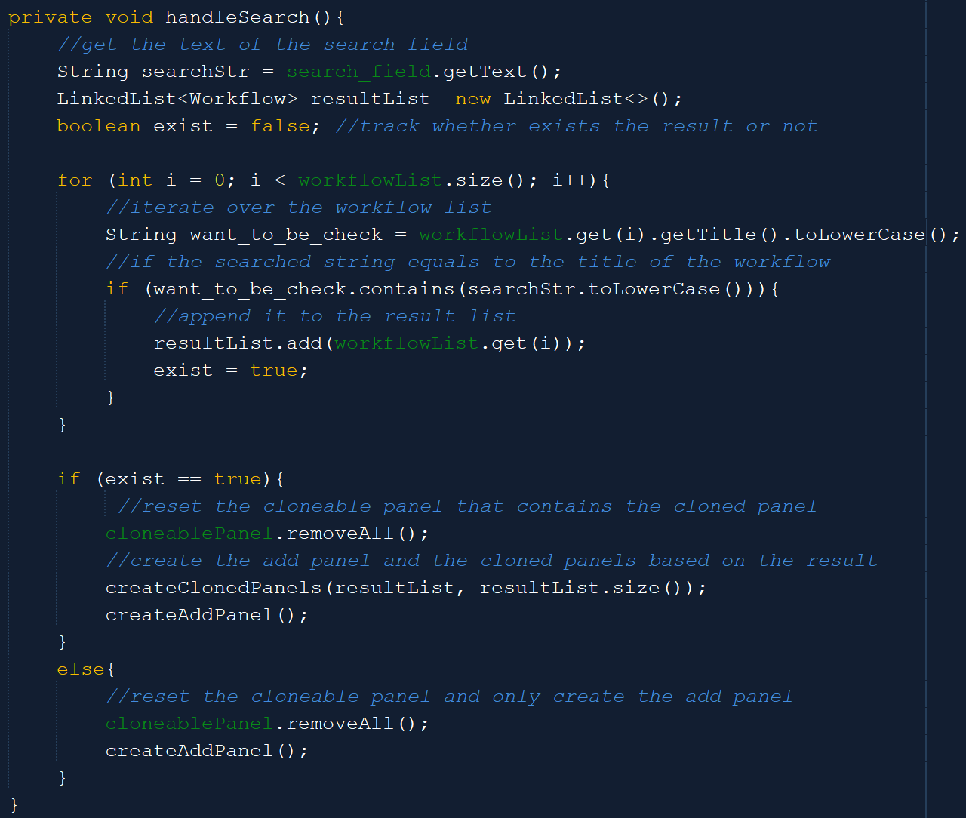

Meanwhile, the handleSearch method is used to display only the result of the searched String. It will first get the text from the search field and check every workflow in the workflow list whether they have the same name as the searched String or not. If yes, then it will display only the workflows that have the searched String in their title and the add panel. If no result exists, then it will only create the add panel.

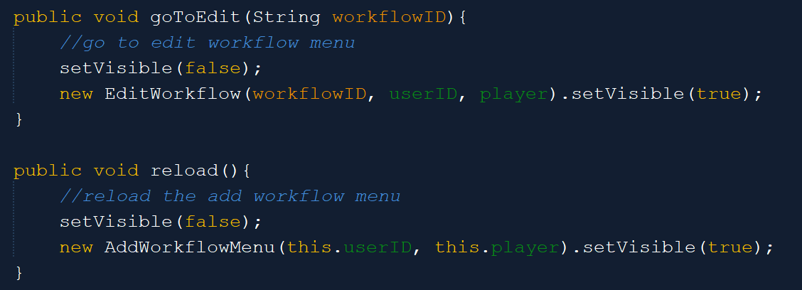

The goToEdit is used to direct the user to the Edit Workflow Menu, while the reload method is used to refresh the Add Workflow Menu frame.

1. **CreateNewWorkflow**

The CreateNewWorkflow frame is supposed to be a child frame that is on top of the Add Workflow Menu frame. It only consists of a field, some labels, and an OK button. This frame’s purpose is to let the user add a new workflow to the existing workflows.

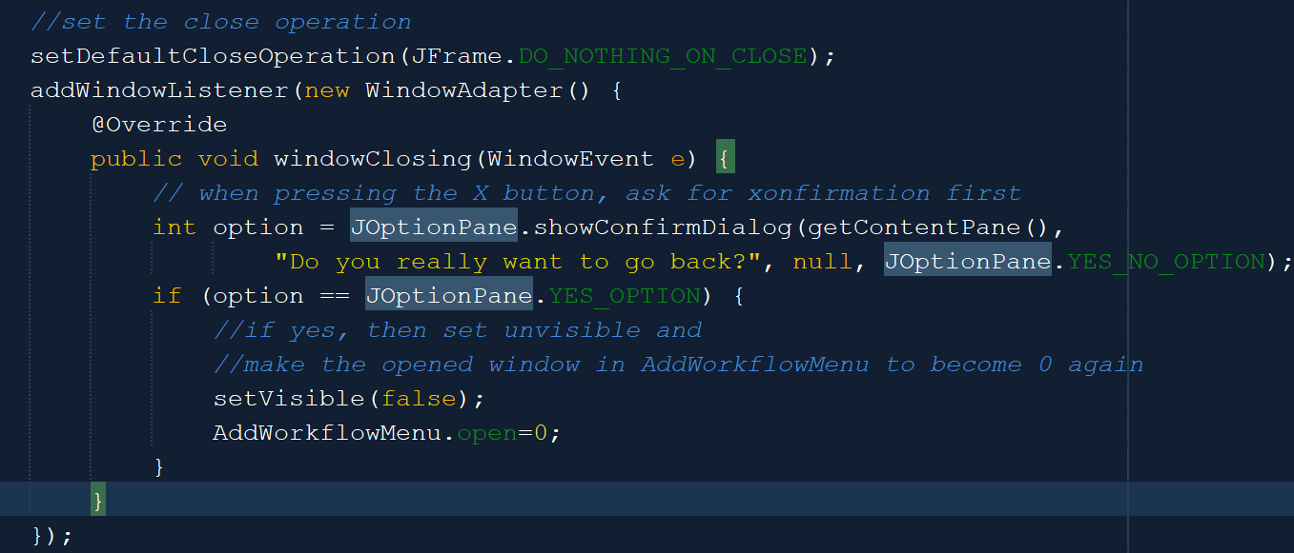

Because it appears on top of the add workflow menu frame and is considered a child frame, not an independent frame, then when the user presses the ‘X’ button on the frame, it will not exit the program. It will then set itself to be invisible again and the user can see the add workflow menu.

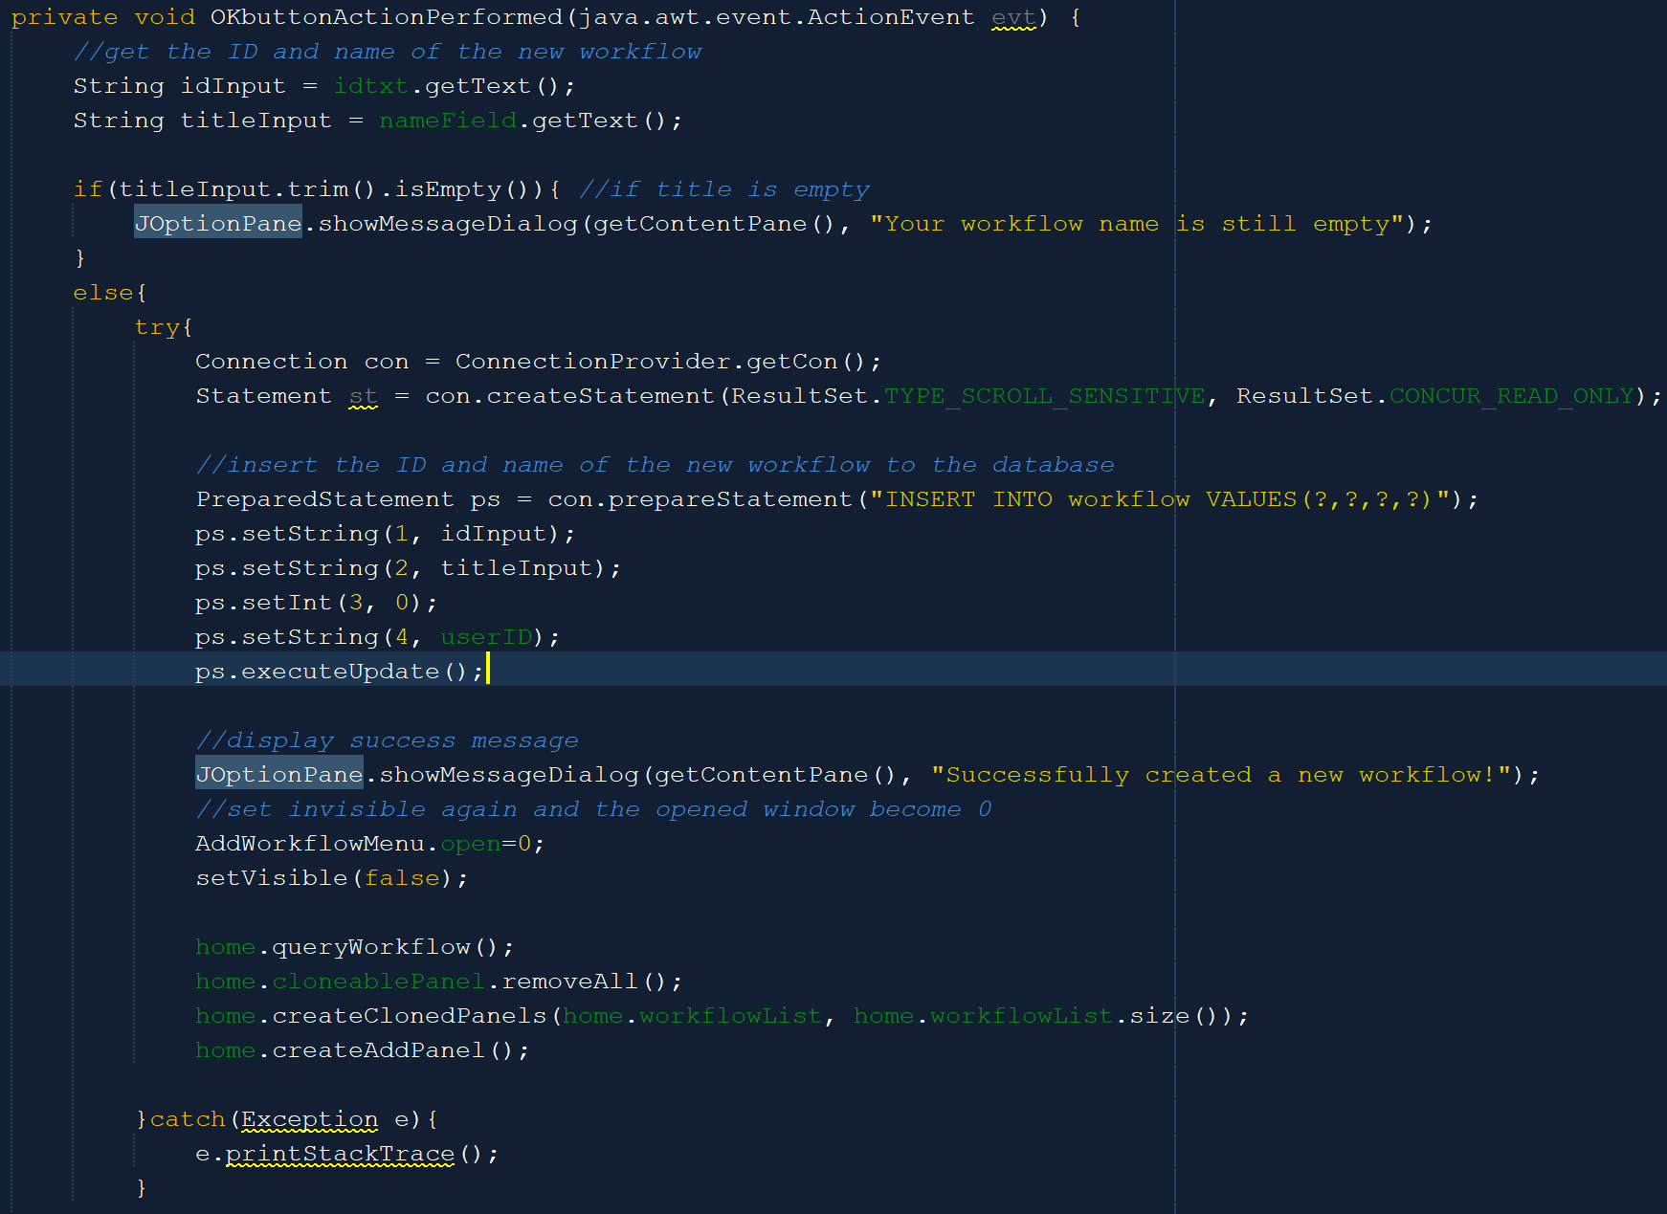

The above method specifies what happens when the OK button is pressed. The method will first get the ID and the name of the new workflow. If the name field is still empty, display the error message. The ID is obtained from the ID label, whereupon initializing this frame, it will first query the last ID of the workflow in the database and generate the ID added by 1 from the one in the database. If all the conditions are met, then the method will insert the new workflow into the database and close this frame.

1. **EditWorkflow**

The Edit Workflow menu is not in the main menu, like the homepage, add workflow menu, calendar page, and Aranara menu, so it does not have a sidebar. However, it is an independent frame, unlike the CreateNewworkflow frame. It has two buttons that redirect the user to other frames, which are the back button to redirect the user to the add workflow menu and the generate text button to show the text result frame on top of the Edit Workflow frame. Its display is also divided into two parts, the left side which is the edit panel, and the right side which is a view of the current existing flows.

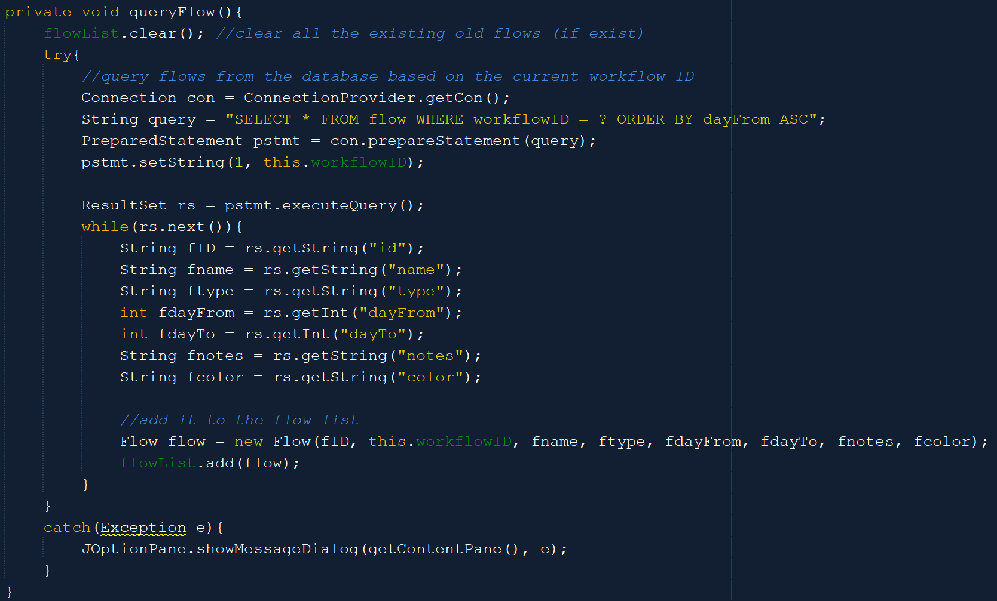

The queryFlow method is used to query all the flows in the database into the flow list based on the user ID. It is also sorted ascending based on the dayFrom, so that when the cloned panel is displayed, it will be displayed from the first flow that has to be done before the D-day until the last flow that has to be done after the D-day. Due to also having cloned panels (CloneablePanelFlow), the Edit Workflow menu also has the myinit and createClonedPanels similar to the one in the Add Workflow menu. The difference is that in this menu, there is no add panel and a row only consists of one panel.

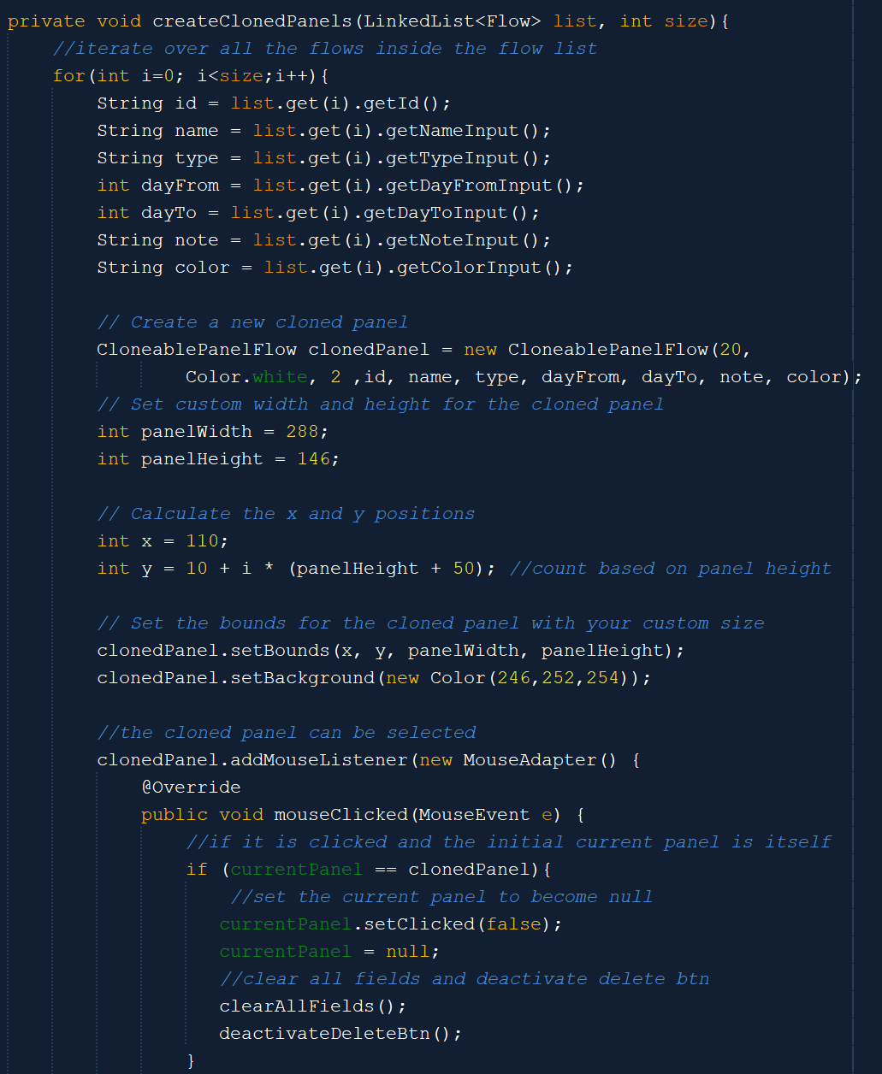

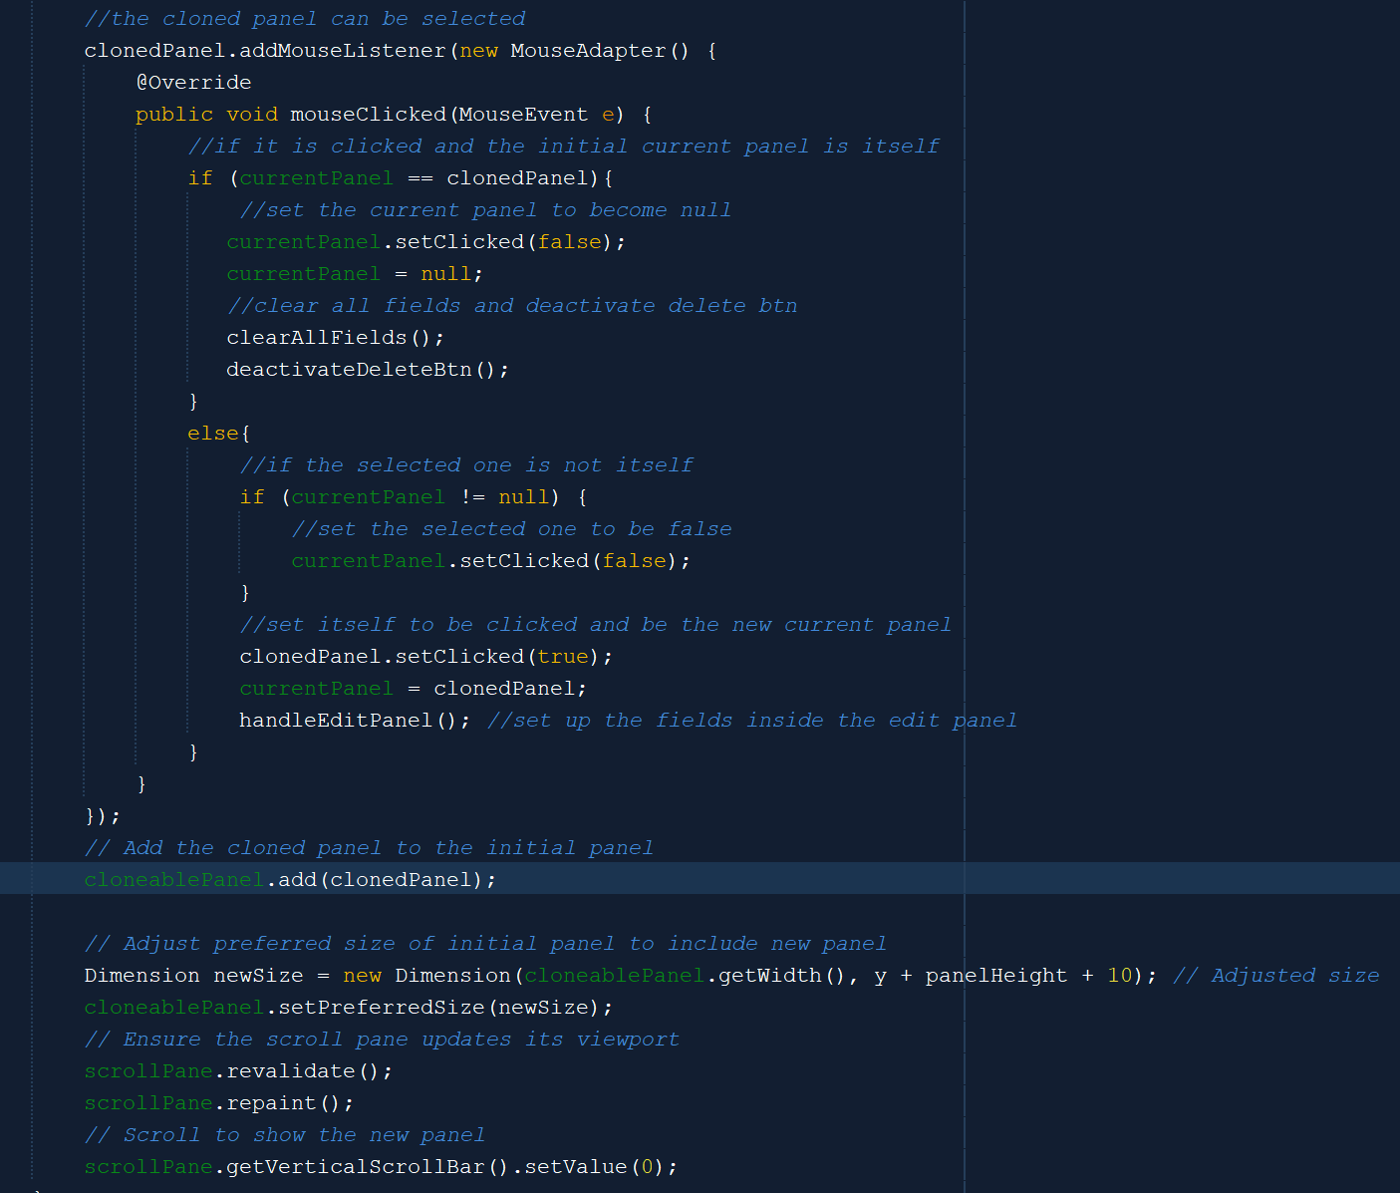



The createClonedPanels is very similar to the one in the Add Workflow Menu, but instead, it takes a Linked List with Flow objects as the input. It also does not calculate the column and row as it is unnecessary. Additionally, the cloned panel can be clicked to be set as the current panel. When the panel is clicked (the current panel is not null), then we set up the fields in the edit panel to contain the information about the Flow that is represented by the panel. If we click a panel that is selected, the current panel will become null again. When this happens, all the fields in the edit panel will be cleared and the delete button will be deactivated.

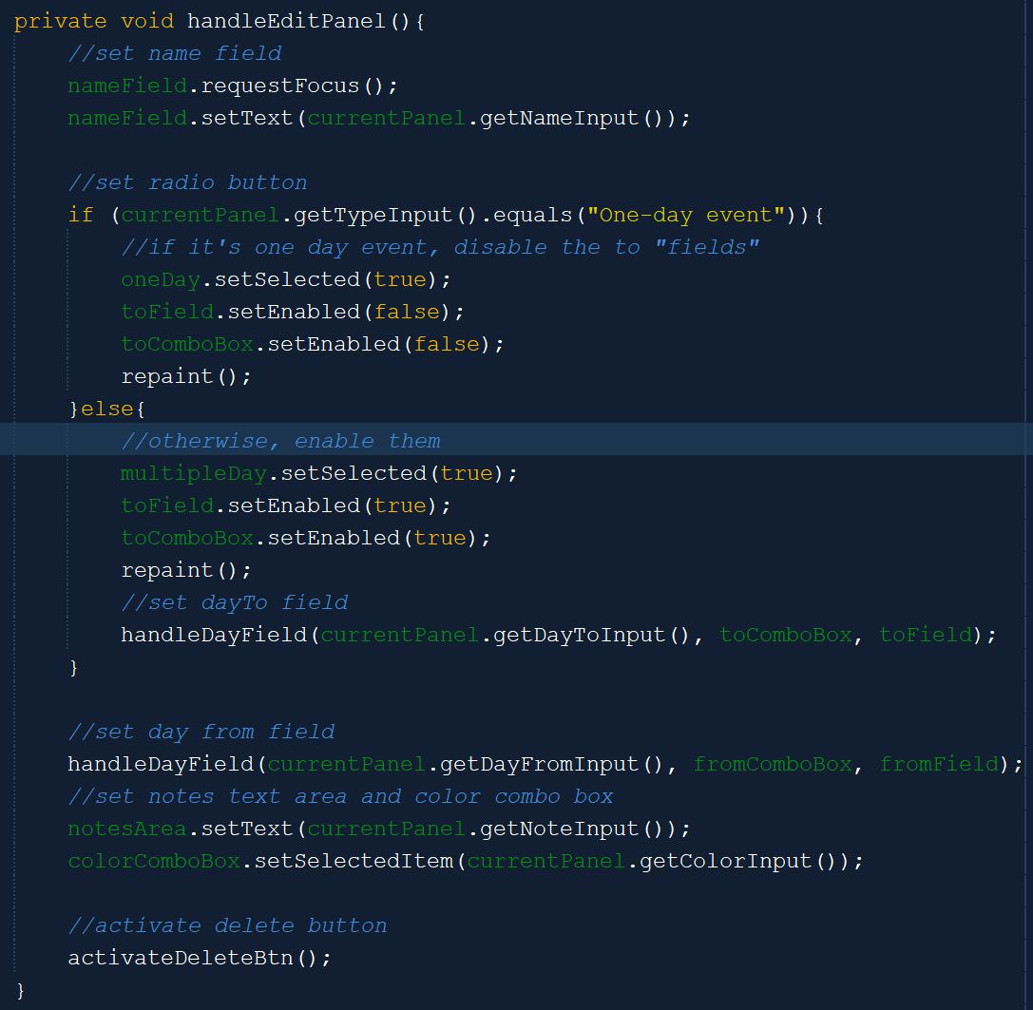

The handleEditPanel method is used to set up the fields inside the edit panel when a panel is selected. It will also activate the delete button.

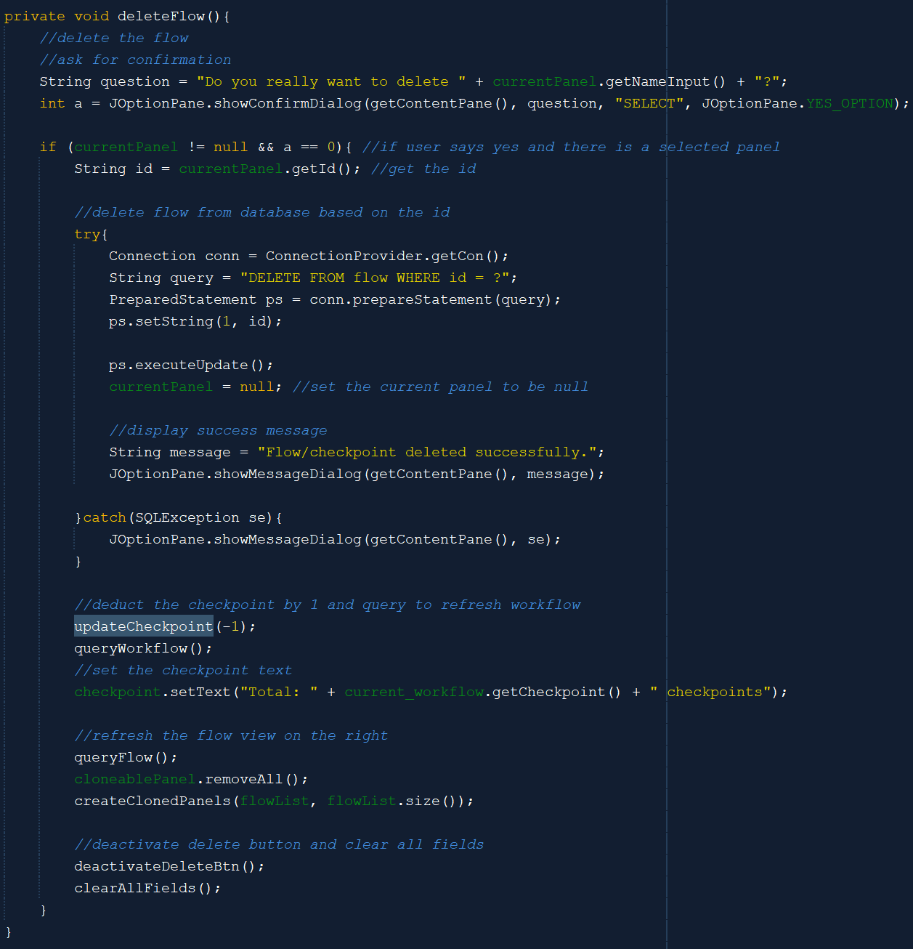

The delete flow method is called when the user clicks the activated delete button in the edit panel. It will first ask the user for confirmation. After that, it will delete the flow from the database and set the current panel as null (no selected panel). After that, it will update the number of checkpoints inside the workflow and refresh the flow view on the right side. It will also refresh the edit panel by clearing all the fields and deactivating the delete button.

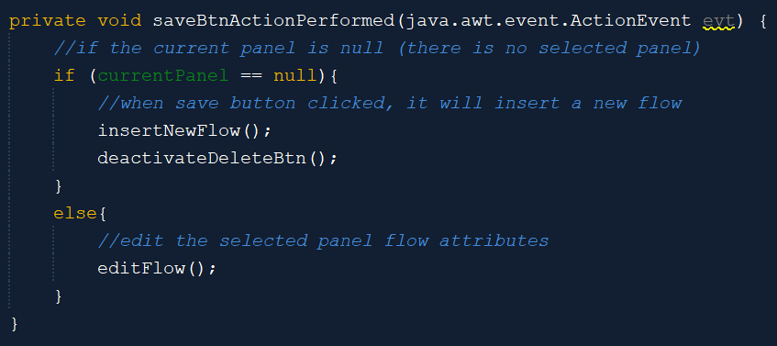

When the edit panel is empty, then when the user clicks the save button, it will insert the data as a new flow. Meanwhile, if the edit panel is not empty (there is a selected panel), then update the flow.

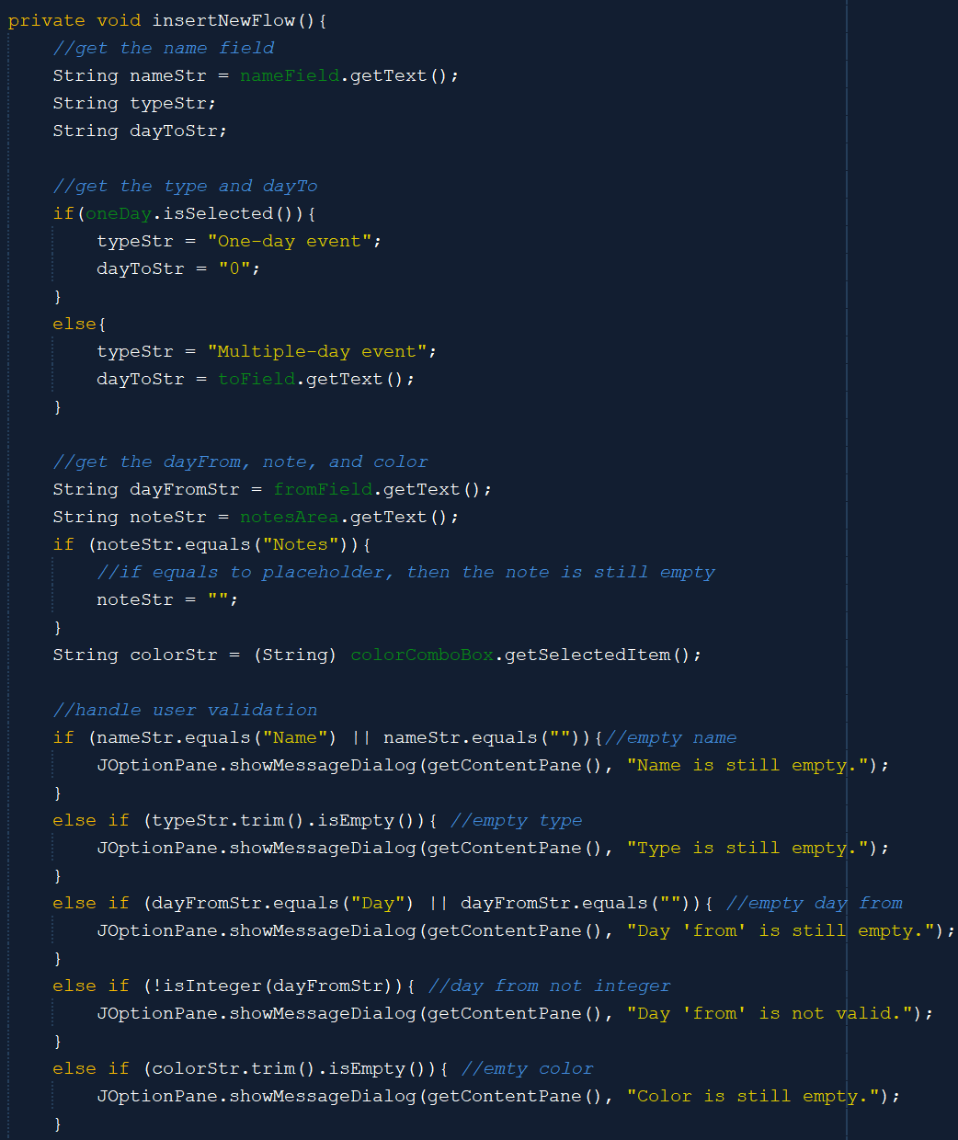

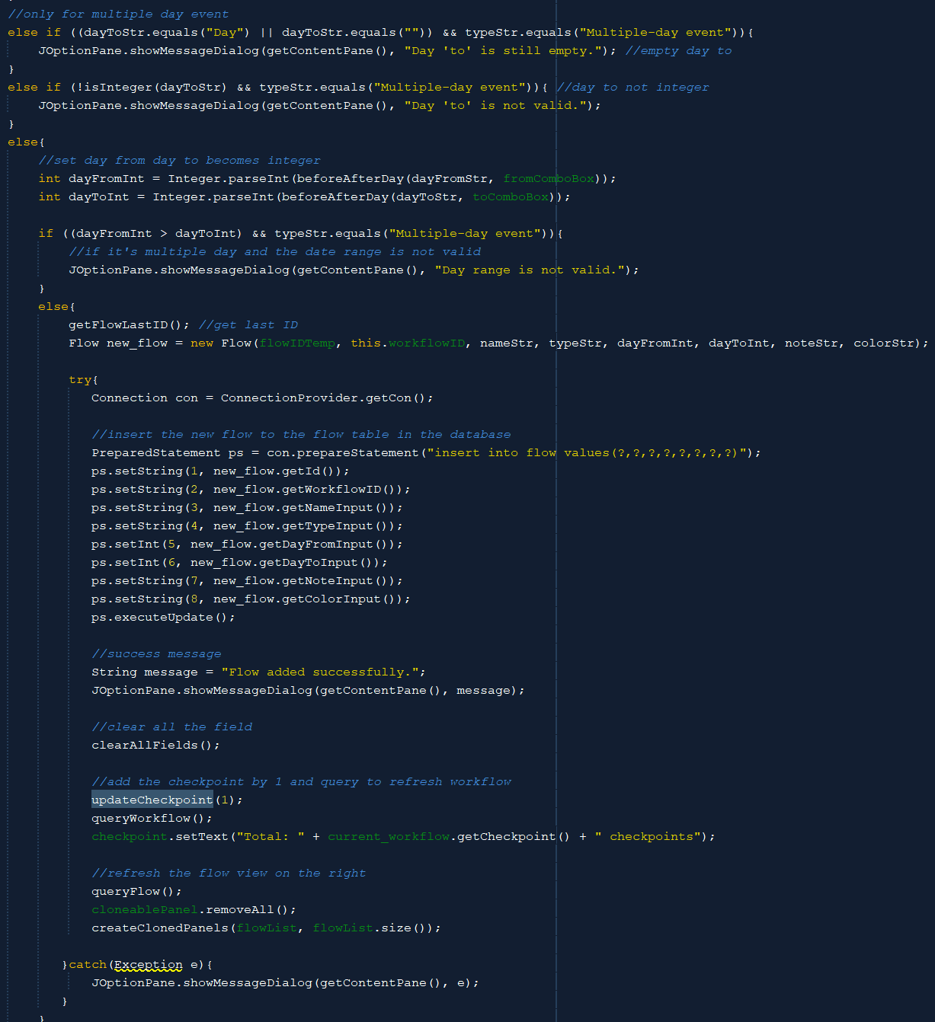

The insertNewFlow method is used to insert the new flow into the database. It will first get all the inputted data from fields, radio buttons, and combo boxes and set it to become Strings. After that, it will check or validate all the data and display the message if the data is not correct or not valid. After all requirements are met, it will get the last ID of Flow and insert the new flow into the database. After that, it will clear all fields in the edit panel, update the checkpoint by adding it with 1, and refresh the flow view on the right side.

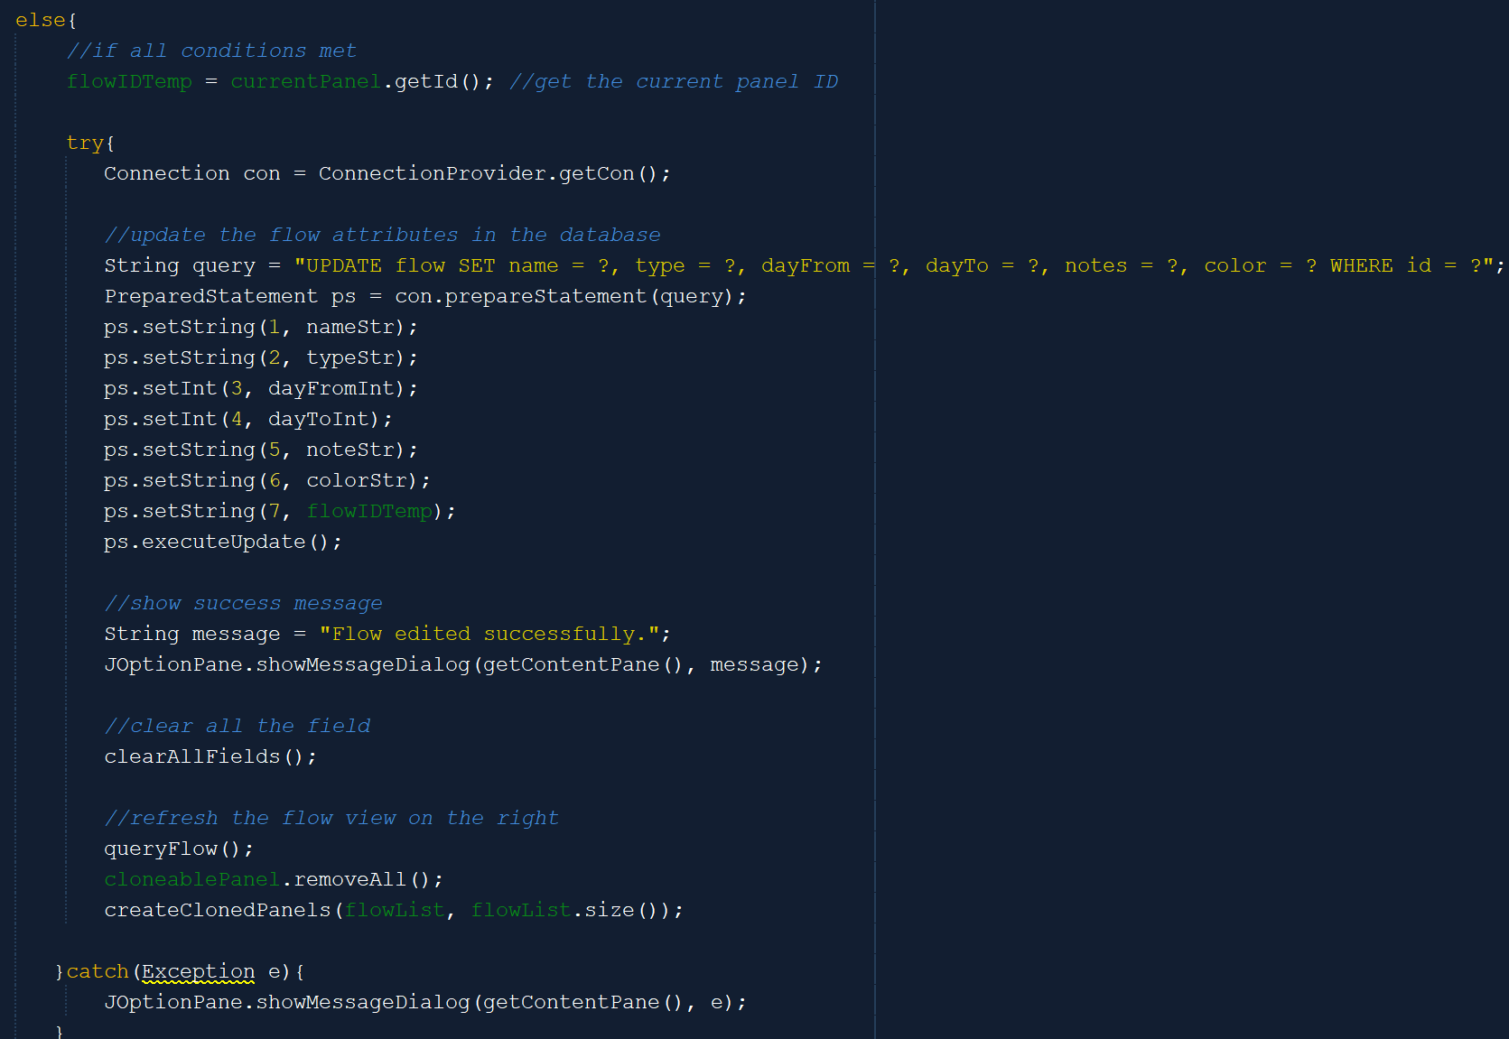

The above code is a part of the editFlow method. The edit flow method is very similar to the previous insertNewFlow method. It will first get all the inputted data and validate it. The differences are in the code that is presented above. After all requirements are met, it will instead get the current panel ID and update the database with the new data based on the ID. After that, it will clear all the fields and refresh the flow view on the right side. No need for updating checkpoints because the number is still the same.

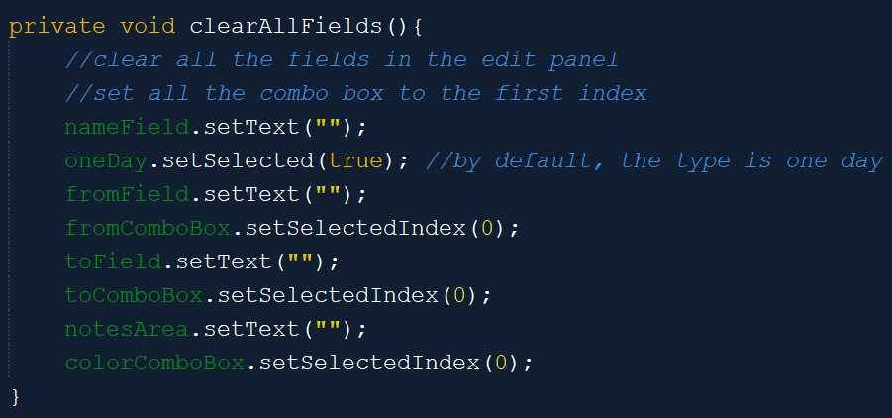

The clearAllFields method is used to clear all the fields in the edit panel after adding, deleting, or editing a Flow. It will set all the fields to be empty again, combo boxes to select their first index, and the type to be a one-day event.

1. **TextResult**

The text result frame is shown when the user clicks the generate workflow to text button on the top right of the edit workflow frame. The text result frame is also not independent. When we click the ‘X’ button in it, it will only close itself and the user will then back to see the Edit Workflow frame.

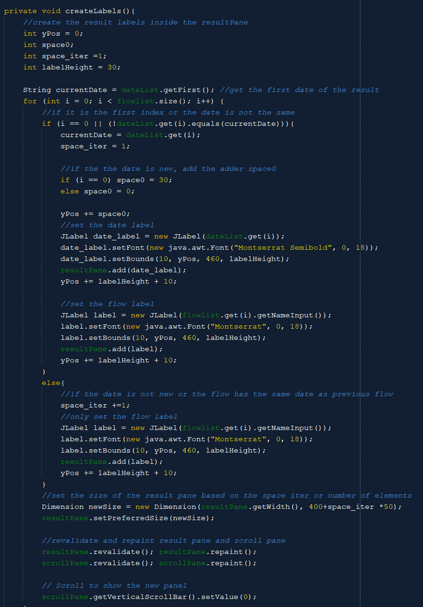

The createLabels method is used to display the result (labels of the date and flow based on the inputted date or D-day). It will first get the first date of the result and iterate over the flow list to generate the flows and their dates. If it is a new date, then there is the space0 adder, so that there is more space when switching dates. The date label will also be initialized with the flow label. If it is not a new date, then, it will only initialize the flow label (flow name). After all are done, the method will calculate the result pane width based on the space iterations or number of elements. Then, it will revalidate the scroll pane and the result pane to display the labels.

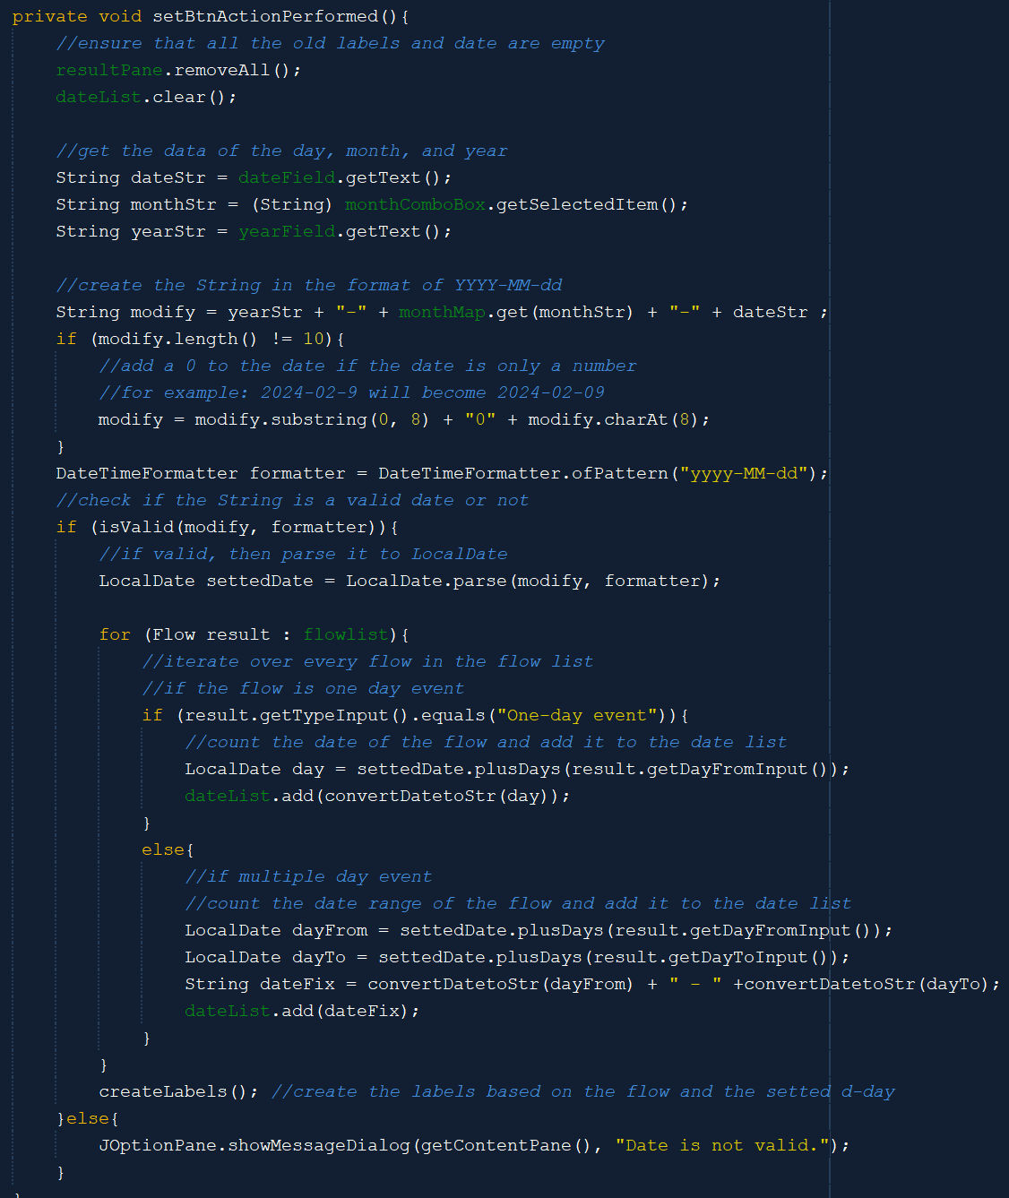

This method specifies what the program will do when the set button is performed or pressed. It will first remove all the dates in the date list and labels in the result pane. After that, it will change the inputted date to String and check if it is a valid date or not. If it is valid, then it will count the date for all flows inside the flow list. After that, it will create the labels based on the flow list and date list.

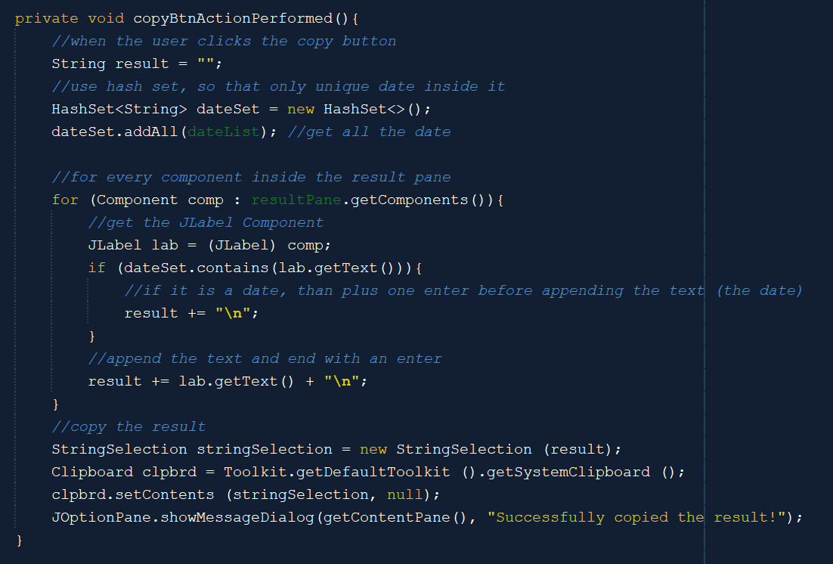

This method specifies what the program does when the copy button is clicked. It will first create a HashSet based on the date list so that it can only contain unique dates. After that, it will get all the labels inside the result pane and append each text inside the label to the result. If the label is the date label, then it will append additional space before appending the date label. After the iterations are done, the result will be copied to the clipboard, and a success message will be shown.

1. **CalendarPage**

The CalendarPage is one of the fourth main menus, so it has a side navigation bar to navigate to other main menus. Therefore, it will also have the hoverButton method like the homepage and add workflow menu. The Calendar Page has two buttons that can let the user open new window on top of it, which are the contact button with the phone logo to open the ContactOthers frame and the insert workflow task button to open the InsertWorkflowTask frame.

The CalendarPage has a large calendar inside it which is the calendarCustom class. It has the calendarPanel and the taskPanel. There are cloned panels inside the task panel, which uses the CloneablePanelTask. Therefore, the myinit and createClonedPanels method is almost the same.

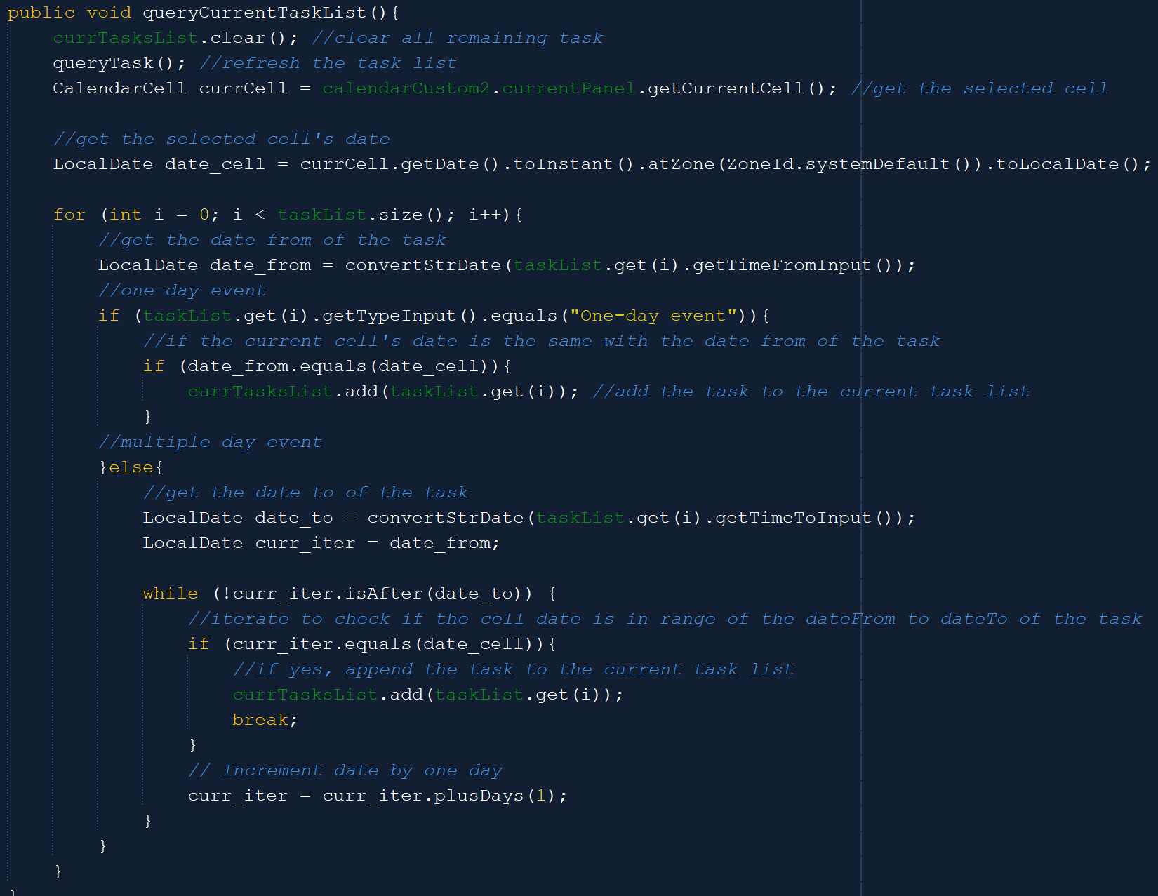

The queryCurrentTaskList method is used to query the task that happens in the selected cell’s date. It will first delete all the remaining old current tasks and refresh all the tasks in the task list. After that, it will get the selected cell’s date and check whether the task date is the same as the cell’s date (if it is a one-day event) or the cell’s date is in range of the task date (if it is a multiple-day event). If yes, then add it to the current task list.

The createClonedPanels logic is basically the same as the previous createClonedPanels method, only the size of the panel is different.



Meanwhile, in the myinit method, instead of creating the cloned panels based on the task list, it will create the cloned panels based on the current task list. The reason is that when the user selects the corresponding cell, it will only display the task for that date.

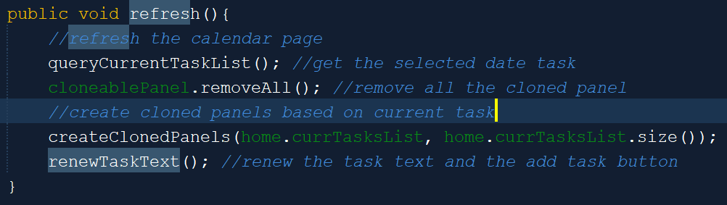

The refresh method is used to refresh the calendar page, specifically the task panel. It will first query the current task list to get the selected cell’s date tasks and create cloned panels based on it. After that, it will renew the task text and the add task button.

1. **AddNewTask**

The add task button in the task panel of the Calendar Page can show a new window on top of the Calendar Page, which is the AddNewTask frame. Because the Add New Task frame is a child window, then when it is closed, it will only close itself, not the entire program. The Task is also similar to the Flow.

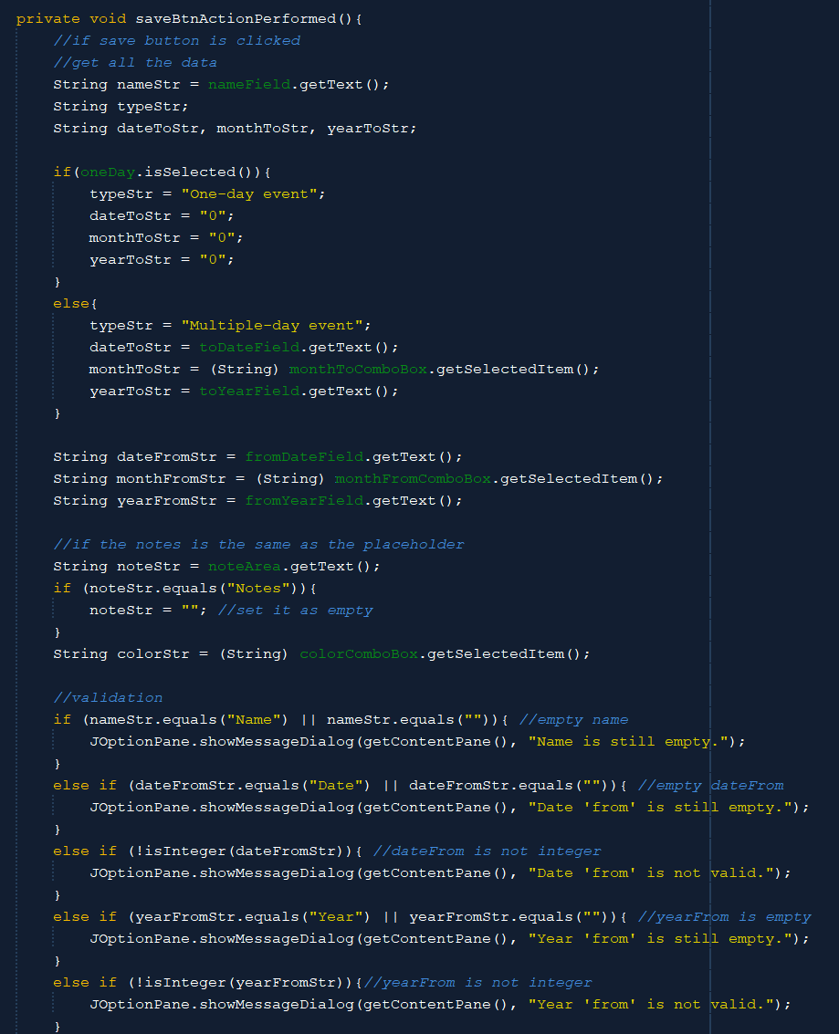

When the user presses the save button, the method will first get all the data inside the field. Note that the field with the ‘to’ name is only obtained and put into use when the type is a multiple-day event.



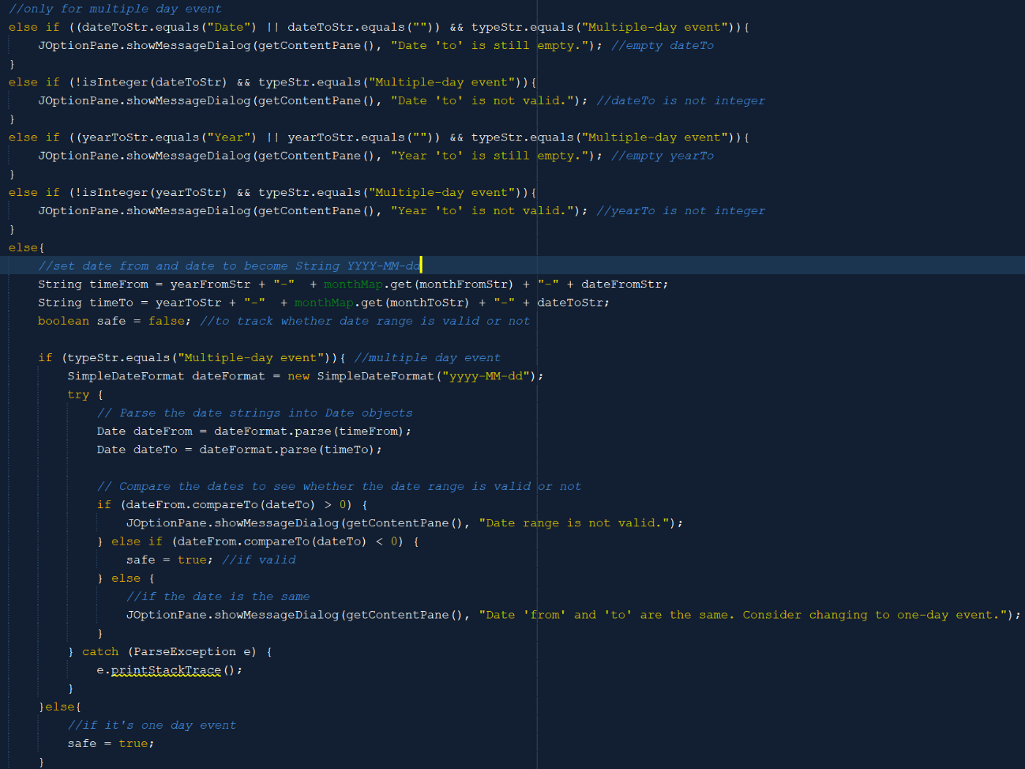

After that, it will validate the user input from the name, date, and year. If the type is multiple-day event, then further validation is needed. It will first validate the dateTo and yearTo. After that, it will check whether the date range is valid or not. If it is valid, then it is safe. The one-day event is automatically safe after the first name, date, and year validations.

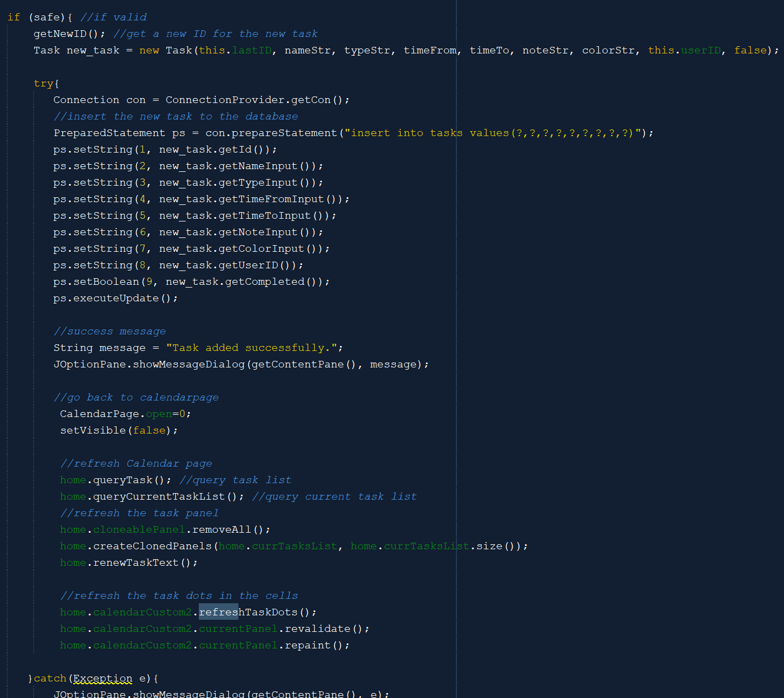

If it is safe, then it will get the new ID for the new task and insert it into the database. After that, it will close the AddNewTask window and refresh the calendar page. It will refresh the task panel, task list, current task list, and calendar panel (task dots).

1. **EditTask**

The Edit Task frame is also a child window of the Calendar Page, so when it is closed, it will only close itself. The Edit Task frame consists of two major operations, which are the edit task and the delete task. Two of them are also similar to the one performed for flows. The edit task method is also very similar to the add task method. The difference is back again on the method to update it in the database.

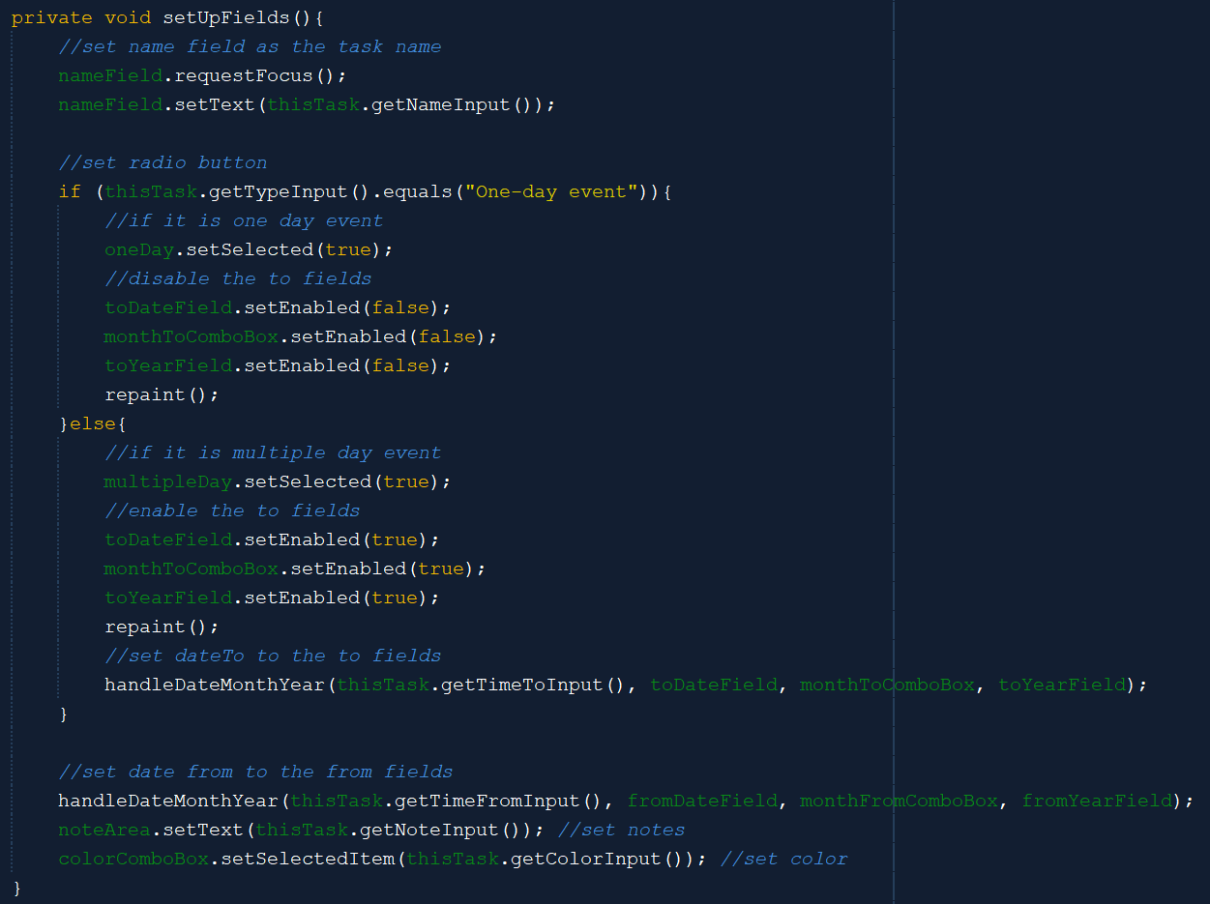

The setUpFields method will set the fields inside the Edit Task frame based on the current task. If the task is a one-day event, then the to fields are disabled. Conversely, the to fields are enabled when the task is a multiple-day event. Meanwhile, the handleDateMonthYear method will handle the date field, month combo box, and year field based on the task date.

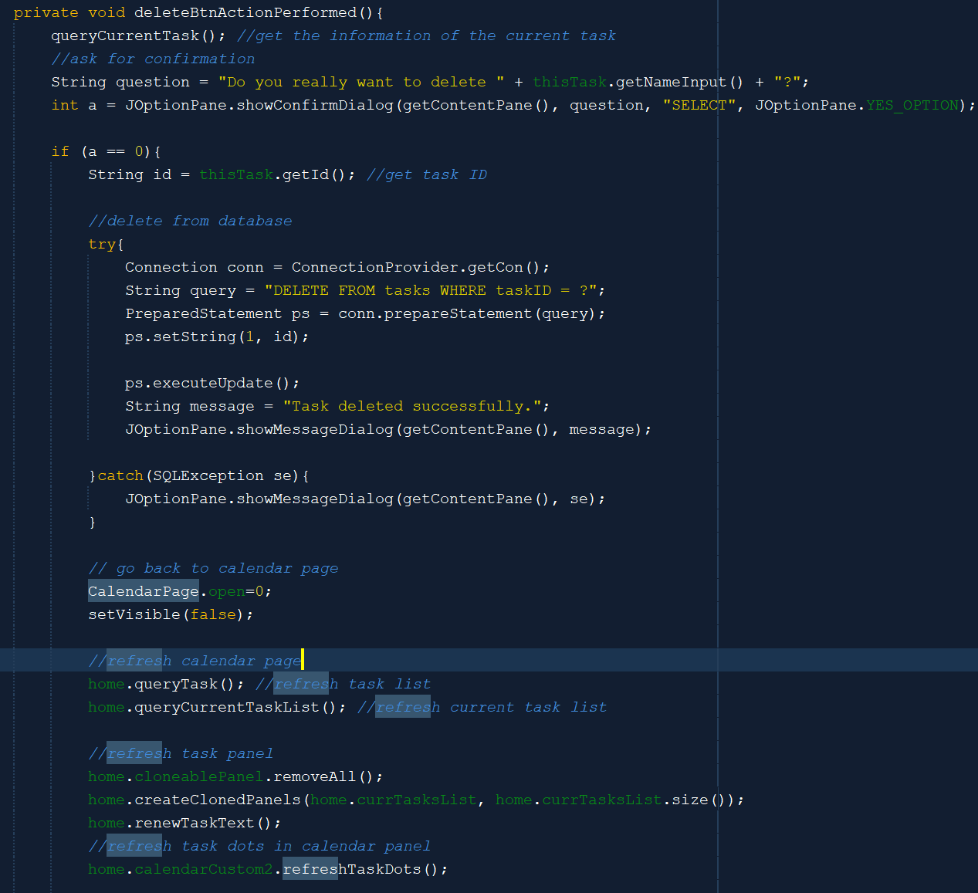



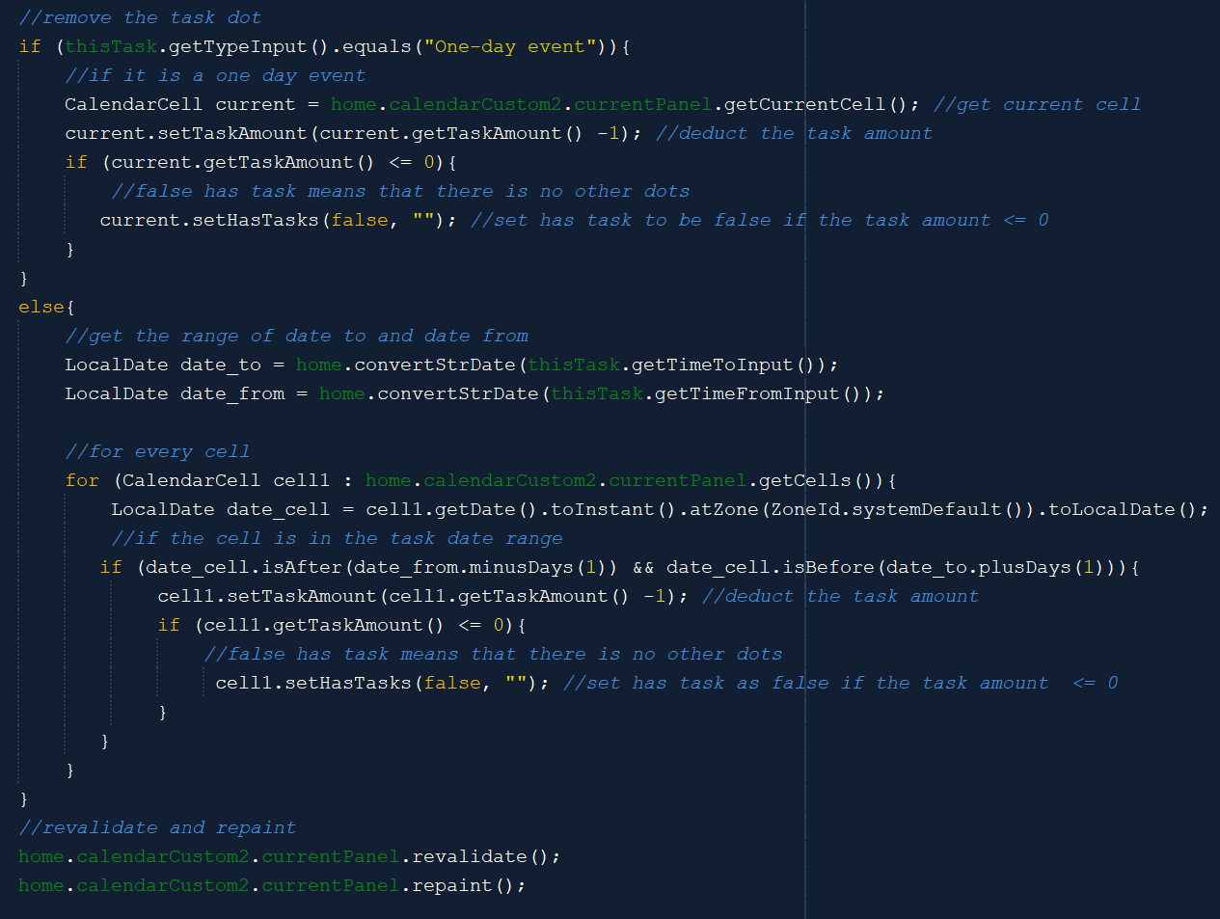

If the delete button is pressed, then it will first get the information of the corresponding task. After that, it will ask the user for confirmation. If the user says yes, then it will delete the task from the database and go back to Calendar Page. At the same time, it will also refresh Calendar Page and remove the task dots. The method removes the task dots by getting all cells that have the date or date range of the task and deducting the cell task amount by 1. The hasTask attribute will be set to false if the cell does not have any other tasks anymore. If the hasTask is false, then there will be no color dot in the cell.

The edit task method is very similar to the add task method in the add new task frame. The validations and the way for it to get the data from the fields are all the same.

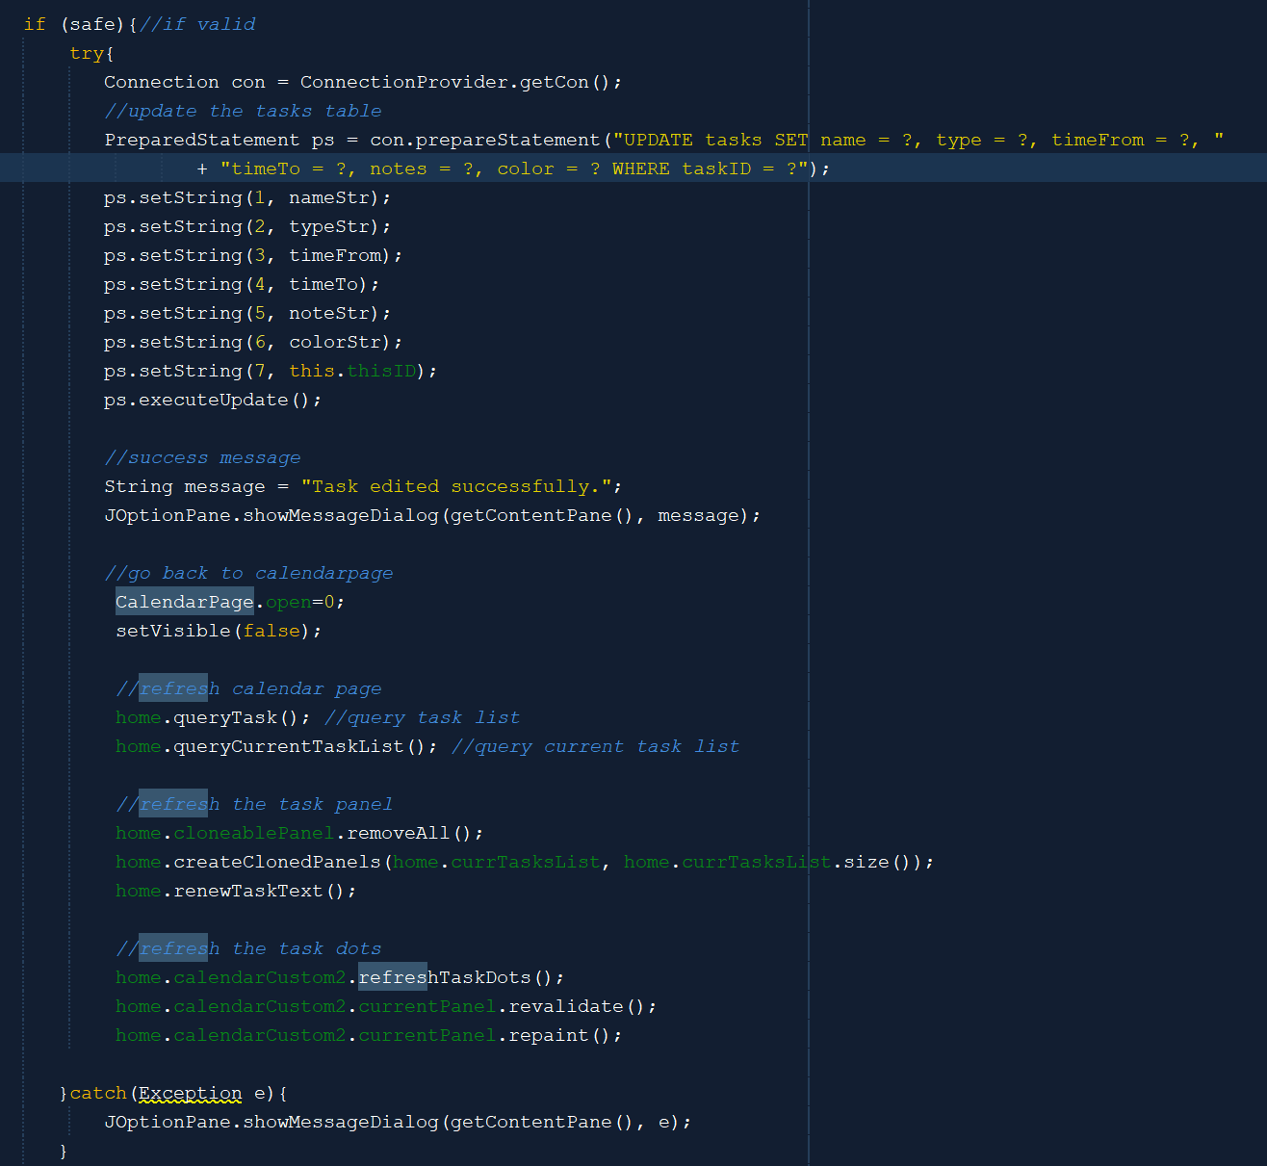

The difference is that here, it will update the database, not insert a new task into the database. After it updates the task in the database based on the task ID, it will refresh the calendar page (task list, current task list, task panel, and task dots).

1. **InsertWorkflowTask**

The InsertWorkflowTask is also a child window of the CalendarPage. It will close only itself when the close button is performed.

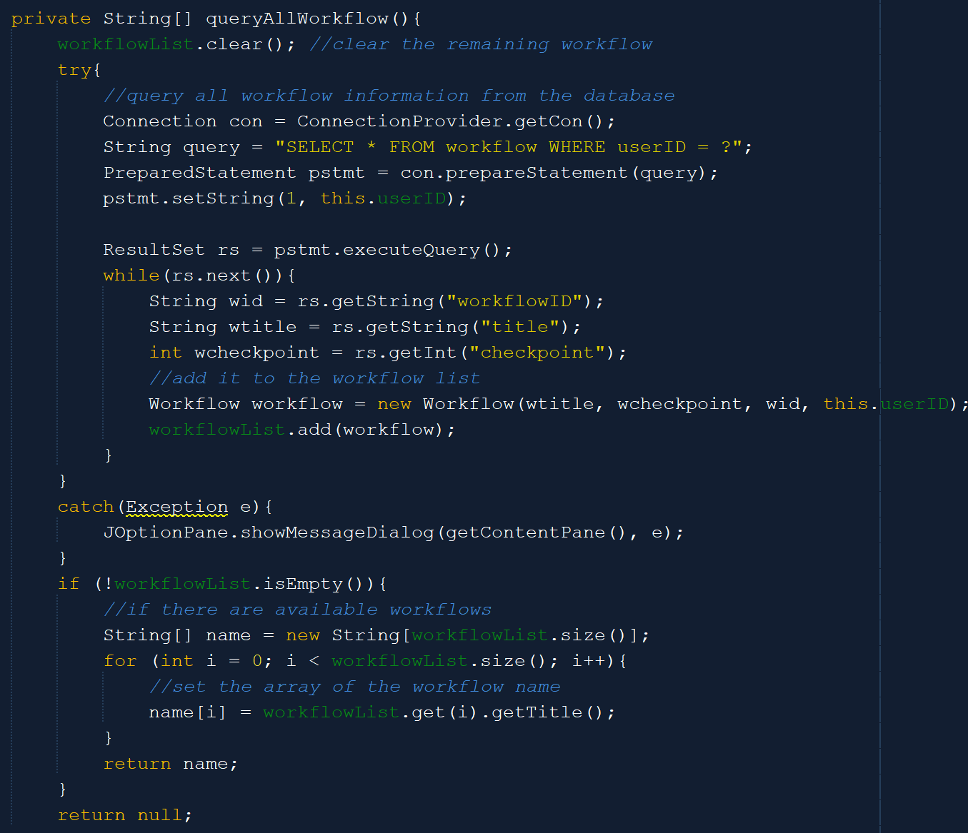



The queryAllWorkflows method is used to set up the workflow combo box inside the frame. It will first query all the workflows from the database and add them to a workflow list. After that, if the workflow list is not empty, it will create a new String array that contains the names of all of the workflows. This String array will be used to set the combo box.

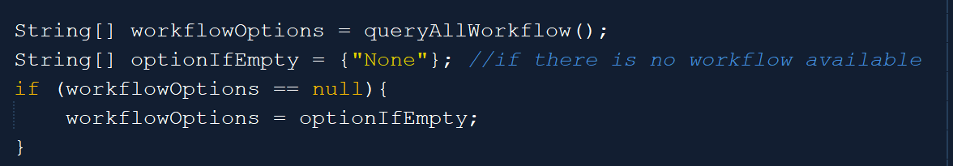

The above code is a part of the initDesign method for the combo box. If the result is null based on the previous method, then the combo box will only contain the option “None”.

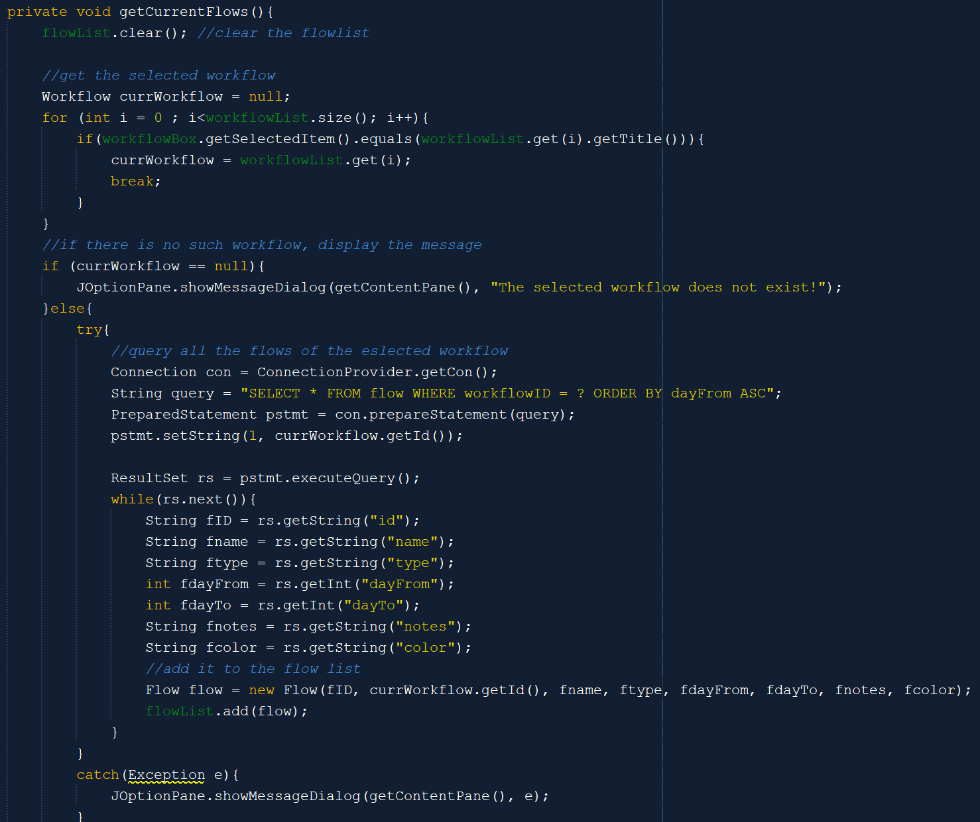



The getCurrentFlows method will be used to get all the flows that a workflow has. It will iterate over the workflow list to see what is the current workflow. If the selected workflow is “None” or does not exist in the workflow list, then it will display the error message. If such workflow exists, then the method will query all the flows of the selected workflow from the database. After that, the flow will be inserted into the flow list.

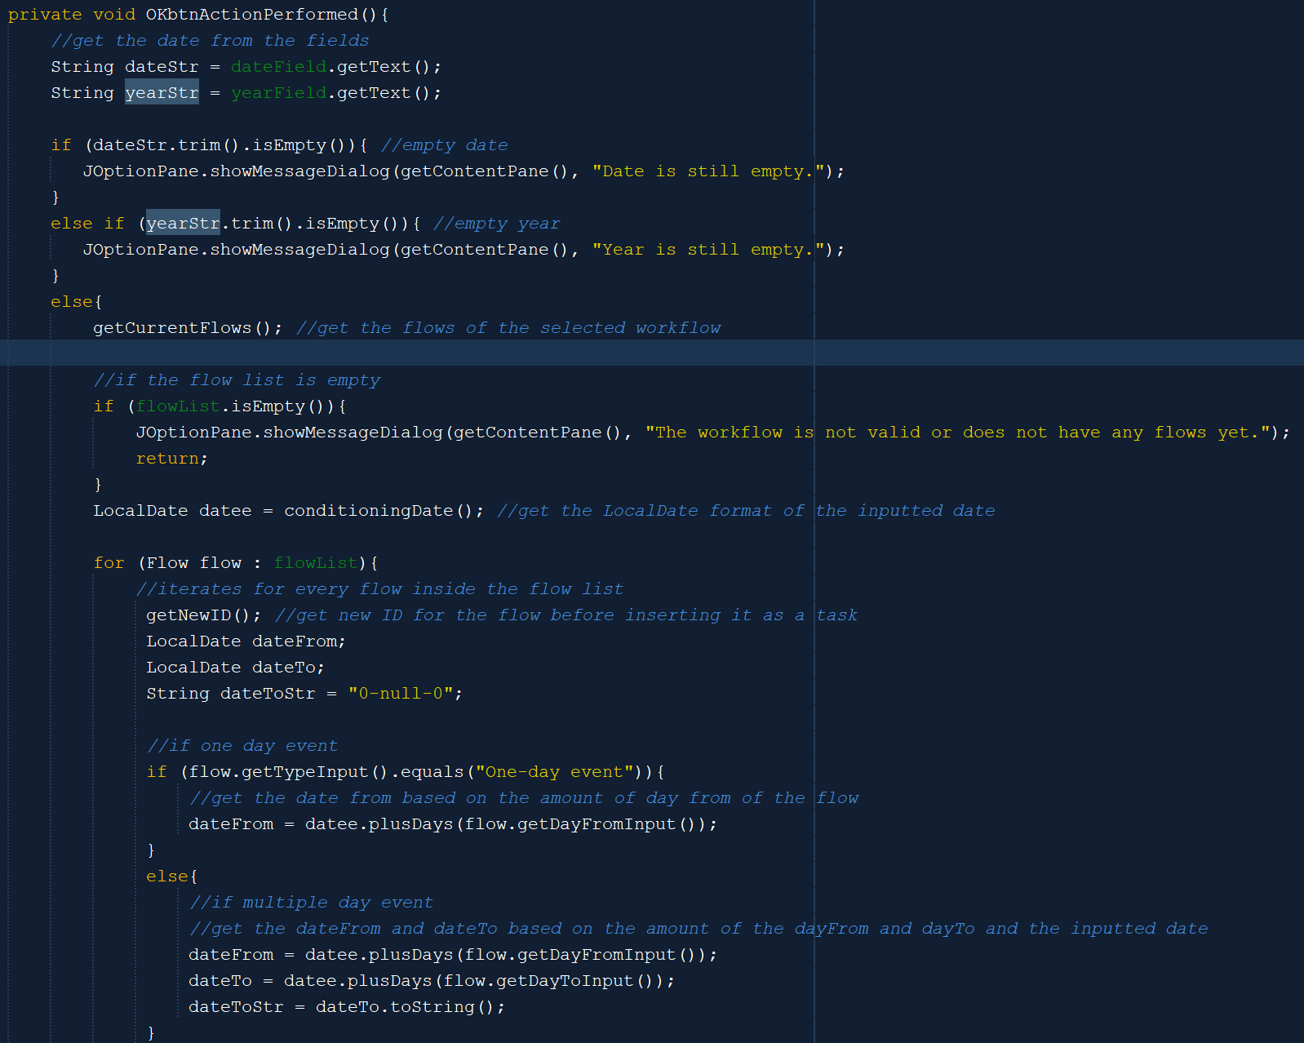

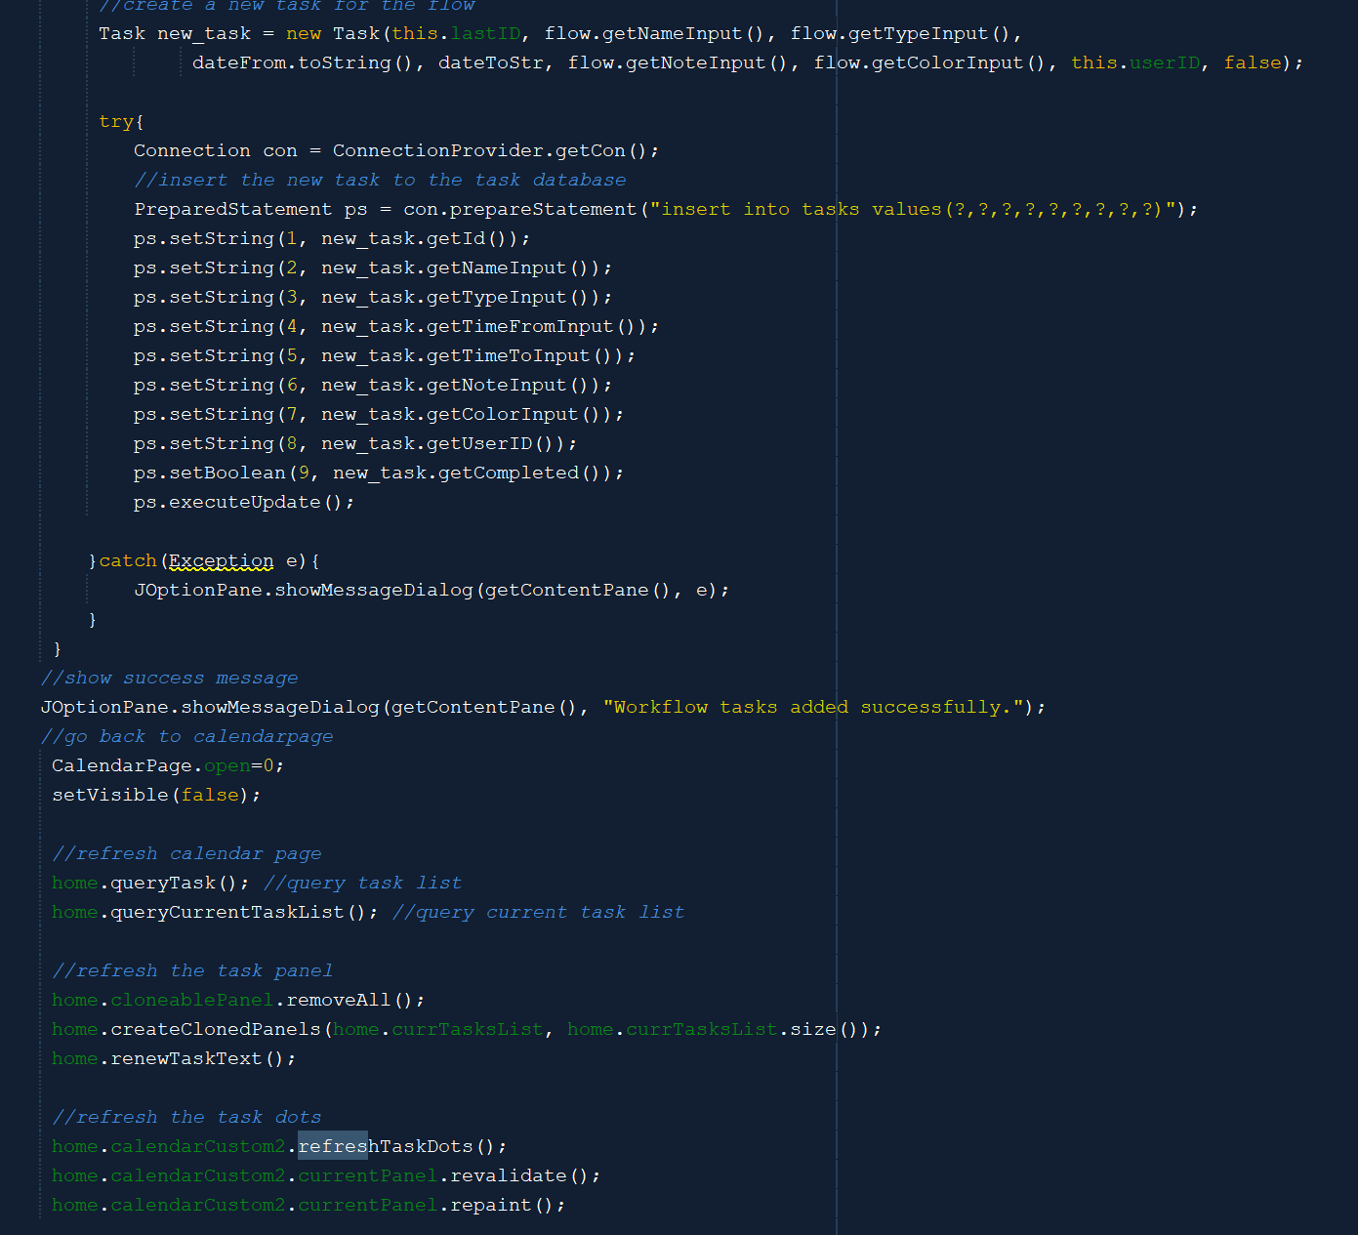

When the OK button is pressed, the method will get the full inputted date from the field and validate it. After that, it will get the flow of the selected workflow. If there is no flow yet in the selected workflow, then display the error message and return. If there are flows, then set the date String into LocalDate format. After that, it iterates over the flow list to set each of them as a task with their new ID and insert them into the database. After all is done, the frame will be closed and the calendar page will be refreshed as usual.

1. **ContactOthers**

The ContactOthers frame will be opened if the user clicks the contact button on top of the calendar panel. This frame can be linked to two other frames, which are the ContactsList frame and the MsgTemplate frame. When the user clicks the edit contact button, they will be redirected to the ContactsList frame, while when the user clicks the edit message button, they will be redirected to the MsgTemplate frame.

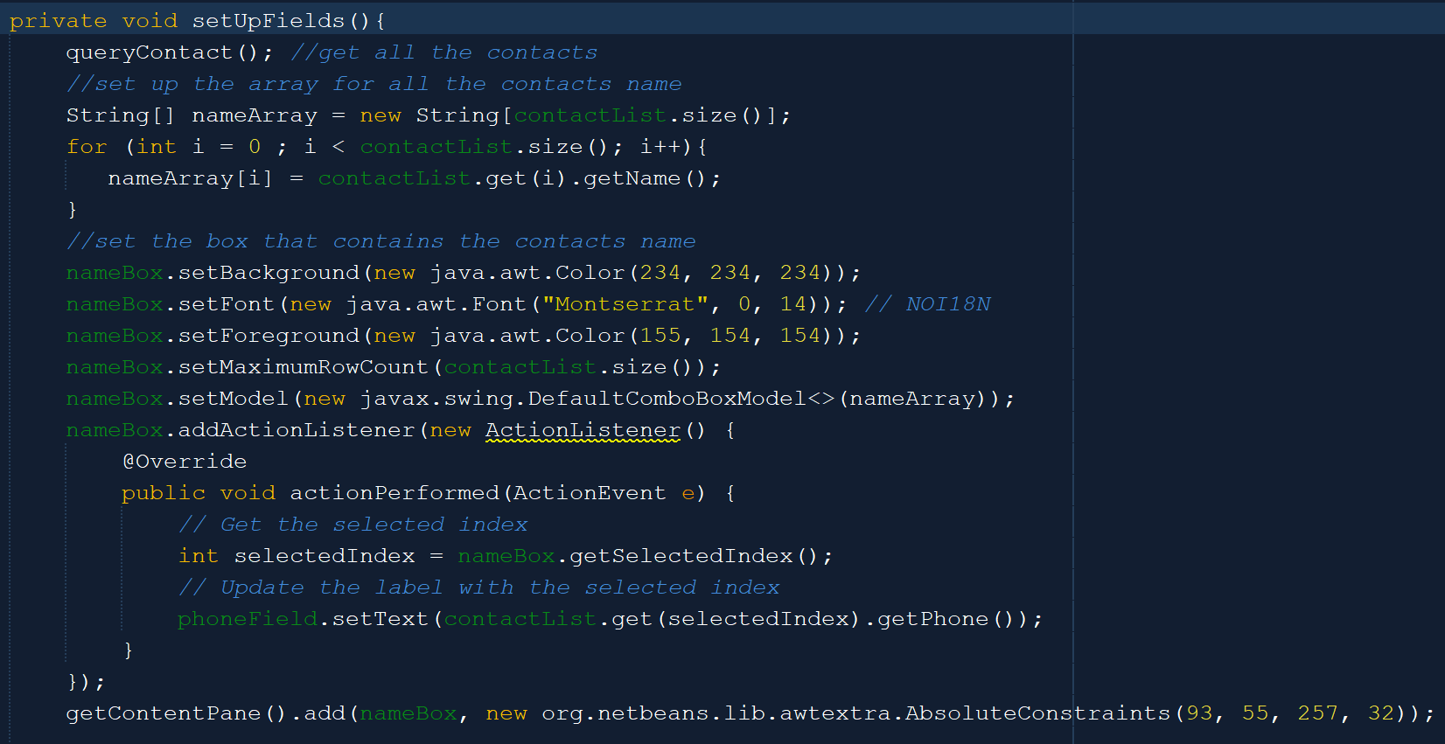

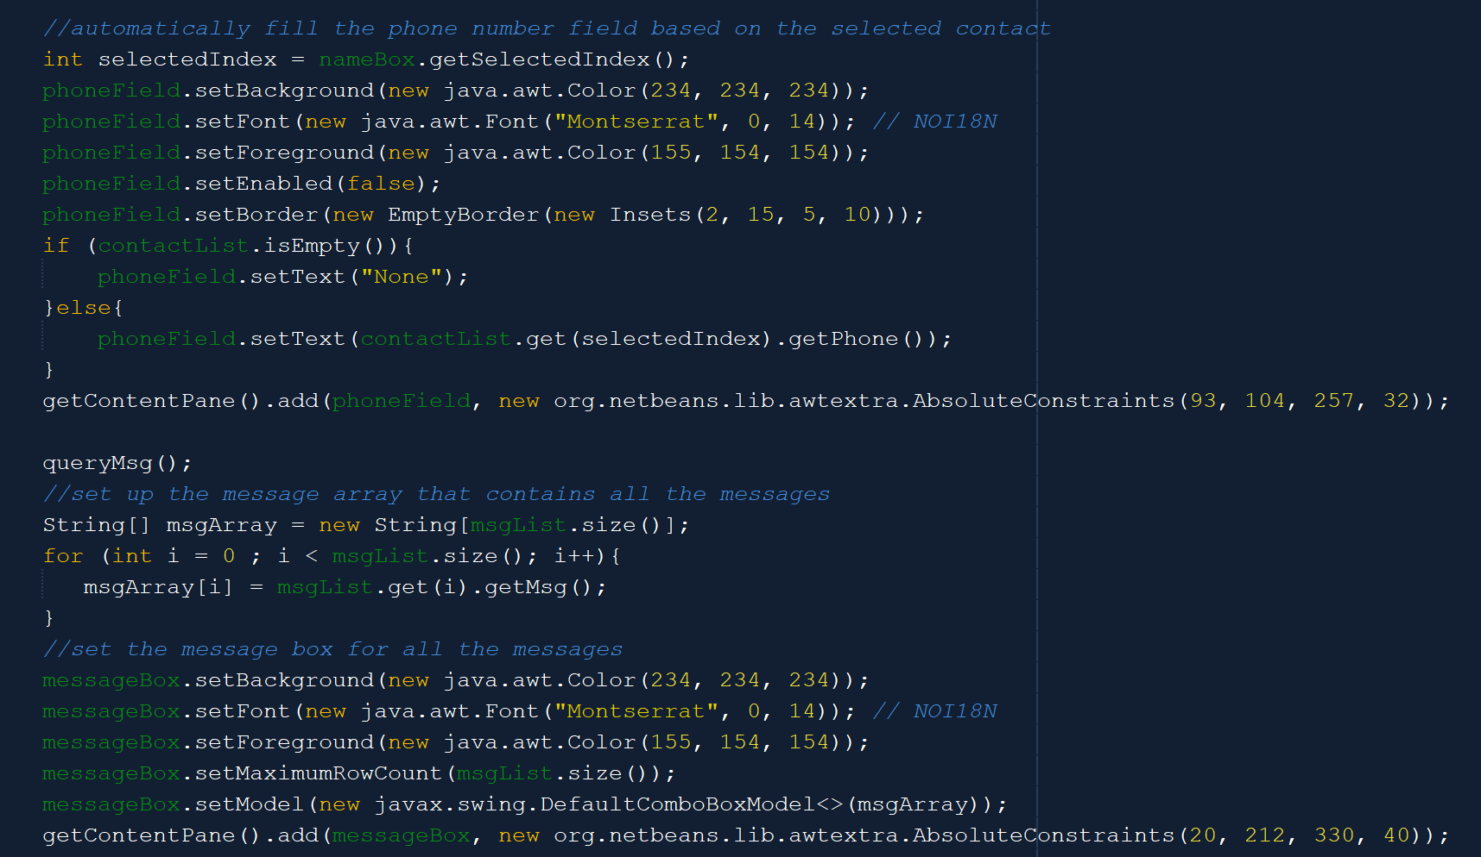

The setUpFields method is used to set up the contact and message template combo boxes and the phone number field. It will first get all the contacts inside the contact list and display their names in the combo box. If the user selects a particular name, then the corresponding contact phone number will be displayed in the phone field. After that, it will get all the message templates and display them inside the combo box.

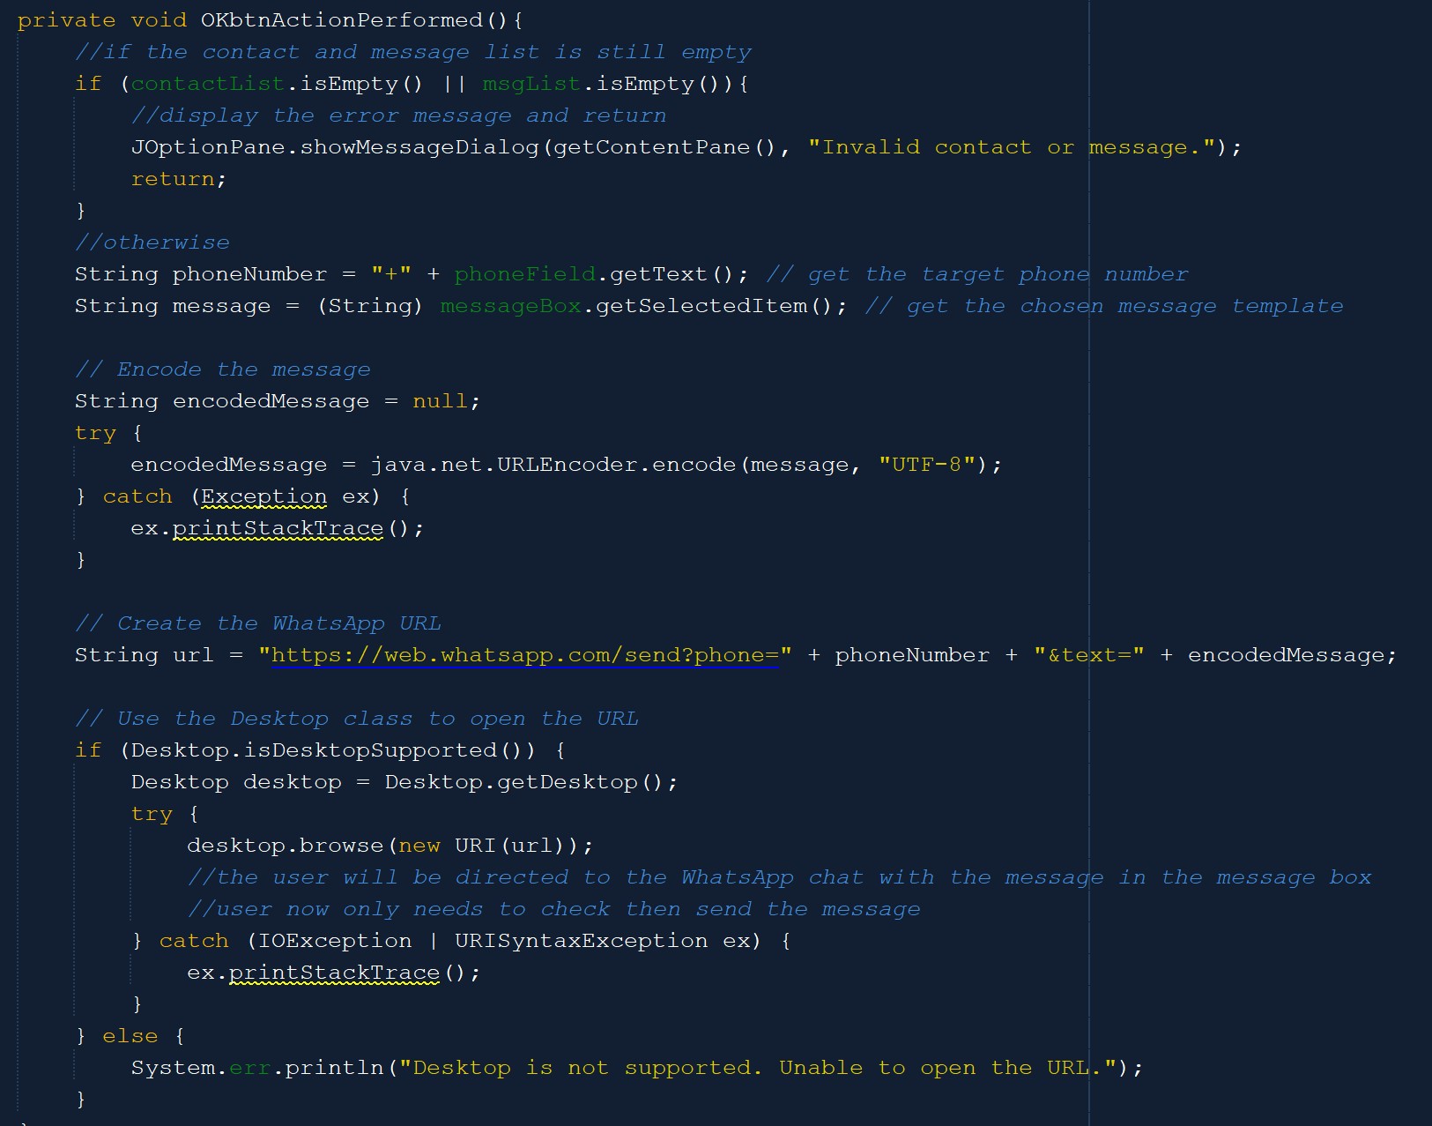



If the contact or message list is still empty (that means that no way a contact or a message can be chosen), then display the error message and return. Otherwise, get the phone number from the phone field and the message template from the combo box. After that, encode the message and create the WhatsApp URL for the phone number and message. Then, the method will use the Desktop class to open the URL and direct the user to the corresponding WhatsApp chat. The message field in the chat is also already filled with the template message, user only needs to check and press send.

1. **ContactsList**

The ContactsList is a child window of the ContactOthers frame. So when the ContactsList is closed, then the ContactOthers frame will become visible again. The ContactsList also utilizes the cloneable panel to display the info of the contacts, so the function is highly similar to other createClonedPanels methods. However, the same as the cloned panel in the Edit Workflow menu, the panel can be selected, so the cloned panels have the mouse listeners as below.

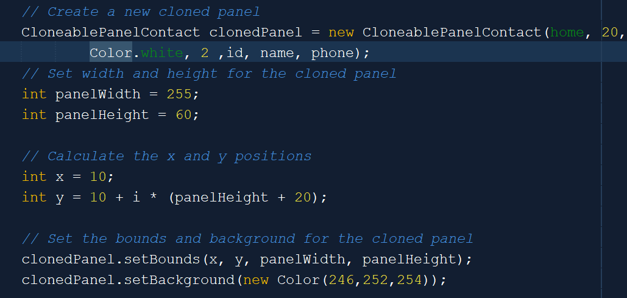

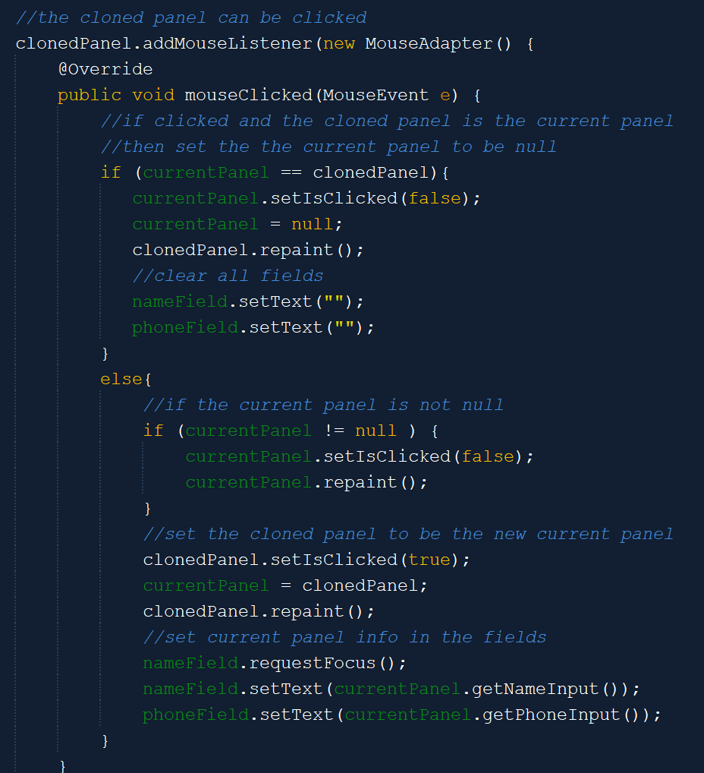One row only has one cloned panel, which is why there is no need to calculate the row and column. The cloneable panel used is also the cloneable panel for contact, which is the CloneablePanelContact.

If the cloned panel is the current selected panel, then when it is clicked again, the current panel will become null again. Otherwise, if the current panel is not null, then switch the current panel to the newly selected cloned panel.

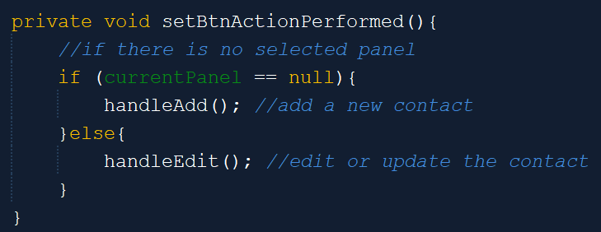

When the set button is pressed, then if the current panel is null, a new contact will be inserted, else the current data of current panel’s contact will be updated.

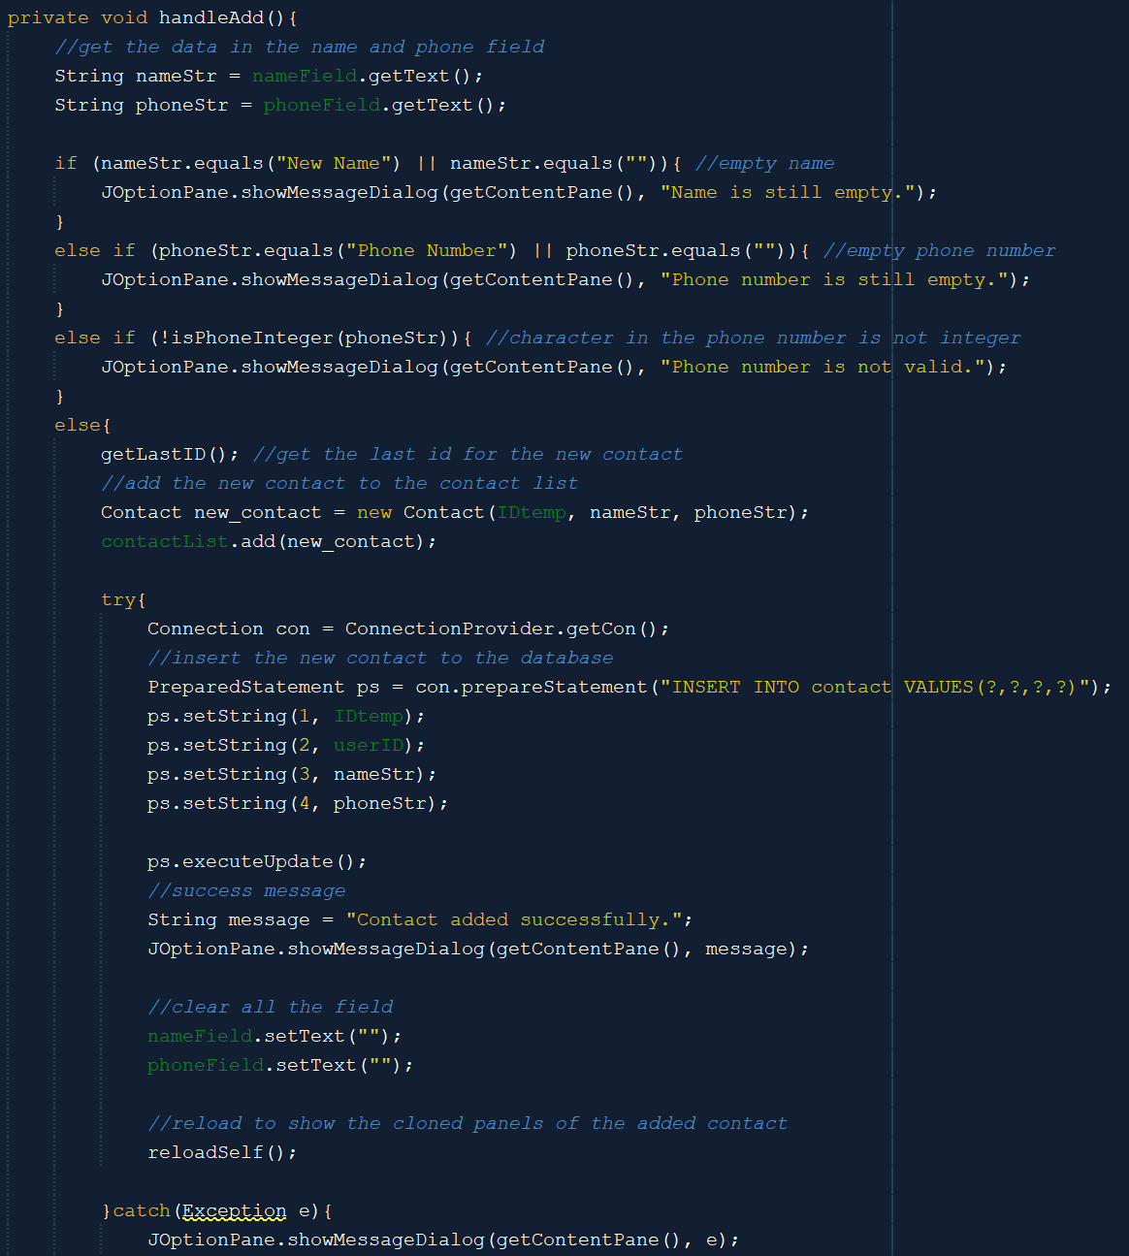

The handleAdd method will get the data from the name and phone number fields. After that, it will validate it or check whether the data is correct or not. If the data is correct, then it will get a new ID for the new contact and add it to the contact list. Then, the new contact will be inserted into the database.

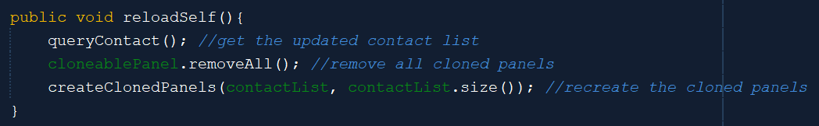

The reloadSelf method is used to refresh the cloned panels inside the frame based on the updated contact list.

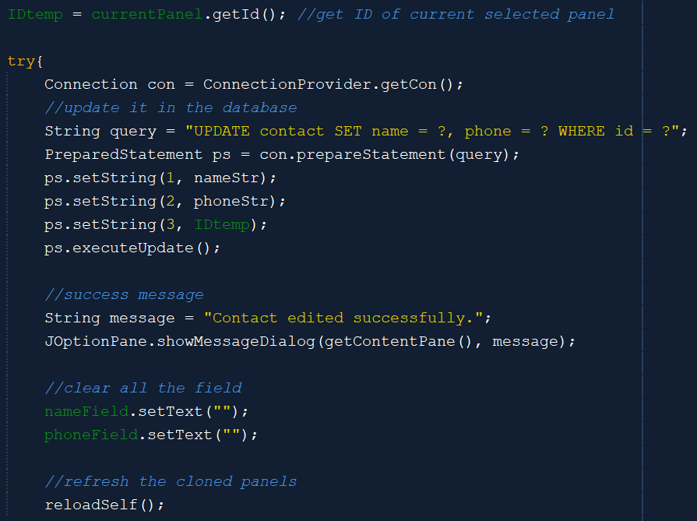

The handleEdit method is similar to the handleAdd method. The difference is only when all the conditions are met. When the data is correct, the handleEdit method will get the current panel’s ID and then update the name and phone inside the database based on the current panel’s ID. It will then clear all the fields and reload itself because there is new information in the cloned panels.

1. **MsgTemplate**

The MsgTemplate frame is opened when the user clicks the edit message button inside the ContactOthers frame. This frame is almost the same as the ContactsList frame. The only difference is that the MsgTemplate frame takes and display Message objects, not Contact. There is also only one field for the user to fill in the message. It also uses the cloned panels. The cloned panels are from the CloneablePanelMsg class, while the createClonedPanels method is the same as the one in the ContactsList (but it takes list of Message instead).

The set button when performed also behaves the same. When there is no selected panel, the data will be inserted as a new message, while if there exists a selected panel, then the data will become the new data for the selected panel.

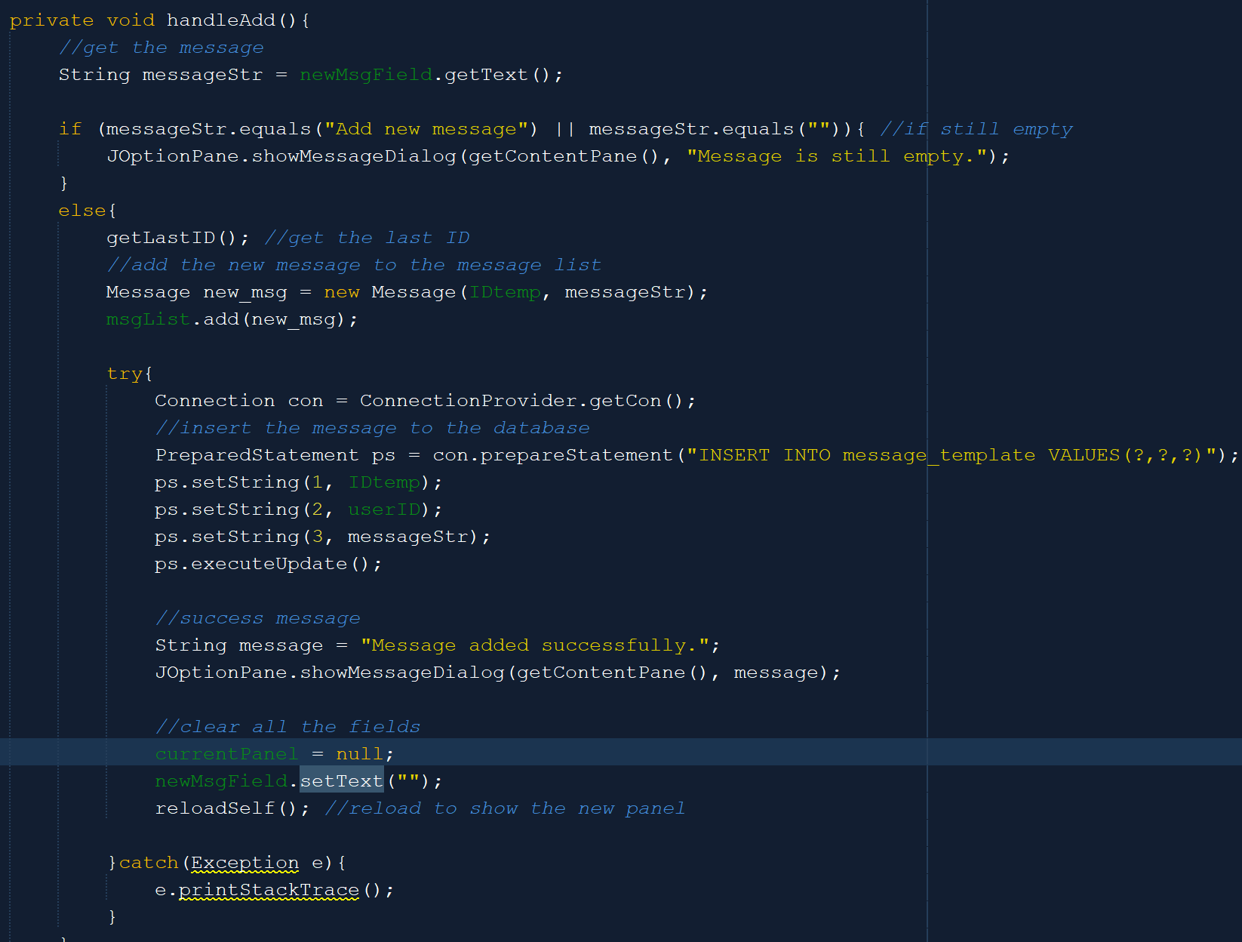

The handleAdd method will first get the message from the message field and then checks whether the result is empty or not. If not, then it will get the last ID of the message and add it to the message list and insert it into the database. All fields and selected panel will be cleared and the cloned panels will be refreshed.

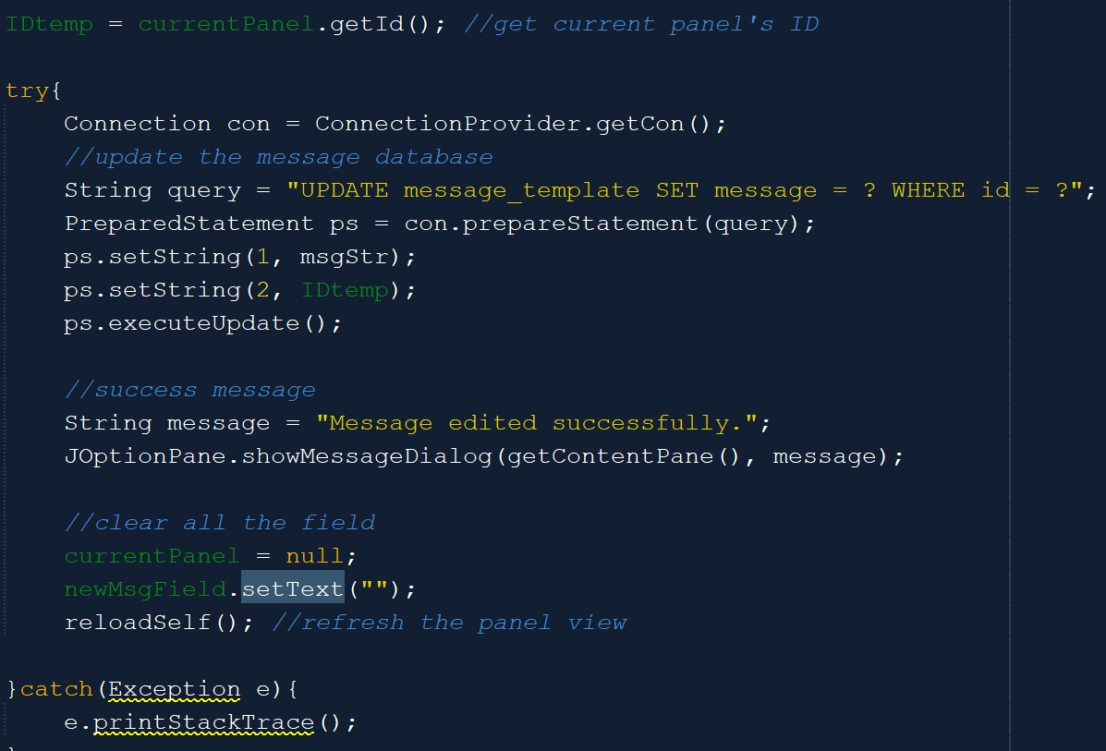

The handleEdit method is also the same. After all the validations, it will get the current ID and update the message in the database based on the ID and the new inputted data. After that, it will clear all fields and selected panel and also refresh the cloned panels.

1. **AranaraMenu**

Last but not least, we have the last main menu, which is the Aranara menu. Due to it being a main menu, the Aranara menu also has a side navigation bar, where users can access other main menus or log out from there. The hoverButton method is also the same.

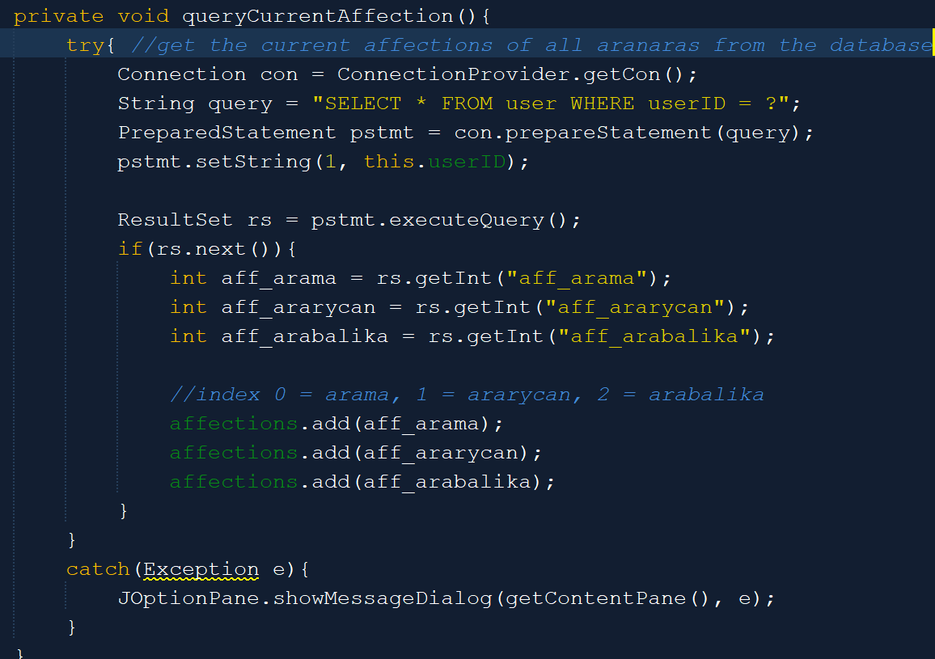

The queryCurrentAffection method is used to query the current affections of all Aranaras and insert them into a Linked List. The first index will be Arama’s affection, the second is Ararycan’s, and the third is Arabalika’s. The affection is used to determine whether an Aranara is unlocked or not.

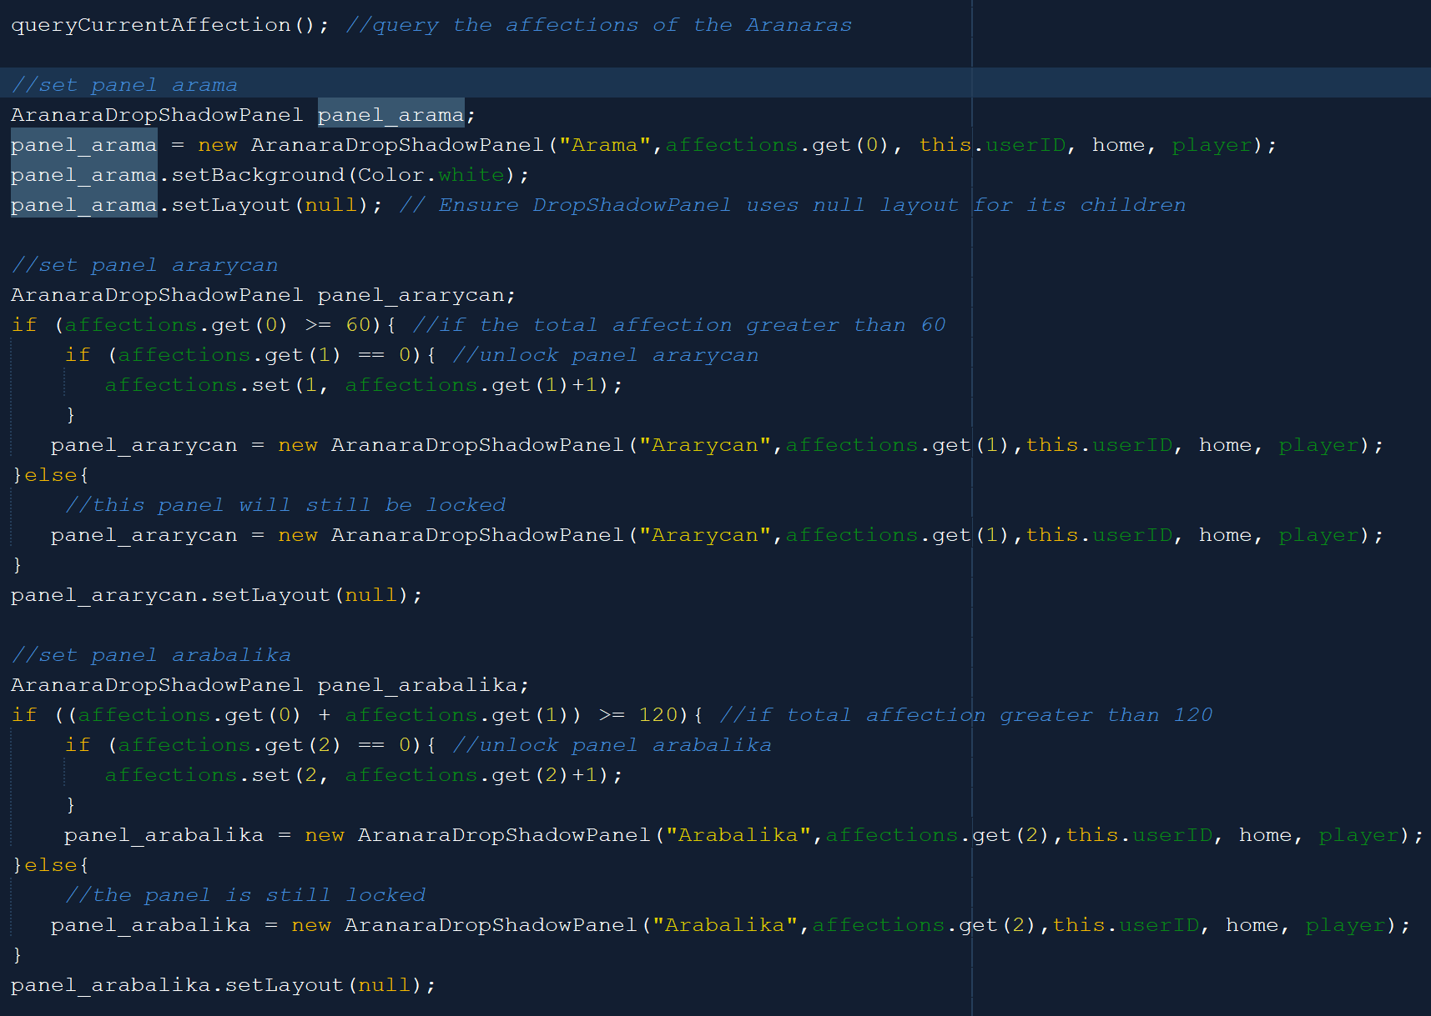



The above code is a part of the initDesign method. In there, after getting all of Aranaras current affection, it will initialize the Aranara panel based on the affections. Because Arama is the default Aranara, then it will automatically be unlocked. Meanwhile, Ararycan is unlocked after the current total affection is greater than 60 and greater than 120 for Arabalika. The user can not access the locked Aranaras as explained in the AranaraDropShadowPanel. When an Aranara is unlocked (Ararycan or Arabalika), their default affection is 1.

1. **EditAranara**

The EditAranara menu is used as a page to interact with the Aranara. It is also an independent page.

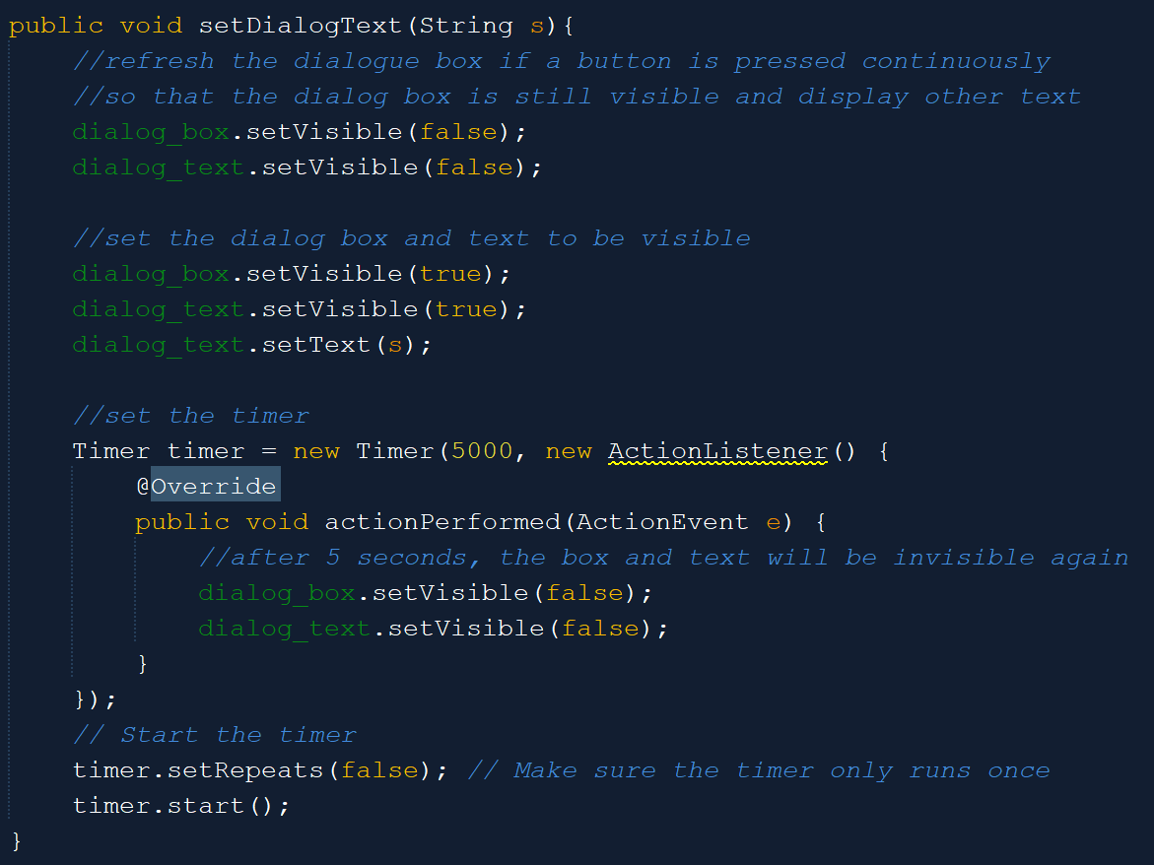The setDialogText method is used to set the dialog box and the desired dialog text to be visible for 5 seconds using the timer.

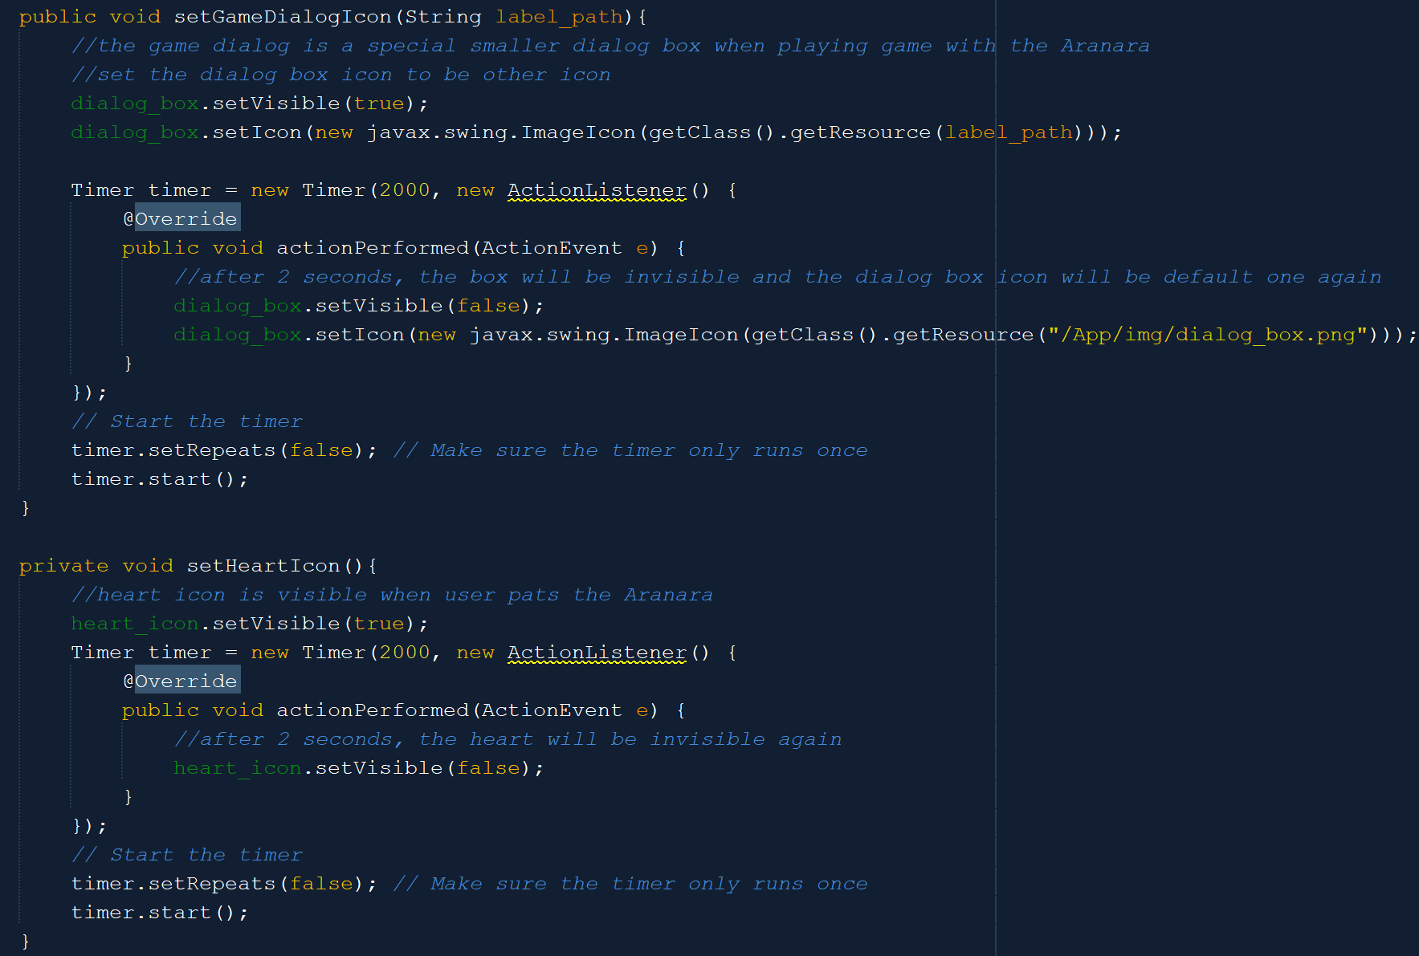

Meanwhile, the set game dialog icon is used to set the dialog box to be the special dialog box that is used when playing the game with the Aranara. The special dialog box will be visible only for 2 seconds, and then the dialog box will revert back to the default dialogue box. The setHeartIcon is used to set the heart icon when the Aranara is patted. The heart icon will only be visible for 2 seconds.

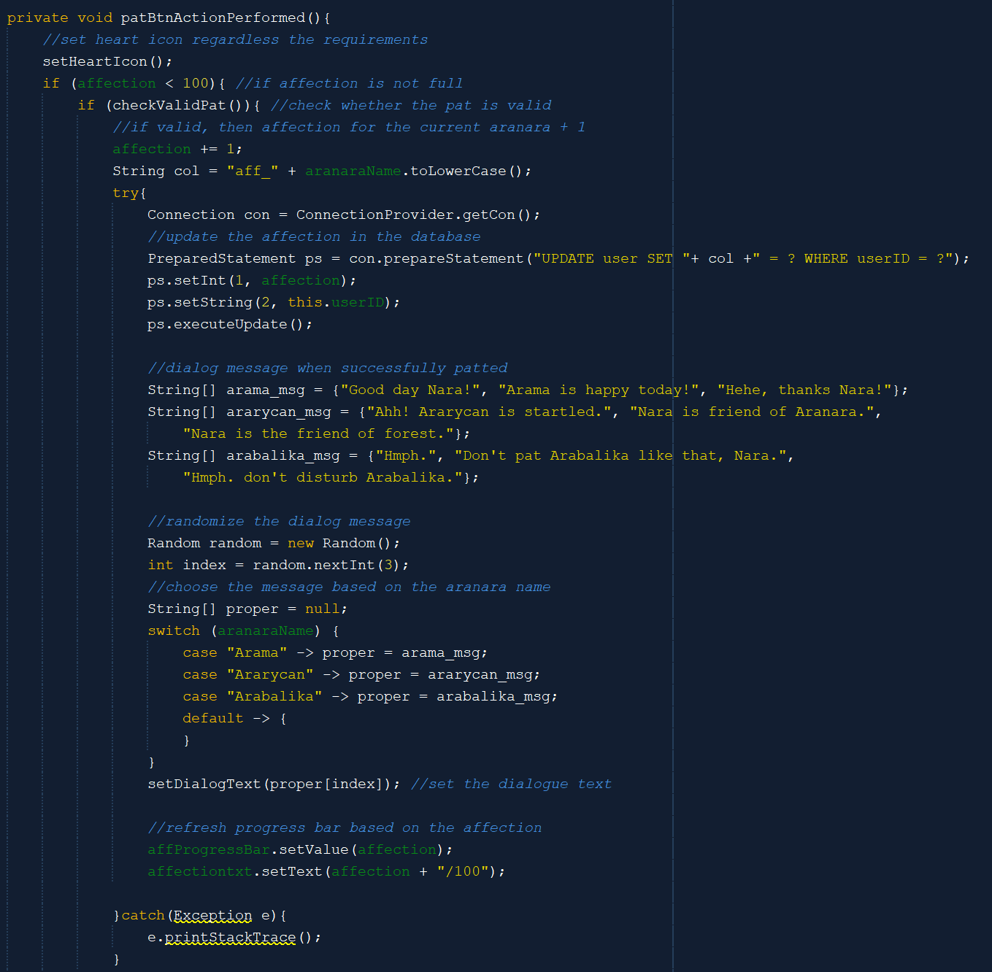



When the pat button is pressed, then regardless of the affections and pat conditions, set the heart icon. After that, the method will check whether the pat is valid or not. If the pat is valid and the affection is lesser than 100, then increase the corresponding Aranara affection and set the random dialogue text based on the Aranara. After that, set the value of the progress bar and the progress label.

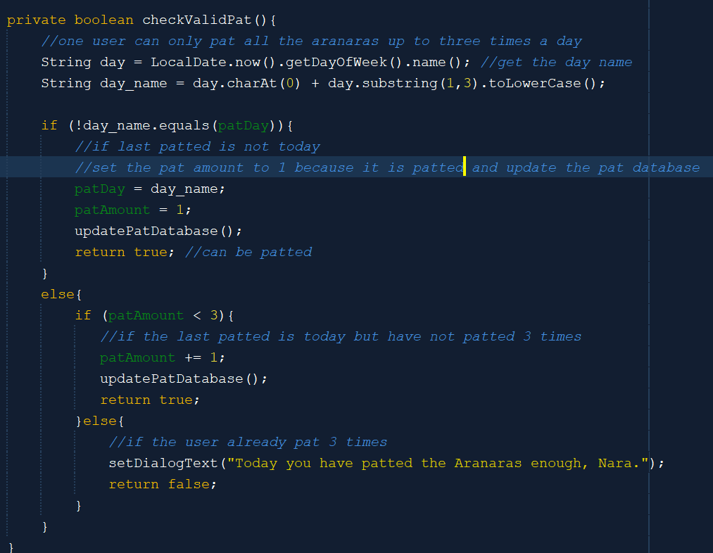

The checkValidPat will check the amount of pat that the user has done for today. Every user can only pat the Aranaras up to three times a day. The method will check if the last patted is today or not, if it is not today, pat the Aranara 1 time and update the database. If it is today, it has to be less than 3 if the user wants to pat the Aranara.

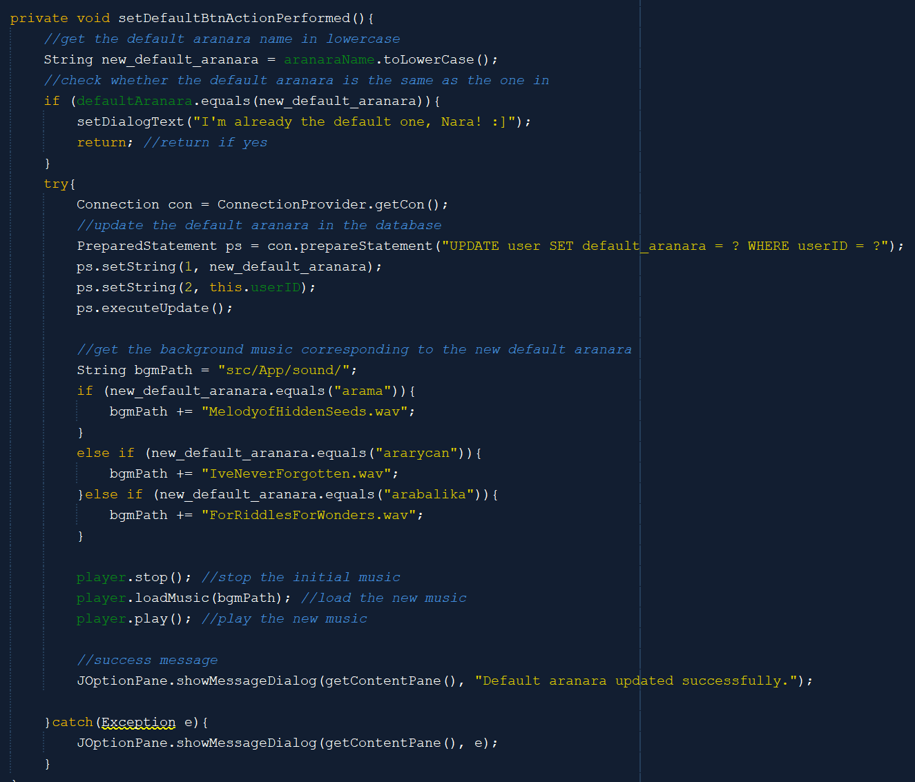

If the set default button is pressed, then check whether the default Aranara is the same as the current Aranara or not. If it is the same, then return. If not, then update the database and set the background music based on the Aranara. Every Aranara has their own background music.

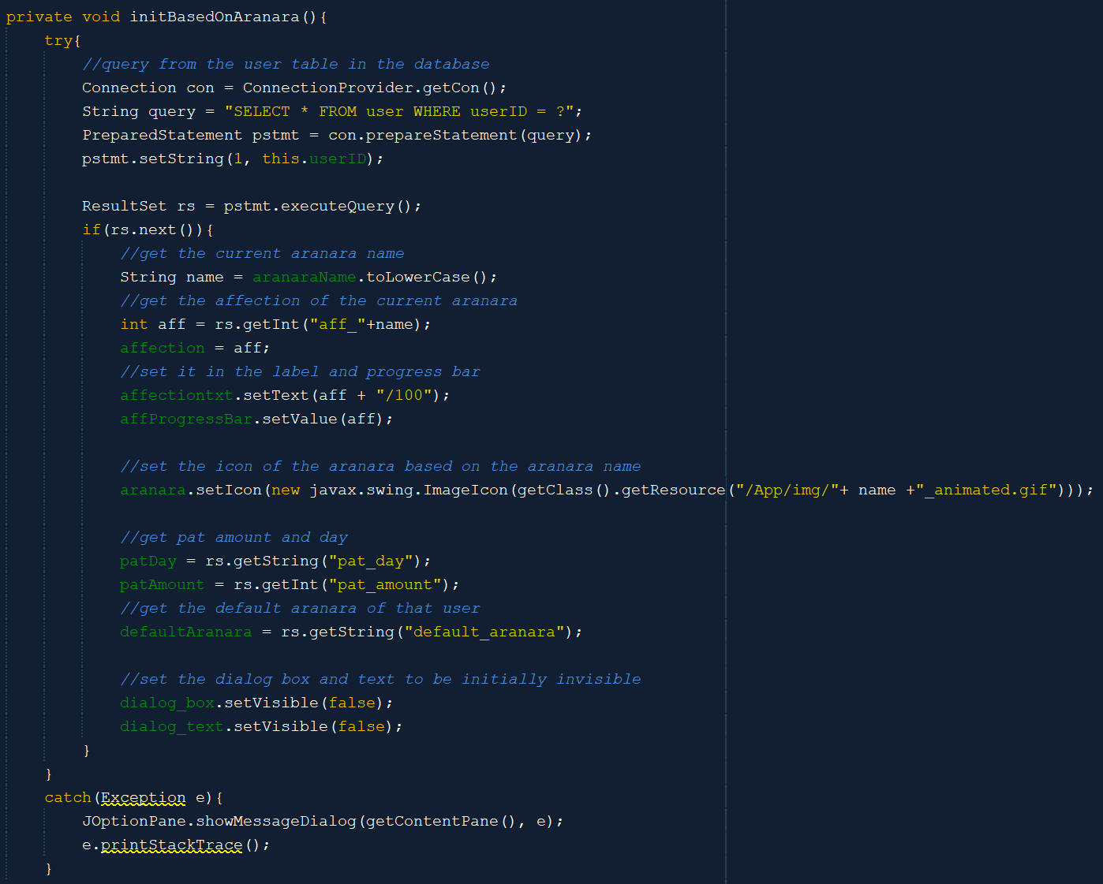

The initBasedOnAranara method is used to initialize the Edit Aranara frame based on the current Aranara that is active on the page. It will set the label and progress bar based on the current Aranara’s affection in the database and set the Aranara icon based on the current Aranara name. It will also query the pat day, pat amount, and default Aranara from the database.

There is also a chat button so that when the user presses it, the AranaraChatMenu will be open. Only when the AranaraChatMenu is open, the back chat button is set to be visible. This button is used to collapse the opened AranaraChatMenu.

1. **AranaraChatMenu**

The AranaraChatMenu consists of eight different buttons that has their own operations if it is pressed. Note that eight of them does not increase the Aranara affection.

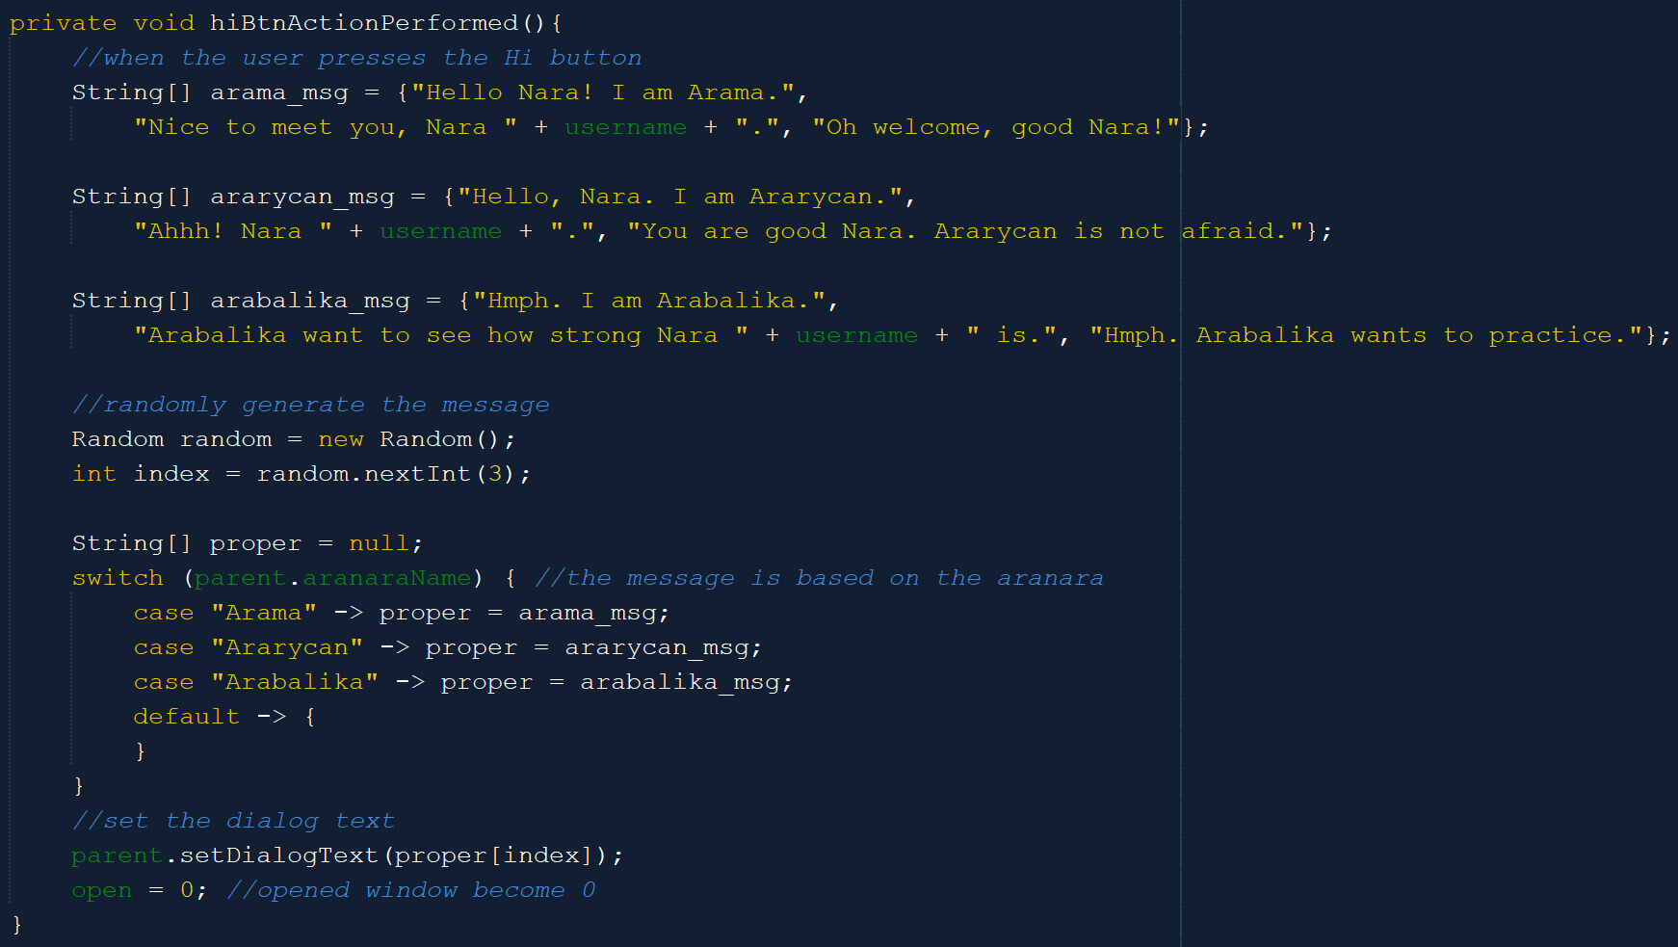

The first one is the hi or greet button. When the button is clicked, it will generate a message on the dialogue box randomly based on the Aranara. Every Aranara has three possible responses.

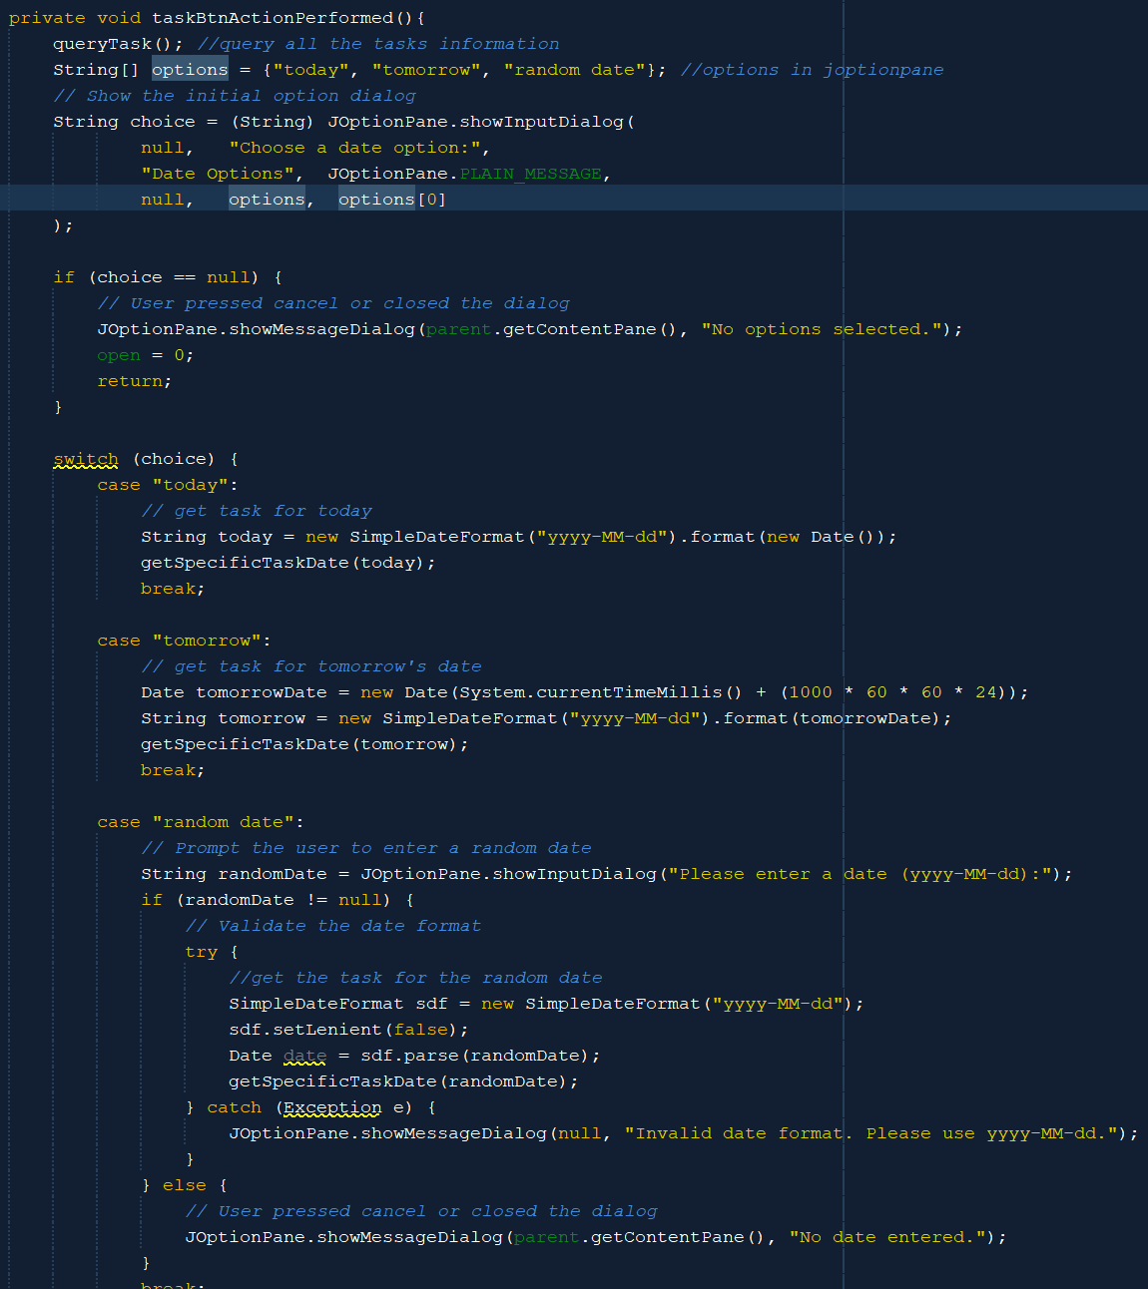

The second one is the task button. It will first query all the available tasks that the user has. After that, it will show a JOptionPane to let the user choose what date they want to know the tasks of. The choices are today, tomorrow, and random date. If random date is entered, there is another JOptionPane to prompt the user to enter the date. The method will check the format of the date. If today or tomorrow is chosen or the random date is valid, then the method getSpecifisTaskDate will be called with the inputted date.

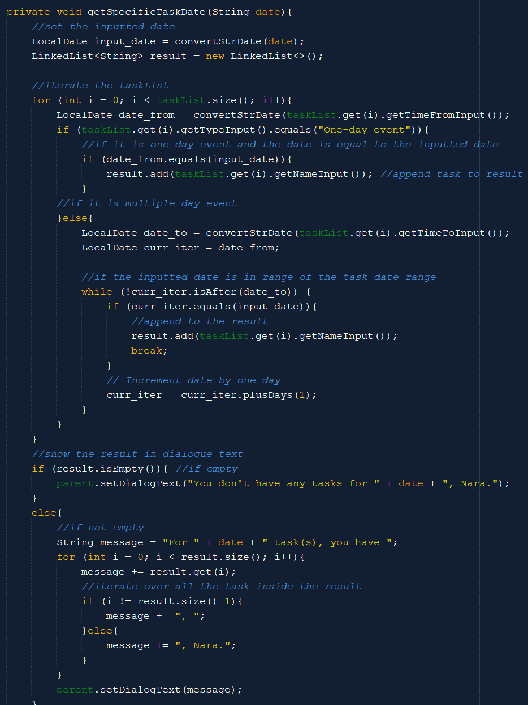

The getSpecificTaskDate is used to get the tasks based on the inputted date. It will iterate over the task list and check whether the inputted date is the same or in the range of the task date. If yes, then append the task name to the result. After that, the method will set up a message in the dialog for the user about the task on that date.

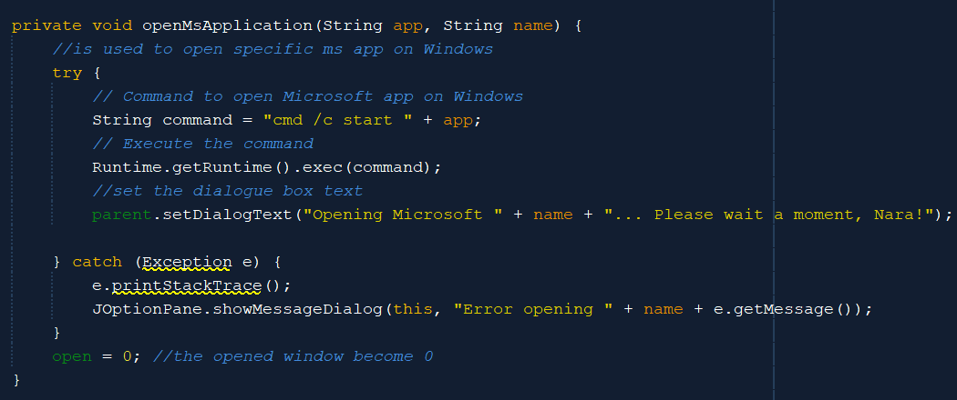

The third, fourth, and fifth buttons consecutively are Microsoft Word, Excel, and PowerPoint. The three of them use the same method which is the openMsApplication method. This method will command to open the Microsoft app based on the specific command. For Word, the command (the app variable) is “winword”, for Excel, it’s “excel”, while for PowerPoint, it’s “powerpnt”. After that, it will execute the command and set the dialogue text of the Aranara based on the app name.

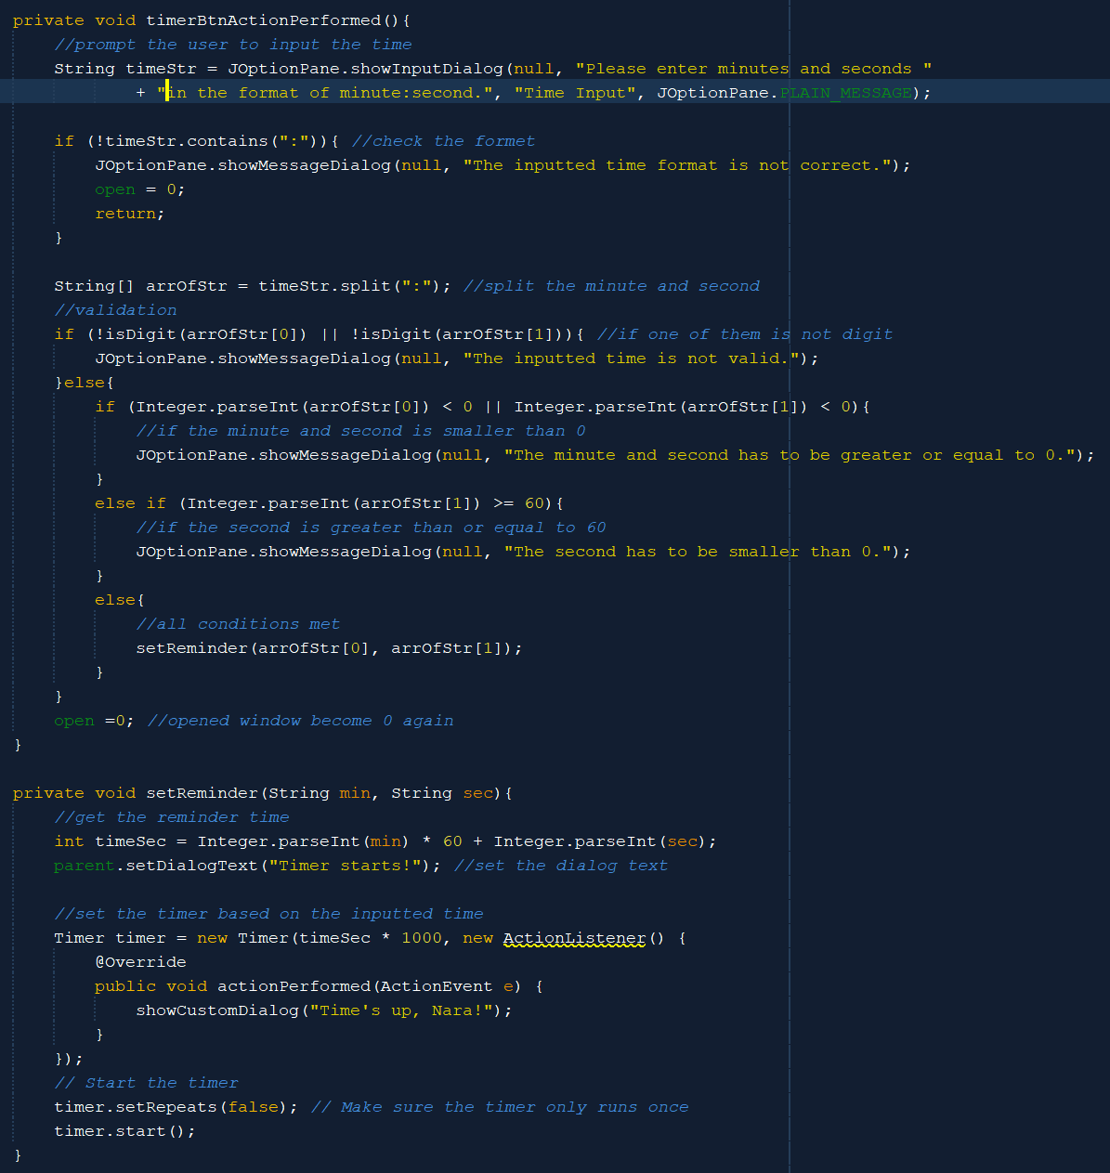

The sixth button is the timer button. When the time button is pressed, it will initialize a JOptionPane to prompt the user to input the minutes and seconds in the format of minute : second. After that, the method will validate the user inputted time. If all conditions are met, it will set the reminder.



The setReminder method will get the time based on the inputted minutes and seconds. It will then start a timer based on the time. After the time passes, there will be a custom JDialog that is set on the top to say that the time is up.

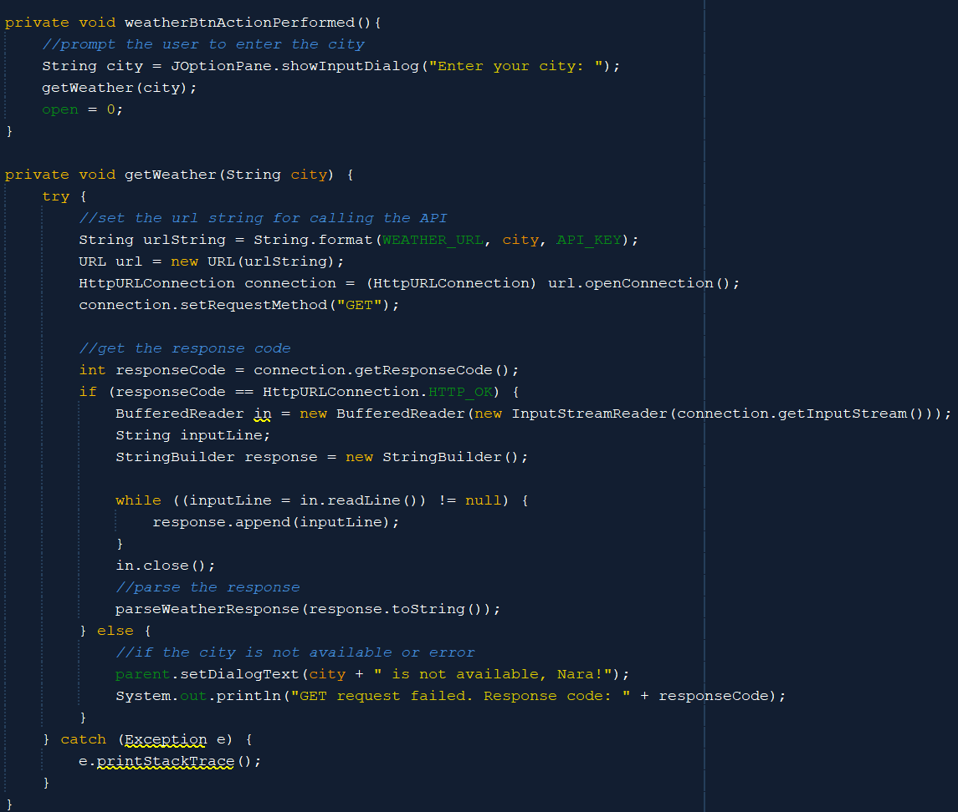

The seventh button is the weather button. When the weather button is pressed, it will prompt the user to input a city. Then, it will get the weather of the city by calling the OpenWeatherMap API. It will then parse the response. If the city is not available or other errors, then set the error message.

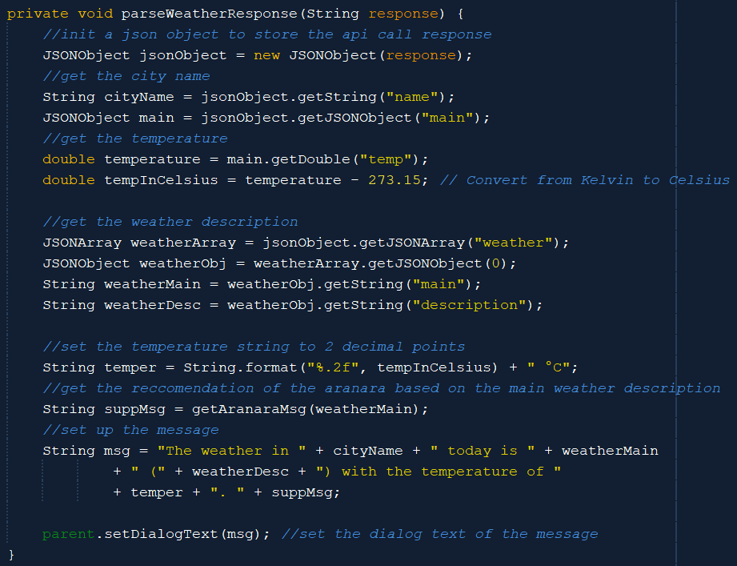

The parseWeatherResponse is used to store the response as a JSON object and parse it. This method will get the temperature, weather main, and the weather description. After that, it will customize the message with some Aranara messages about the weather. After that, the completed message will be set to the dialogue box.

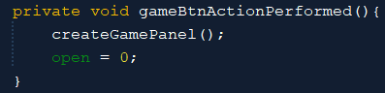

The last button is the game button. The game is rock, paper, scissors. When the game button is pressed, the method will create a game panel that consists of the rock, paper, and scissors button. User can choose between those three.

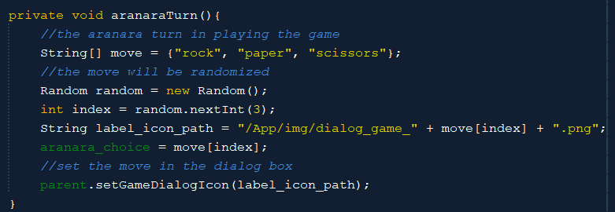

After the user moves, the Aranara will randomly choose between rock, paper, or scissors. After that, the Aranara move will be visible on the special dialogue box for 2 seconds.

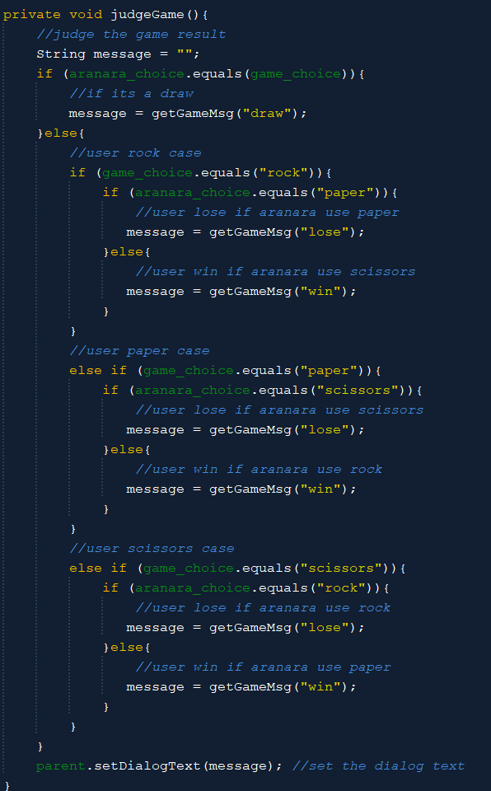

After that, the judgeGame method will be called to determine the result of the game. There are three kinds of results which are the draw, win, and lose. Every result has its corresponding sound effects and every Aranara has its own dialogue about the result. The judgeGame logic is based on the regular rock, paper, and scissors game, where rock is triumphant over scissors, paper over rock, and scissors over the paper.

1. **Evidence of Working Program**

These are only some samples of SchedNara frames with dummy content.

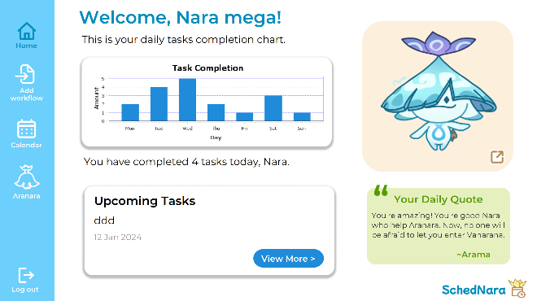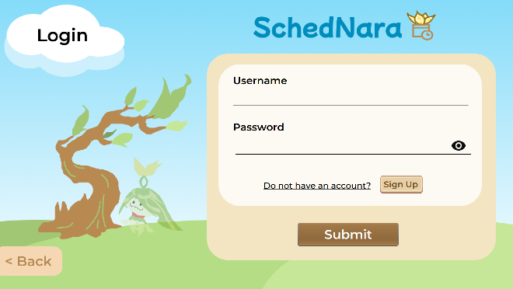The login page and the homepage

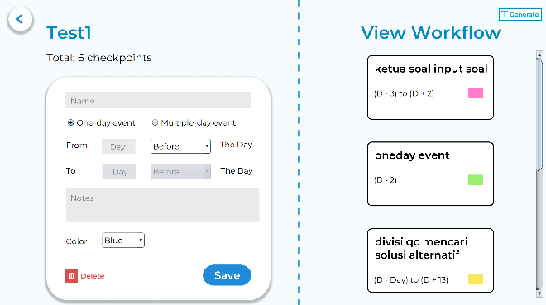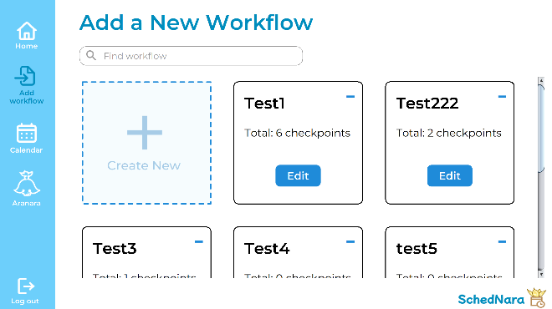The add workflow menu and the edit workflow page

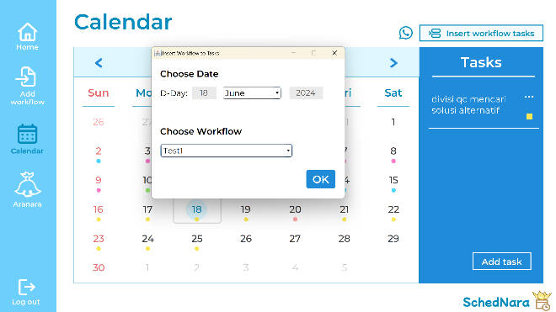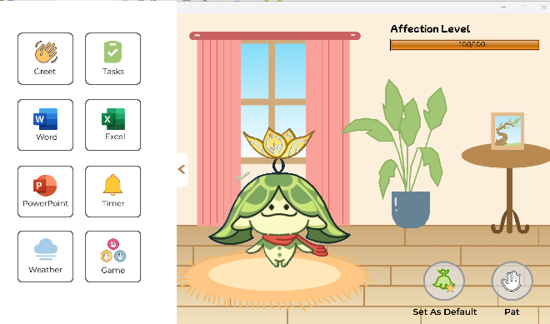The calendar page and the edit Aranara menu (Aranara activity page)

1. **Lesson Learnt (Reflection)**

From this Object Oriented Programming final project, I learn a lot of technical and non-technical skills. First of all, I would like to thank Sir Jude for giving us this project, so that I can learn the Object Oriented Programming in Java. When I first got this project, I immediately thought of the problem and minor inefficiency that I have to do with my organizational job every month, in which I have to count the date of the organizational task based on the monthly workflow. Hence, I created SchedNara. The design is also based on my favorite Aranara so that I can be more motivated in doing this project.

I learned a lot of technical skills from this project, from creating a GUI application to calling the weather API in Java. Because this project idea was originally from me, I did not watch many tutorials, therefore I had to debug a lot along the way. I learned that Java Swing is not as flexible as Python. One example is that it does not allow the resizing of the image icon on the label. Hence, this is a new experience for me.

Meanwhile, the non-technical skill that I have learned from this project is that we should not rush the report less than a week before the submission date. Due to having more time, I focus more on adding features to SchedNara, resulting in less amount of time to do the project report. The thing that surprises me is that I have to spend a day full only for creating the class diagram due to SchedNara having 42 classes. I realized that I should not focus on adding too many features when the deadline is near and should focus on the report. I did not regret creating SchedNara as I can expect myself to still use it in the future. I also realized that SchedNara can be further improved and I will do so in the future if I have the time.

Lastly, I am satisfied with this project more than the previous semester's Algorithm and Programming Final Project due to SchedNara being more original. Besides that, most of the features that I needed and wanted have already been added to SchedNara, so I have no regrets anymore. Although my time management is still bad, I feel that it is better than in the previous semester and I am happy with my skill advancement.

1. **Resources**

Learning resources:

* Calendar panel display in Java : <https://youtu.be/YivaMCfichQ?si=nsv0AYzm3s4dWicD>
* OpenWeatherMap API : <https://openweathermap.org/forecast>
* Debug : <https://stackoverflow.com/> and <https://chatgpt.com/>

Image, font, and audio resources are stated in part C.